**EMBARGOED UNTIL 26th January 2017 – 9AM PT // 6PM CET**

Please see **high res images** [here](https://we.tl/N0rpDNNLQW).

https://photos-1.dropbox.com/t/2/AADGtoUtA_QvFHsthMg1nAUj7Gx6DY3dy7WoRx4x3iSgBg/12/576581935/png/32x32/1/_/1/2/badge_of_sport_logo_bwp_v1.png/ELrfltEEGPtTIAIoAg/oEYgsAvzae2jTMdzyQbUwZpyldBTOwuTrtv24NG0m8c?size=800x600&size_mode=3

**adidas Soccer Launches New MESSI 16 Blue Blast**

**- MESSI 16 added to the Blue Blast Collection -**

**- Blue and pink colors feature on MESSI 16 Blue Blast -**

**- AGILITYKNIT, PUREAGILITY HEEL LINING and SPRINTFRAME outsole all feature -**

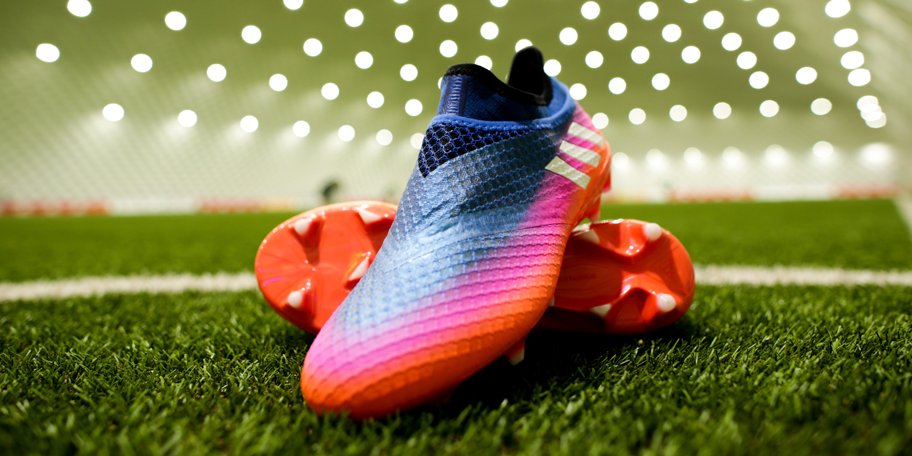

**Portland, Ore., January 26, 2017** – adidas unveils today the latest edition to the Blue Blast Collection with the release of the special edition MESSI 16 Blue Blast, which will be worn by the five-time Ballon d’Or winner, Leo Messi.

As with the other versions of MESSI 16 available from adidas Soccer, the MESSI 16 Blue Blast has been designed to suit Leo Messi’s unique and distinctive playing style and has features including:

* A SPRINTFRAME outsole delivering stability when changing direction at high-speed
* AGILITYKNIT used on the boot to ensure zero wear-in time
* A PURECUT SOCK SYSTEM and PUREAGILITY HEEL LINING both feature to create an uncompromised fit

For further information please visit **adidas.com/us/soccer** or go to **facebook.com/adidassoccer** or follow **@adidassoccer** on twitter to join the conversation.

**- END -**

**For further media information please visit** [**http://news.adidas.com/US/home/SOCCER**](http://news.adidas.com/US/home/SOCCER) **or contact:**

|  |  |
| --- | --- |
| Cristina Maillo Belda  PR Manager, adidas Soccer  Email: [Cristina.maillobelda@external.adidas.com](mailto:Cristina.maillobelda@external.adidas.com)  Tel: 503. 915.9129 |  |

**About adidas Soccer**

adidas is the global leader in soccer. It is the official sponsor / official supplier partner of the most important soccer tournaments in the world, such as the FIFA World Cup™, the FIFA Confederations Cup, the UEFA Champions League, the UEFA Europa League, the UEFA European Championships and Major League Soccer. adidas also sponsors some of the world’s top clubs including Manchester United, Real Madrid, FC Bayern Munich, Juventus, Chelsea and AC Milan. Some of the world’s best players also on the adidas roster are Leo Messi, Paul Pogba, Gareth Bale, Thomas Müller, Luis Suárez, James Rodríguez, Diego Costa and Mesut Özil.