https://photos-1.dropbox.com/t/2/AADGtoUtA_QvFHsthMg1nAUj7Gx6DY3dy7WoRx4x3iSgBg/12/576581935/png/32x32/1/_/1/2/badge_of_sport_logo_bwp_v1.png/ELrfltEEGPtTIAIoAg/oEYgsAvzae2jTMdzyQbUwZpyldBTOwuTrtv24NG0m8c?size=800x600&size_mode=3

**adidas Soccer Adds X16 Blue Blast to Blue Blast Collection**

**- X16 Blue Blast to be worn by the likes of Bale, Muller and Suarez -**

**- Blue and pink colors feature on new X16 Blue Blast -**

**- X16 Blue Blast features PURECUT SOCK SYSTEM, NON STOP GRIP (NSG) and a SPRINTFRAME outsole -**

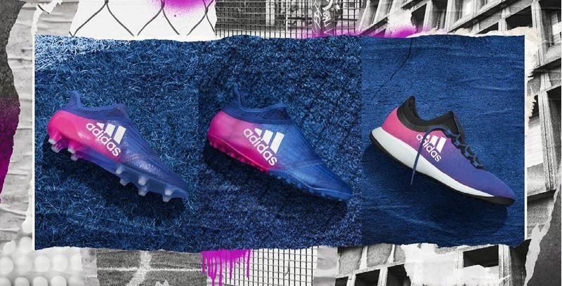

**Portland, Ore., January 26, 2017** – adidas Soccer unveils today the X16 Blue Blast boot, the latest product in the Blue Blast collection, which will be worn by the likes of global stars Gareth Bale, Thomas Müller and Luis Suárez.

The X16 Blue Blast features:

* Striking blue and pink colorway
* NON STOP GRIP (NSG) finish, giving players unrivalled levels of control
* PURECUT SOCK SYSTEM, which sees laces hidden under an upper layer
* SPRINTFRAME outsole to create stability during high-speed changes of direction

The X16 Blue Blast will be available in the following models:

* Stadium: details as outlined above
* Cage: details as per stadium boot, but with gum finish used on the outsole
* Street: EVA molded sole

For further information please visit **adidas.com/us/soccer** or go to **facebook.com/adidassoccer** or follow **@adidassoccer** on twitter to join the conversation.

**- END -**

**For further media information please visit** [**http://news.adidas.com/US/home/SOCCER**](http://news.adidas.com/US/home/SOCCER) **or contact:**

|  |  |
| --- | --- |
| Cristina Maillo Belda  PR Manager, adidas Soccer  Email: [Cristina.maillobelda@external.adidas.com](mailto:Cristina.maillobelda@external.adidas.com)  Tel: 503. 915.9129 |  |

**About adidas Soccer**

adidas is the global leader in soccer. It is the official sponsor / official supplier partner of the most important soccer tournaments in the world, such as the FIFA World Cup™, the FIFA Confederations Cup, the UEFA Champions League, the UEFA Europa League, the UEFA European Championships and Major League Soccer. adidas also sponsors some of the world’s top clubs including Manchester United, Real Madrid, FC Bayern Munich, Juventus, Chelsea and AC Milan. Some of the world’s best players also on the adidas roster are Leo Messi, Paul Pogba, Gareth Bale, Thomas Müller, Luis Suárez, James Rodríguez, Diego Costa and Mesut Özil.