adidas Football releases new Red Limit ACE 16+ UltraBOOST

- Red Limit ACE 16+ UltraBOOST the latest product from the Limited Collection -
- Red Limit ACE 16+ UltraBOOST features black Primeknit upper and red heel counter -
- Available in limited numbers from 30th November –

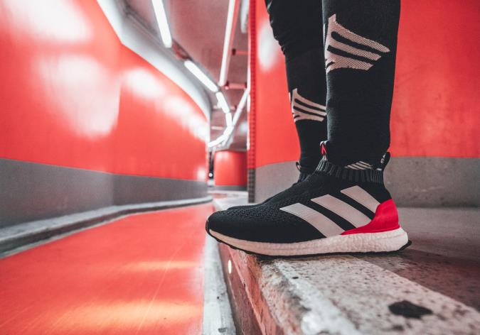

Herzogenaurach 30th November - Today adidas Football announced the launch of the Red Limit ACE 16+ UltraBOOST. The shoe brings together the best from adidas Football and adidas Running and is the latest product to be released as part of the Limited Collection.

In the Red Limit ACE 16+ UltraBOOST, a black Primeknit upper and red heel counter from adidas Football’s ACE 16+ PURECONTROL – the world’s first high-performance laceless football boot – are merged with industry leading BOOST technology used in adidas Running products, to deliver a sleek look along with optimum comfort.

The limited edition release is part of the wider Red Limit Collection which includes the ACE 17+ PURECONTROL and X16 on-pitch, cage and street silos, as well as the MESSI 16 and will be available to purchase in limited numbers from adidas.com.

For further information please visit adidas.com/football or go to facebook.com/adidasfootball or follow @adidasfootball on twitter to join the conversation.

- ENDS -

For further media information please visit or contact:

Simon Bristow  PR Director – Herzo Newsroom  Email: simon.bristow@adidas.com  Tel: +49/9132/84-73 703 | Julien Lanfrey  Global Public Relations Manager I Football Email: Julien.lanfrey@adidas.com  Tel: +49/1609/77-16-429
Notes to editors:
About adidas Football
adidas is the global leader in football. It is the official sponsor / official supplier partner of the most important football tournaments in the world, such as the FIFA World Cup™, the FIFA Confederations Cup, the UEFA Champions League, the UEFA Europa League and the UEFA European Championships. adidas also sponsors some of the world’s top clubs including Manchester United, Real Madrid, FC Bayern Munich, Juventus, Chelsea and AC Milan. Some of the world’s best players also on the adidas roster are Leo Messi, Paul Pogba, Gareth Bale, Thomas Müller, Luis Suárez, James Rodríguez, Diego Costa and Mesut Özil.

