adidas Launches Limited Collection Mundial Team Modern Craft

- Mundial Team Modern Craft available in all-black and all-white silos -
- Lifestyle shoe pays homage to the iconic Copa Mundial -
- The latest release from the Limited Collection -
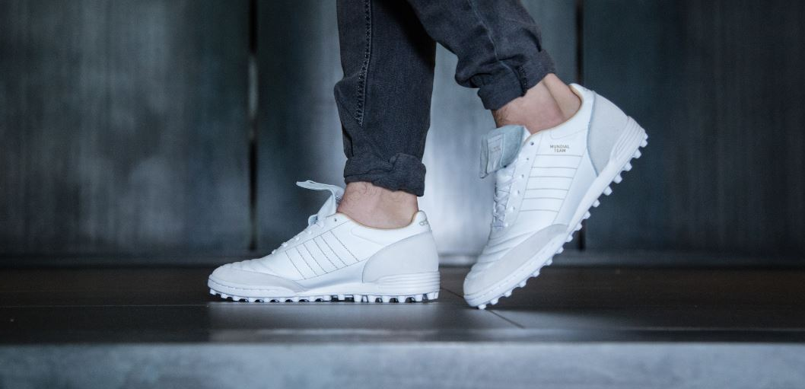

Herzogenaurach, 14th November – One of adidas’ most iconic boots has been brought into the 21st century with the release of the Mundial Team Modern Craft. The shoe is the latest release from adidas’ Limited Collection, a range of exclusive lifestyle footwear designed for the streets.

Taking inspiration from the Copa Mundial, the Mundial Team Modern Craft features a sleek, premium design engineered for an urban environment, and is available in all-black and all-white silos.

Both black and white versions are made with a K-Leather upper, with the tongue and midsole in the same colour, delivering an all-black and all-white look respectively. The classic three stripes are etched on the shoe while a suede toe cap and heel counter – along with gold eyelets to cover the tips of the laces – ensures a premium look and feel.

The Mundial Team Modern Craft collection will be available to purchase in limited quantities from today.

For further information please visit adidas.com/football or go to facebook.com/adidasfootball or follow @adidasfootball on twitter to join the conversation.

- END -

For further media information please visit http://news.adidas.com/GLOBAL/PERFORMANCE/FOOTBALL or contact:

Simon Bristow  PR Director – Herzo Newsroom  Email: simon.bristow@adidas.com  Tel: +49/9132/84-73 703 | Julien Lanfrey  Global PR Manager, adidas Football  Email: julien.lanfrey@adidas.com  Tel: +49/160/977 16429
Notes to editors:
About adidas Football
adidas is the global leader in football. It is the official sponsor / official supplier partner of the most important football tournaments in the world, such as the FIFA World Cup™, the FIFA Confederations Cup, the UEFA Champions League, the UEFA Europa League and the UEFA European Championships. adidas also sponsors some of the world’s top clubs including Manchester United, Real Madrid, FC Bayern Munich, Juventus, Chelsea and AC Milan. Some of the world’s best players also on the adidas roster are Leo Messi, Paul Pogba, Gareth Bale, Thomas Müller, Luis Suárez, James Rodríguez, Diego Costa and Mesut Özil.

