adidas Unveils Krasava, the Official Match Ball for FIFA Confederations Cup 2016

- New design features striking red pattern to represent a Russian Ruby –
- Ball’s name is often used to describe a beautiful and creative team performance -
- Ball to be used on pitch for the first time on November 14th 2016 -

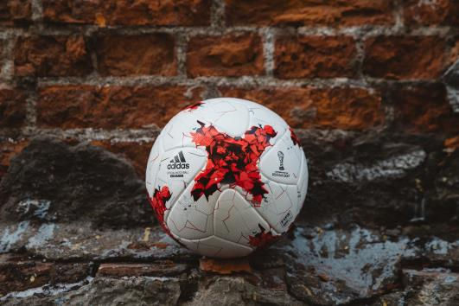

Herzogenaurach, 11th November 2016 – adidas has today launched Krasava, the Official Match Ball for the FIFA Confederations Cup 2017 in Russia, where the six continental champions, including Mexico and Russia, as well as World Champions Germany will battle it out a year before the 2018 FIFA World CupTM kicks off.

The pattern on the ball features a striking red design with jagged lines running through it, designed to represent the design of a Russian Ruby and the metaphorical jewel of the game. The ball’s name, “Krasava”, is a word commonly used by Russian sports fans to describe a beautiful performance and is the ultimate praise for a team when they play with creativity and flair.

The structure of the ball incorporates the same innovative and widely-praised panel shape as the Beau Jeu and Fracas, adidas balls that were used in the group and knockout stages of UEFA Euro 2016. It offers premium surface structure, enhanced grip and in-flight visibility.

The new ball will be seen on-pitch for the first time on November 14th, when Russia takes on Romania in a friendly. It is available to purchase from November 11th from selected retailers and adidas.com.

For further information please visit adidas.com/football or go to facebook.com/adidasfootball or follow @adidasfootball on twitter to join the conversation.

- END -
For further media information please visit http://news.adidas.com/GLOBAL/PERFORMANCE/FOOTBALL or contact:

Simon Bristow  PR Director – Herzo Newsroom  Email: simon.bristow@adidas.com  Tel: +49/9132/84-73 703 | Julien Lanfrey  Global Public Relations Manager I Football Email: Julien.lanfrey@adidas.com  Tel: +49/1609/77-16 429
Notes to editors:
About adidas Football
adidas is the global leader in football. It is the official sponsor / official supplier partner of the most important football tournaments in the world, such as the FIFA World Cup™, the FIFA Confederations Cup, the UEFA Champions League, the UEFA Europa League and the UEFA European Championships. adidas also sponsors some of the world’s top clubs including Manchester United, Real Madrid, FC Bayern Munich, Juventus, Chelsea and AC Milan. Some of the world’s best players also on the adidas roster are Leo Messi, Paul Pogba, Gareth Bale, Thomas Müller, Luis Suárez, James Rodríguez, Diego Costa and Mesut Özil.

