EMBARGOED: 9AM CET, FRIDAY 4TH NOVEMBER, 2016

Mother Nature Tackles The Superlight Range
- adidas introduces new graphical treatment to rugby boot range -
- Top international rugby players to showcase new range this weekend -

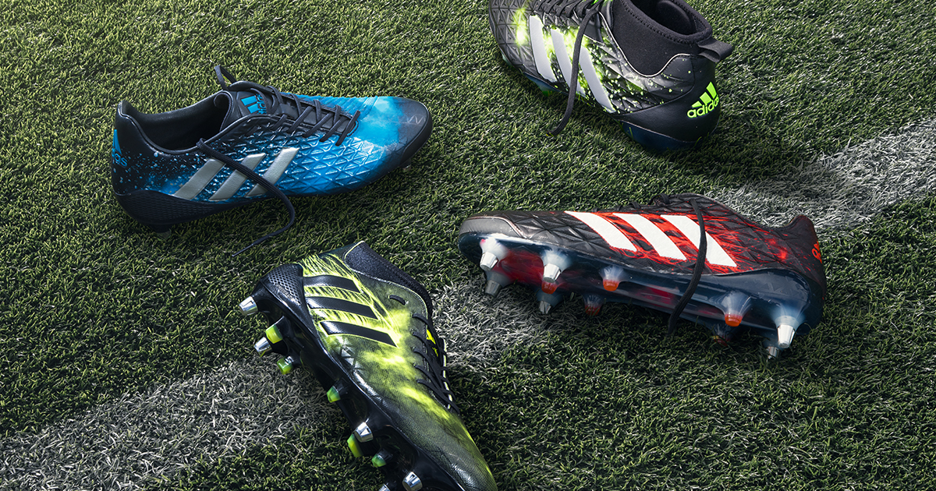

Cape Town, Friday 4th November, 2016 - adidas Rugby will on Saturday, 5th November, 2016 unveil the ‘Elements Pack’, a striking update to its industry leading Superlight range.

The four models in the range, specifically designed for each position on the field, have received a graphical treatment inspired by the natural elements Earth, Fire, Ice and Wind.

The adipower Kakari Force is the ultimate boot for the tight-five and features the element of Earth, symbolising the strength and stability needed to dominate the scrum, as shown by South African international Malcolm Marx. The Kakari Light, made for loose forwards, is on fire and reflects the explosive power shown by players such as Siya Kolisi and New Zealand’s Kieran Read when they are first to the breakdown.

Predator Malice featuring the ice graphic has been developed for kicking backs such as new SA captain Pat Lambie and NZ’s Beauden Barrett, who are renowned for being cool under pressure. Completing the lineup is the CrazyQuick Malice featuring a wind graphic indicative of the speed and illusivness of outside backs like SA’s record-breaking speedster, Bryan Habana.

The ‘Elements Pack’ will be seen on field this weekend as the south’s best teams venture to the north for their annual November international matches.

The entire boot range will be available at adidas retail stores, adidas ecom at www.adidas.co.za and Sportsmans Warehouse, well as major rugby retailers countrywide from 1st December, at a RRP ranging from R999 for junior models boots, to R2999 for elite models.

For up-to-date news from adidas South Africa or more information about the new ‘Elements Pack’, visit the adidas news stream: news.adidas.com/za. Or follow @adidasZA on Twitter or Instagram with #UnleashDefeat

- ENDS -

For more information, please contact:
Howard Kahn
Sports Marketing Manager, Rugby PR - adidas SA
M: +27 82 375 3369
E: howard.kahn@adidas.com

