adidas Launches Limited Edition Barricade Inspired by Traditional Barber Shop Textures
- High quality brown leather upper nods to the famous barber chair -
- Brass cage support reminiscent of iconic shop surroundings -

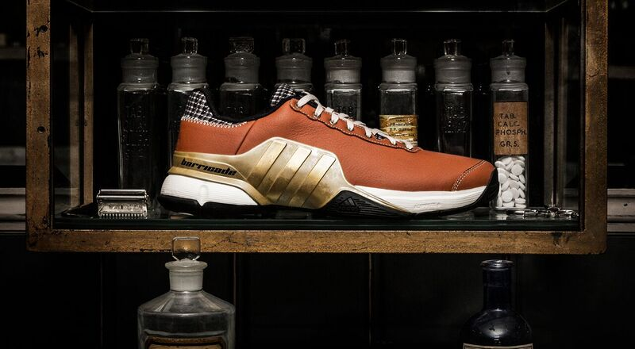

Herzogenaurach, Germany, 1st November 2016: adidas today launched the latest addition to the Barricade tennis range, the Barricade 2016 Mustachio. The limited edition shoe is inspired by the aesthetic of the iconic barber shop.

The Barricade 2016 Mustachio features high quality, full grain brown leather giving a premium and unique new finish to the traditional Barricade 2016 shoe. The leather is wrapped by a brass-finished chassis replicating the superior fixtures and fittings with a barber shop. The shoe is also detailed with the classic houndstooth pattern and includes an embossed logo on the heel – adding to the premium and hand-crafted finish.

The classic houndstooth pattern sits around the top of the shoe, with the logo embossed into the leather on the heel.

The limited edition Barricade 2016 Mustachio will be available online from 1st November at adidas.com.

ENDS

For further media information please contact:
Lindsey Rossell
lindsey.rossell@hkstrategies.com
+44 (0) 207 413 3163

Notes to editors:

About adidas Tennis
adidas Tennis is represented by top players such as Simona Halep, Ana Ivanovic, Angelique Kerber, Garbiñe Muguruza, Caroline Wozniacki, Tomas Berdych, Lucas Pouille, Dominic Thiem, Jo-Wilfried Tsonga, Sascha Zverev and Novak Djokovic (Footwear Only). For more information on adidas Tennis, please visit www.adidas.com/tennis. For additional images please visit our media news room on news.adidas.com and follow us on Twitter or on Instagram under @adidasTennis.

About adidas
The adidas Group is a global leader in the sporting goods industry, offering a broad portfolio of footwear, apparel and hardware for sport and lifestyle around the core brands adidas, Reebok, TaylorMade and CCM Hockey. Headquartered in Herzogenaurach, Germany, the Group employs more than 55,000 people across the globe and generated sales of around € 17 billion in 2015.

www.adidas.com/tennis
https://twitter.com/adidastennis
https://www.instagram.com/adidastennis/

