Mother Nature Tackles The Superlight Range
- adidas introduces new graphical treatment to rugby boot range -
- All Blacks showcase new range vs. Ireland on Soldier Field, Chicago -

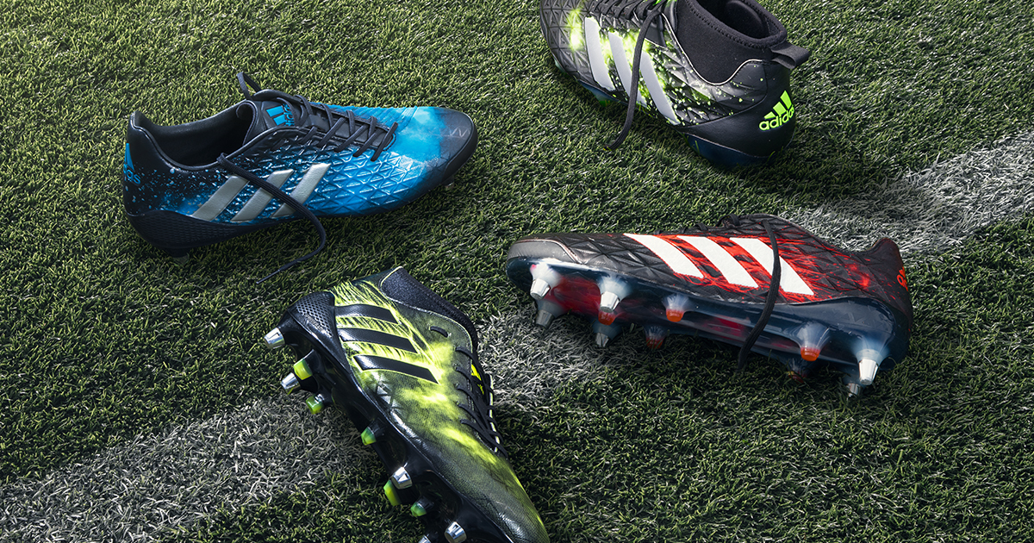

Saturday 5th November, 2016 - adidas Rugby has today unveiled the ‘Elements Pack’, a striking update to its industry leading Superlight range.

The four models in the range, specifically designed for each position on the field, have received a graphical treatment inspired by the natural elements Earth, Fire, Ice and Wind.

The adipower Kakari Force is the ultimate boot for the tight-five and features the element of Earth, symbolising the strength and stability needed to dominate the scrum. The Kakari Light, made for loose forwards, is on fire and reflects the explosive power shown by players such as Kieran Read and Sam Warburton when they are first to the breakdown.

Predator Malice featuring the ice graphic has been developed for kicking backs such as Beauden Barrett, who are renown for being cool under pressure. Completing the lineup is the CrazyQuick Malice featuring a wind graphic indicative of the speed and illusivness of outside backs like Antony Watson and Sonny Bill Williams.

The Elements Pack will be seen on field tomorrow when the World Champion All Blacks play Ireland, at Soilder Field in Chicago. The range will be stocked at adidas stores and major sporting goods retailers, rugby retailers worldwide, as well as online at www.adidas.com from December 1st. Pricing starts at €50 RRP for junior boots to €200 RRP for elite models.

- ENDS -

For more information, please contact:
Adam Daysh
Global Communications Manager - adidas Rugby
M: +64 27 577 3439
E: adam.daysh@adidas.com

