adidas Launches New Limited Edition Messi 10/10 Boots to Celebrate the Greatest Number 10 Ever

- Only 100 pairs of new Messi 10/10 boots to be produced worldwide in US size 8.5, the size worn by Messi himself -
- Available exclusively in New York, and online at adidas.com and soccer.com -

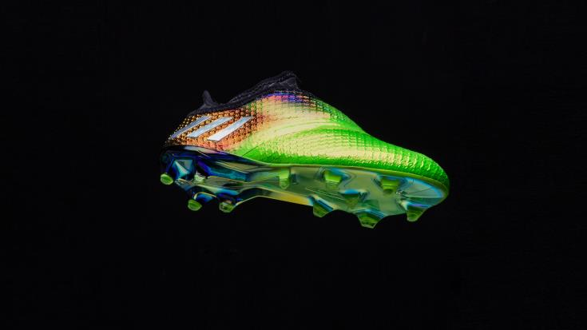

PORTLAND, Ore. – October 7, 2016 – adidas has today revealed new limited edition Messi 10/10 boots to celebrate and pay tribute to Leo Messi, five time Ballon d’Or winner and football’s greatest number 10 of all time.

Only 100 pairs of the new Messi 10/10 boots have been produced worldwide in US size 8.5, the same worn by Leo himself.

The special collector’s item will be available exclusively on Monday October 10 at an adidas Soccer pop-up shop in New York City, in addition to adidas.com and select US retailers.

The new Messi 10/10 boots include an AGILITY TOUCH SKIN LAYER and AGILITY PURECUT UPPER to deliver enhanced fit, while an AGILITY SPRINTFRAME OUTSOLE generates unstoppable traction. These technical features have been incorporated to represent Messi’s unique playing style.

This is the second successive year that adidas has launched a limited edition pair of Messi 10/10 boots to celebrate and a third iteration of these collector’s item boots will be launched on 10th October 2017.

For further information please visit adidas.com/football or go to facebook.com/adidasfootball or follow @adidasfootball on twitter to join the conversation.

- END -

For further media information please visit http://news.adidas.com/GLOBAL/PERFORMANCE/FOOTBALL or contact:

Simon Bristow  PR Director – Herzo Newsroom  Email: simon.bristow@adidas.com  Tel: +49/9132/84-73 703 | Julien Lanfrey  Global PR Manager, adidas Football  Email: julien.lanfrey@adidas.com  Tel: +49/160/977 16429
Notes to editors:
About adidas Football
adidas is the global leader in football. It is the official sponsor / official supplier partner of the most important football tournaments in the world, such as the FIFA World Cup™, the FIFA Confederations Cup, the UEFA Champions League, the UEFA Europa League and the UEFA European Championships. adidas also sponsors some of the world’s top clubs including Manchester United, Real Madrid, FC Bayern Munich, Juventus, Chelsea and AC Milan. Some of the world’s best players also on the adidas roster are Leo Messi, Paul Pogba, Gareth Bale, Thomas Müller, Luis Suárez, James Rodríguez, Diego Costa and Mesut Özil.

