adidas introduces special edition adizero Ubersonic 2 Think Pink
Footwear released in association with Think Pink to mark Breast Cancer Awareness month
- adidas will contribute to charity AKTIV Against Cancer for every pair sold –

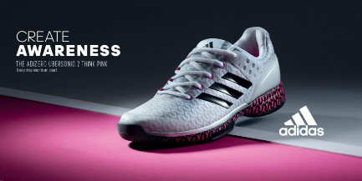

Herzogenaurach, Germany, 1st October 2016: adidas has today launched the adizero Ubersonic 2 Think Pink, designed in support of Breast Cancer Awareness month. The footwear - is the final release from the limited edition adidas Ubersonic women’s footwear Energy Pack.

The traditional adizero Ubersonic 2 is emblazoned with the Think Pink logo across the woven upper and on the Adiprene+ midsole. For every adizero Ubersonic Think Pink sold, adidas will donate to its longstanding partner, AKTIV Against Cancer; an organisation that works to help cancer patients continue to be active after diagnosis.

Alex Chan, Global Category Director, adidas Tennis says, “Breast cancer awareness is an important cause and we really believe in the role sport has in promoting women’s health. We wanted to create a special edition adizero Ubersonic 2 Think Pink, to help support anyone facing this battle, either personally or by association, and we remain proud longstanding partners of AKTIV Against Cancer.”

The limited edition adizero Ubersonic Think Pink will be available online from 1st October at adidas.com and adidas stores worldwide.

ENDS

For further media information please contact
Lindsey Rossell
lindsey.rossell@hkstrategies.com
+44 (0) 207 413 3163

Notes to editors:
About adidas Tennis
adidas Tennis is represented by top players such as Simona Halep, Ana Ivanovic, Angelique Kerber, Garbiñe Muguruza, Caroline Wozniacki, Tomas Berdych, Lucas Pouille, Dominic Thiem, Jo-Wilfried Tsonga, Sascha Zverev and Novak Djokovic (Footwear Only). For more information on adidas Tennis, please visit www.adidas.com/tennis. For additional images please visit our media news room on news.adidas.com and follow us on Twitter or on Instagram under @adidasTennis.

About adidas
The adidas Group is a global leader in the sporting goods industry, offering a broad portfolio of footwear, apparel and hardware for sport and lifestyle around the core brands adidas, Reebok, TaylorMade and CCM Hockey. Headquartered in Herzogenaurach, Germany, the Group employs more than 55,000 people across the globe and generated sales of around € 17 billion in 2015.

www.adidas.com/tennis
https://twitter.com/adidastennis
https://www.instagram.com/adidastennis/

