adidas Football releases new ACE 16+ PURECONTROL UltraBOOST in Triple White

- Triple White silo follows the limited edition Black, Solar Yellow and Vapor Green colourways –
- Latest release available in limited numbers from September 28th –
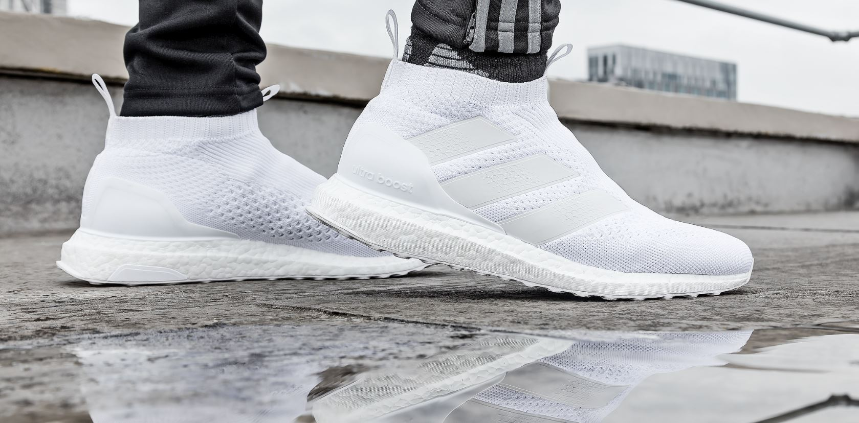

adidas Football has today announced the release of the Triple White ACE 16+ PURECONTROL UltraBOOST. Following the limited edition releases of the Black, Solar Yellow and Vapour Green colourways, the shoe brings together the best from adidas Football and adidas Running.

The Primeknit upper from adidas Football’s ACE 16+ PURECONTROL – The world’s first high- performance laceless football boot - is merged with the industry leading BOOST technology used in adidas Running products, ensuring players’ off-pitch needs are met.

The Triple White ACE 16+ PURECONTROL UltraBOOST will be available to purchase in limited numbers from adidas.com.

For further information please visit adidas.com/football or go to facebook.com/adidasfootball or follow @adidasfootball on twitter to join the conversation.

- ENDS -
For further media information please visit http://news.adidas.com/GLOBAL/PERFORMANCE/FOOTBALL or contact:

Simon Bristow  PR Director – Herzo Newsroom  Email: simon.bristow@adidas.com  Tel: +49/9132/84-73 703 | Julien Lanfrey  Global Public Relations Manager I Football Email: Julien.lanfrey@adidas.com  Tel: +49/1609/77-16-429
Notes to editors:
About adidas Football
adidas is the global leader in football. It is the official sponsor / official supplier partner of the most important football tournaments in the world, such as the FIFA World Cup™, the FIFA Confederations Cup, the UEFA Champions League, the UEFA Europa League and the UEFA European Championships. adidas also sponsors some of the world’s top clubs including Manchester United, Real Madrid, FC Bayern Munich, Juventus, Chelsea and AC Milan. Some of the world’s best players also on the adidas roster are Leo Messi, Paul Pogba, Gareth Bale, Thomas Müller, Luis Suárez, James Rodríguez, Diego Costa and Mesut Özil.

