EMBARGOED UNTIL 10am (CET) THURSDAY 1ST SEPTEMBER

adidas Launches Viper Pack to Continue Early Season Excitement

- Viper Pack sees X 16+ PURECHAOS and ACE 16+ PURECONTROL re-imagined with intuitive snakeskin graphics -
- Purecut Sock System used in X 16+ PURECHAOS to provide ultimate fit -
- Non Stop Grip (NSG) technology used in ACE 16+ PURECONTROL to deliver cleanest striking area -
- Viper Pack available in limited numbers from today -

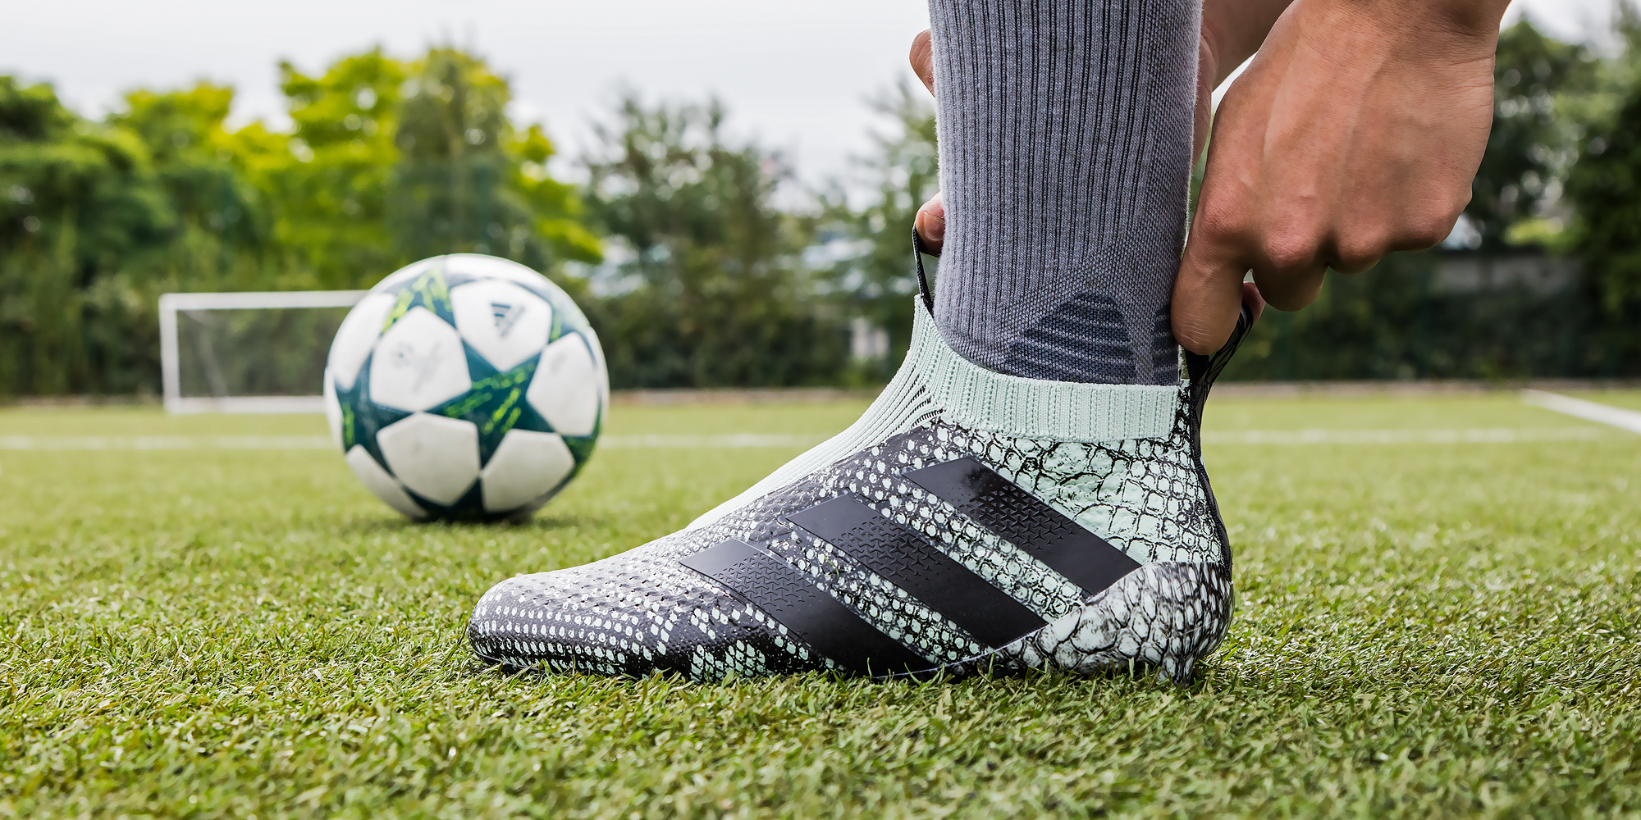
Herzogenaurach, 1st September – With the 2016/17 season having just kicked off, adidas has today added to the early season excitement amongst fans and footballers of the future by launching the Viper Pack, featuring both the X 16+ PURECHAOS and ACE 16+ PURECONTROL in an eye-catching snakeskin design.

Aimed at inspiring young footballers to amplify their dynamic displays on the pitch, the Viper Pack is a stylish adaptation of the ACE 16+ PURECONTROL and X 16+ PURECHAOS which uses bright, visual snakeskin graphics.

The ACE 16+ PURECONTROL Viper Pack version offers a Primeknit upper and NON STOP GRIP (NSG) technology, delivering an unrivalled surface for close ball control, while the X 16+ PURECHAOS Viper Pack version features a state-of-the-art PURECUT SOCK SYSTEM, covering the boot laces to give players the ultimate fit.

The Viper Pack will be available in all adidas stores and on adidas.com from today.

For further information please visit adidas.com/football or go to facebook.com/adidasfootball or follow @adidasfootball on twitter to join the conversation.

- END -

For further media information please visit http://news.adidas.com/GLOBAL/PERFORMANCE/FOOTBALL or contact:

Simon Bristow  Global PR Director – Herzo Newsroom  Email: simon.bristow@adidas.com  Tel: +49/9132/84-73 703 | Julien Lanfrey  Global PR Manager, adidas Football  Email: julien.lanfrey@adidas.com  Tel: +49/160/977/16429
Notes to editors:
About adidas Football
adidas is the global leader in football. It is the official sponsor / official supplier partner of the most important football tournaments in the world, such as the FIFA World Cup™, the FIFA Confederations Cup, the UEFA Champions League, the UEFA Europa League and the UEFA European Championships. adidas also sponsors some of the world’s top clubs including Manchester United, Real Madrid, FC Bayern Munich, Juventus, Chelsea and AC Milan. Some of the world’s best players also on the adidas roster are Leo Messi, Paul Pogba, Gareth Bale, Thomas Müller, Luis Suárez, James Rodríguez, Diego Costa and Mesut Özil.

