PUREBOOST X
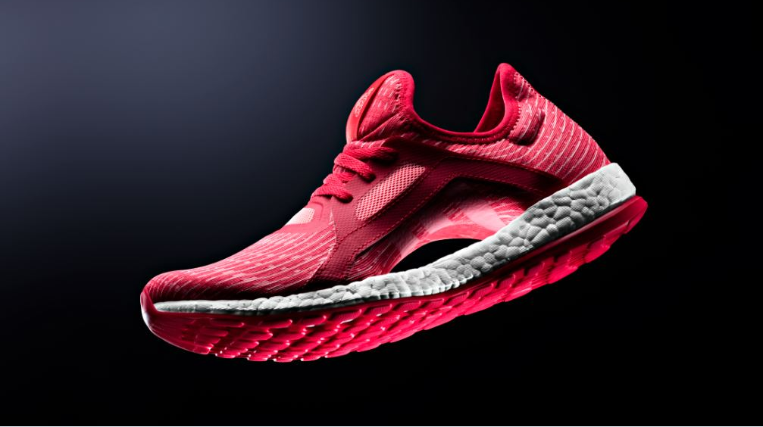
PureBOOST X is the unique running shoe created solely for women, by women. Based on years of testing and research with women around the world, adidas created a sleek, form fitting running shoe built to meet the relentless energy of their active lifestyle. While most running shoes are adaptations of male shoes PureBOOST X was designed with only the female athlete in mind, resulting in a high performance meets high fashion running shoe for women.

PureBOOST X’s distinctive floating arch and adjustable lacing system hug the contours of the female foot to deliver a personalised, supportive fit and completely fresh look and feel. An adaptive stretch mesh upper wraps and flatters the foot while providing ventilation to keep runs cool and comfortable. PureBOOST X also features a full length BOOST midsole, made of thousands of tiny capsules, designed to unleash energy with every stride. A Stretch Web outsole allows for flex at any point enabling the foot to maintain its natural motion during a run.

PureBOOST X is now available in 9 colourways including the newly released Ray Red colourway. This colourway will be featured on the feet of some of the world’s greatest athletes this Summer.

Fans of PureBOOST X can now design and personalise their own versions with miadidas. With a range of colours and materials available, miadidas allows women to customise and create individual designs that complement their fitness style.

From lacing up through cooling down or making a statement with style, PureBOOST X feels exhilarating and looks amazing the moment you put it on.

adidas PureBOOST X is available now in stores and at adidas.com/pureboostx RRP (120€/USD).

