adidas Launches Dark Space Pack as Players Prepare for 2016/17 Season

- All back versions of X 16+ PURECHAOS and ACE 16+ PURECONTROL make up Dark Space Pack -
- Purecut Sock System used in X 16+ PURECHAOS to provide ultimate fit -
- Non Stop Grip (NSG) technology used in ACE 16+ PURECONTROL to deliver cleanest striking area -
- Dark Space Pack available in limited numbers from today -

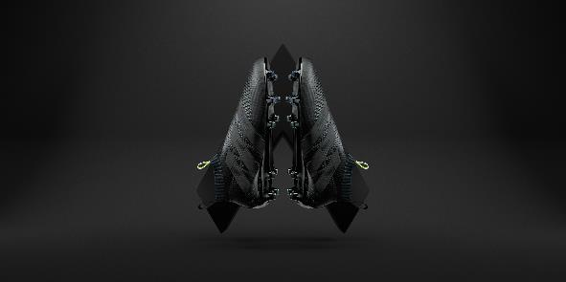

Herzogenaurach, 4th August – As the 2016/17 season approaches, adidas has today launched the Dark Space Pack, featuring all black versions of both the X 16+ PURECHAOS and ACE 16+ PURECONTROL.

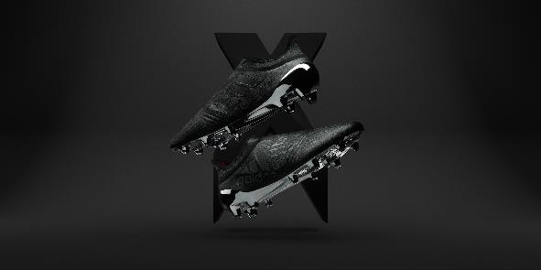

For the new Dark Space Pack, both the ACE 16+ PURECONTROL and X 16+ PURECHAOS have been transformed into a sleek, blackout design.

The ACE 16+ PURECONTROL Dark Space version offers a Primeknit upper and NON STOP GRIP (NSG) technology, delivering an unrivalled surface for close ball control, while the X 16+ PURECHAOS Dark Space version features a state-of-the-art PURECUT SOCK SYSTEM, covering the boot laces to give players the ultimate fit.

The Dark Space Pack will be available in all adidas stores and on adidas.com from today.

For further information please visit adidas.com/football or go to facebook.com/adidasfootball or follow @adidasfootball on twitter to join the conversation.

- END -

For further media information please visit http://news.adidas.com/GLOBAL/PERFORMANCE/FOOTBALL or contact:

Simon Bristow  Global PR Director – Herzo Newsroom  Email: simon.bristow@adidas.com  Tel: +49/9132/84-73 703 | Julien Lanfrey  Global PR Manager, adidas Football  Email: julien.lanfrey@adidas.com  Tel: +49/160/977/16429
Notes to editors:
About adidas Football
adidas is the global leader in football. It is the official sponsor / official supplier partner of the most important football tournaments in the world, such as the FIFA World Cup™, the FIFA Confederations Cup, the UEFA Champions League, the UEFA Europa League and the UEFA European Championships. adidas also sponsors some of the world’s top clubs including Manchester United, Real Madrid, FC Bayern Munich, Juventus, Chelsea and AC Milan. Some of the world’s best players also on the adidas roster are Leo Messi, Paul Pogba, Gareth Bale, Thomas Müller, Luis Suárez, James Rodríguez, Diego Costa and Mesut Özil.

