EMBARGOED 29TH JULY – 10AM (CET)

adidas Launches Chelsea Film as part of First Never Follows Film Series

- Diego Costa, Oscar, Nemanja Matic and more star in film to shut down fan criticism -
- Chelsea film launches new club third kit for 2016/17 season -
- Players debut new Speed of Light boots in Chelsea film -

Herzogenaurach, 29th July 2016 – adidas has today launched a new film starring Diego Costa, Oscar, Nemanja Matic, Gary Cahill, Kenedy and Ruben Loftus-Cheek of Chelsea, as part of its First Never Follows film series ahead of the new Premier League season.

The series – featuring bespoke films of some of the biggest clubs, players and managers in the world - provides a defiant response from a series of star players to the feverous gossip, debate and hype that surrounds each club in the build-up to the start of the 2016/17 season.

The film features an angry London taxi driver who, upon seeing Costa on his way to training, unreservedly shares his opinion and criticism of the club and its players in a manner typical of rival fans in pre-season. The film then cuts to the players working hard to prepare themselves for the 2016/17 season with a series of skills and training drills, effectively dispelling all of his criticism and misplaced views.

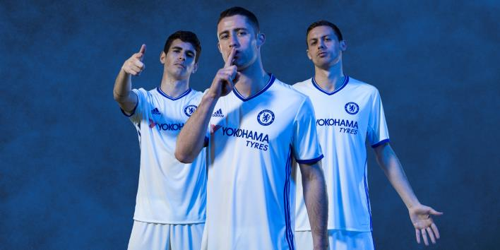

The film launches the new Chelsea third kit - an all-white strip featuring a large embossed lion on the sleeve. It includes the classic adidas three stripes on the side panels in Chelsea blue, two different coloured crests, and a tailored “Chelsea FC“ collar tape.

Costa, Oscar, Matic, Cahill and Loftus-Cheek also wear the new Speed of Light boots in the film – the ACE 16+ PURECONTROL in Solar Yellow and X16+ PURECHAOS in Solar Red which will be worn on pitch for the start of the 2016/17 season.

To view the film, visit: https://youtu.be/VRygQ699KnI

For further information please visit adidas.com/football or go to facebook.com/adidasfootball or follow @adidasfootball on twitter to join the conversation.

- END -

For further media information please visit http://news.adidas.com/GLOBAL/PERFORMANCE/FOOTBALL or contact:

Simon Bristow  Global PR Director – Herzo Newsroom  Email: simon.bristow@adidas.com  Tel: +49/9132/84-73 703 | Julien Lanfrey  Global PR Manager, adidas Football  Email: julien.lanfrey@adidas.com  Tel: +49/160/977/16429
Notes to editors:
About adidas Football
adidas is the global leader in football. It is the official sponsor / official supplier partner of the most important football tournaments in the world, such as the FIFA World Cup™, the FIFA Confederations Cup, the UEFA Champions League, the UEFA Europa League and the UEFA European Championships. adidas also sponsors some of the world’s top clubs including Manchester United, Real Madrid, FC Bayern Munich, Juventus, Chelsea and AC Milan. Some of the world’s best players also on the adidas roster are Leo Messi, Paul Pogba, Gareth Bale, Thomas Müller, Luis Suárez, James Rodríguez, Diego Costa and Mesut Özil.

