EMBARGOED 29TH JULY – 9AM (CET)

adidas Launches Real Madrid Film as part of First Never Follows Film Series

- UEFA Champions League winners feature in film looking at the season ahead -
- Gareth Bale, Karim Benzema, Marcelo and James Rodriguez all star in Real Madrid film -
- Real Madrid film launches new club third kit for 2016/17 season -

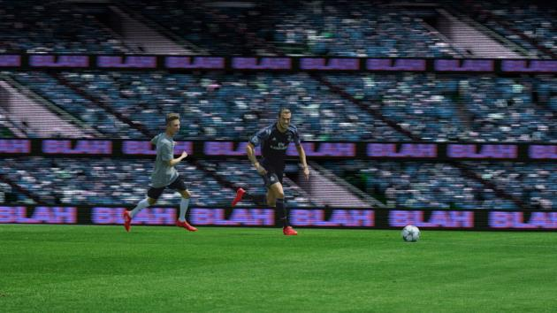

Herzogenaurach, 29th July 2016 – adidas has today launched a Real Madrid special, as part of its new First Never Follows film series. A number of players from Real Madrid’s UEFA Champions League winning squad feature in the film, alongside manager Zinedine Zidane, as they shut down criticism off the pitch by performing on it.

The series – featuring bespoke films of some of the biggest clubs, players and managers in the world - provides a defiant response from a series of star players to the feverous gossip, debate and hype that surrounds each club in the build-up to the start of the 2016/17 season.

The film shows the squad, who made history in last season’s UEFA Champions League with la Undecima, arriving at a game amidst the clamour of hostile fans. Rather than confronting the ‘blah, blah blah’ off the pitch, the players let their performance on-pitch speak for itself, with Bale and Benzema teaming up to silence the hostile fans with a breath-taking goal, complete with Bale’s trademark ‘Road Runner’ feats on the way.

In the film, Gareth Bale, Karim Benzema, Marcelo and James Rodriguez wear the new third kit for the coming season, as well as the new Speed of Light boots – the ACE 16+ PURECONTROL in Solar Yellow and X16+ PURECHAOS in Solar Red – which will be worn on pitch for the first time in the UEFA Super Cup on 9th August and for the start of the 2016/17 season.

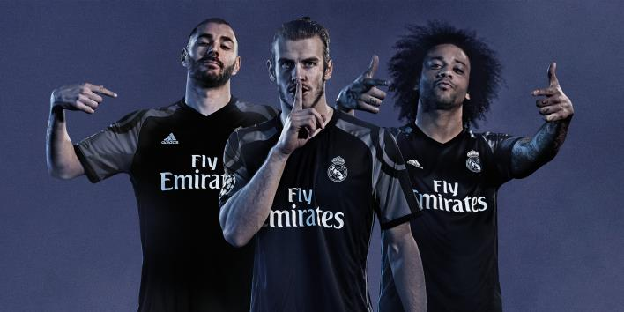

The new Real Madrid third kit is a black colourway with purple accents. The design on the shoulders represents the road from the Santiago Bernabéu Stadium to the fountain of Cibeles, which the club’s passionate fan base will recognise well as the traditional victory route taken by the team to celebrate a trophy win. The Undecima coat of arms on the shirt celebrates the fact that Real Madrid was the first club to lift the UEFA Champions League eleven times.

To view the film, visit: https://youtu.be/BQfKSAUTt44

For further information please visit adidas.com/football or go to facebook.com/adidasfootball or follow @adidasfootball on twitter to join the conversation.

- END -

For further media information please visit http://news.adidas.com/GLOBAL/PERFORMANCE/FOOTBALL or contact:

Simon Bristow  Global PR Director – Herzo Newsroom  Email: simon.bristow@adidas.com  Tel: +49/9132/84-73 703 | Julien Lanfrey  Global PR Manager, adidas Football  Email: julien.lanfrey@adidas.com  Tel: +49/160/977/16429
Notes to editors:
About adidas Football
adidas is the global leader in football. It is the official sponsor / official supplier partner of the most important football tournaments in the world, such as the FIFA World Cup™, the FIFA Confederations Cup, the UEFA Champions League, the UEFA Europa League and the UEFA European Championships. adidas also sponsors some of the world’s top clubs including Manchester United, Real Madrid, FC Bayern Munich, Juventus, Chelsea and AC Milan. Some of the world’s best players also on the adidas roster are Leo Messi, Paul Pogba, Gareth Bale, Thomas Müller, Luis Suárez, James Rodríguez, Diego Costa and Mesut Özil.

