adidas unveils exclusive Speed of White Pack for female football stars at the Olympic Games

- Dedicated boots designed for female stars at the Olympic Games -
- ACE 16+ and X16+ get fresh new look in white and solar red colourway -
- Heather O’Reilly and Morgan Brian among female stars to wear Speed of White boots -

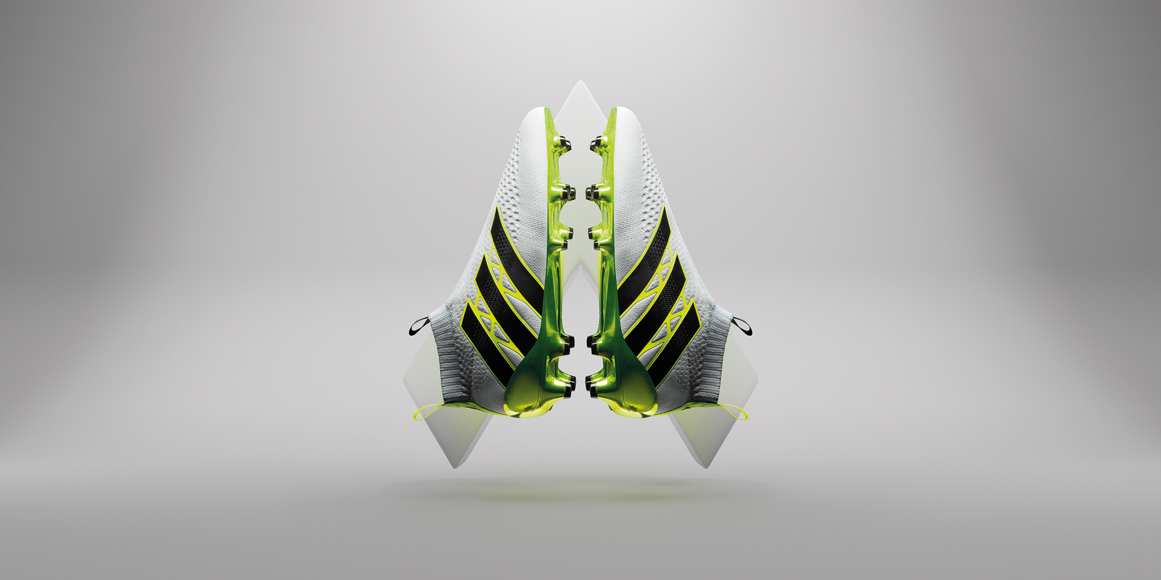

Herzogenaurach, 18th July 2016 – adidas Football today released the Speed of White Pack, a range of boots designed specifically for the brand’s female football stars to wear at the Olympic Games this summer.

The Speed of White pack features unique colourways of both the X16+ PURECHAOS and ACE 16+ PURECONTROL, designed to represent the colours associated with light speed – red, white and yellow.

The Speed of White X16+ PURECHAOS has been designed in white and solar red. The boot is a clean and simple design with the technical features to match. A DYNAMIC TECHFIT COMPRESSION upper keeps wear-in time to a minimum, with a NON STOP GRIP (NSG) finish and TECHFIT lacing system providing a glove-like fit. The boot will be worn this summer by United States national team players like Stephanie McCaffrey and Heather O’Reilly.

The Speed of White ACE 16+ PURECONTROL has also received a colour update ahead of the summer. The boot has been designed in white, solar yellow and black. The PURECUT upper creates an uninterrupted striking surface, whilst the lightweight SPRINTFRAME provides unparalleled levels of stability. The ACE 16+ PURECONTROL will be worn on pitch by Morgan Brian and Becky Sauerbrunn, also of the United States national team.

For further information please visit adidas.com/football or go to facebook.com/adidasfootball or follow @adidasfootball on twitter to join the conversation.

- END -

For further media information please visit http://news.adidas.com/GLOBAL/PERFORMANCE/FOOTBALL or contact:

Simon Bristow  PR Director – Herzo Newsroom  Email: simon.bristow@adidas.com  Tel: +49/9132/84-73 703 | Alan McGarrie  Global Director PR & Social Media, adidas Football  Email: alan.mcgarrie@adidas.com  Tel: +49/9132/84-4686

Notes to editors:
About adidas Football
adidas is the global leader in football. It is the official sponsor / official supplier partner of the most important football tournaments in the world, such as the FIFA World Cup™, the FIFA Confederations Cup, the UEFA Champions League, the UEFA Europa League and the UEFA European Championships. adidas also sponsors some of the world’s top clubs including Manchester United, Real Madrid, FC Bayern Munich, Juventus, Chelsea and AC Milan. Some of the world’s best players also on the adidas roster are Leo Messi, Paul Pogba, Gareth Bale, Thomas Müller, Luis Suárez, James Rodríguez, Diego Costa and Mesut Özil.

