Zinedine Zidane inspires a new generation ahead of the UEFA EURO 2016TM Final

- Inspiring message projected on to the famous Arc de Triomphe monument in Paris -
- Zidane delivers the message that “First Never Follows” -
- Message tells next generation of players to “write their own history” -

Paris, 10th July 2016 – As UEFA EURO 2016TM moves into the Final, adidas today unveiled a “First Never Follows” projection on to the façade of the famous Arc de Triomphe monument in the centre of Paris, featuring legendary midfielder, Zinédine Zidane, and rising star Paul Pogba.

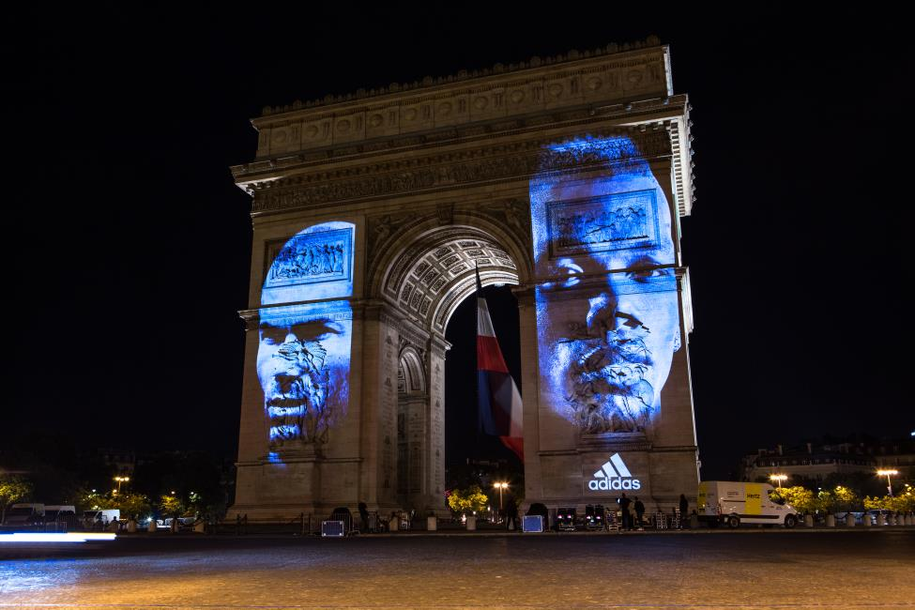

The projection onto one of the world’s most recognisable landmarks shows the face of Zidane with the accompanying words: “Écrire Sa Propre Histoire” meaning “Write Your Own History”.

The projection then shows the faces of Zinédine Zidane and Paul Pogba together, before the message ends with the face of Pogba and the line “First Never Follows”.

Zinédine Zidane is widely considered to be one of the greatest players of all time, winning the FIFA World Player of the Year Award on three separate occasions; in addition to the FIFA World Cup and UEFA European Championships with his country. Now, it’s time for the next generation of players including Pogba to write their own history during tonight’s UEFA EURO 2016 Final in Paris.

For further information please visit adidas.com/football or go to facebook.com/adidasfootball or follow @adidasfootball on twitter to join the conversation.

- END -

For further media information please visit http://news.adidas.com/GLOBAL/PERFORMANCE/FOOTBALL or contact:

Simon Bristow  PR Director – Herzo Newsroom  Email: simon.bristow@adidas.com  Tel: +49/9132/84-73 703 | Alan McGarrie  Global Director PR & Social Media, adidas Football  Email: alan.mcgarrie@adidas.com  Tel: +49/9132/84-4686
Notes to editors:
About adidas Football
adidas is the global leader in football. It is the official sponsor / official supplier partner of the most important football tournaments in the world, such as the FIFA World Cup™, the FIFA Confederations Cup, the UEFA Champions League, the UEFA Europa League and the UEFA European Championships. adidas also sponsors some of the world’s top clubs including Manchester United, Real Madrid, FC Bayern Munich, Juventus, Chelsea and AC Milan. Some of the world’s best players also on the adidas roster are Leo Messi, Paul Pogba, Gareth Bale, Thomas Müller, Luis Suárez, James Rodríguez, Diego Costa and Mesut Özil.

