BARCELONA IS READY TO RUN HARD AND PLAY HARD WITH ‘ADIDAS RUNNERS’

- adidas connects like-minded people looking for more than a run club, both in their hometown and around the world
- A running movement like never before, adidas Runners combines serious sweat sessions with post-training parties
- Personalized training plans, expert coaching and secret experiences help members smash goals, celebrate success and have fun doing it

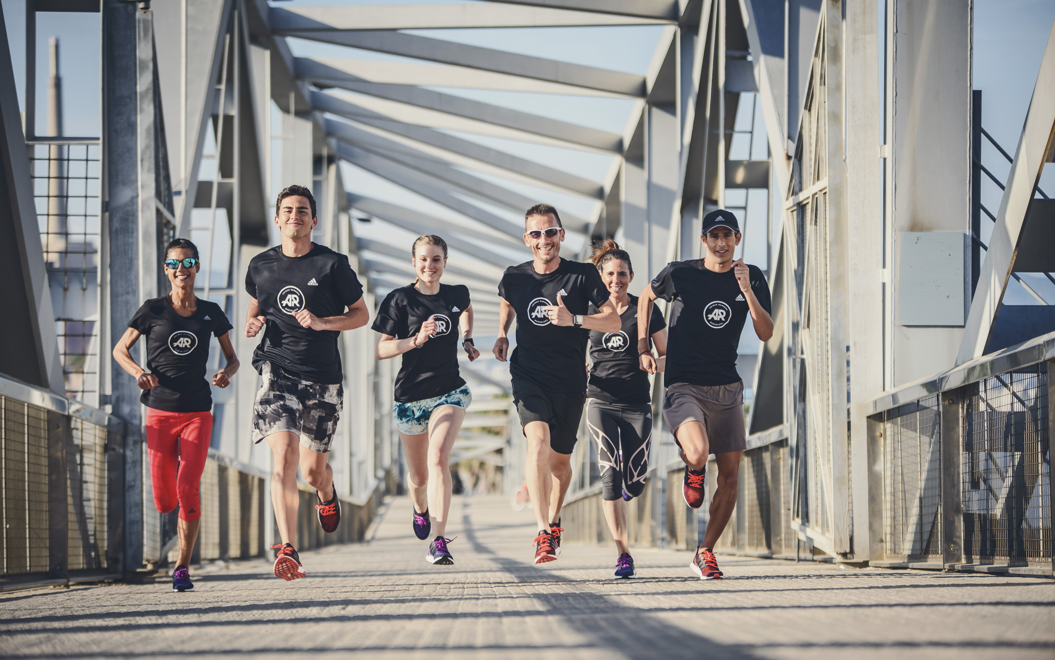

HERZOGENAURACH, June – adidas today launches adidas Runners Barcelona, a global running movement to energize, support and unite runners all over the world. adidas Runners is a community open to anyone looking to inject fun into their routine – get ready to train fierce, perform strong, and party to the end.

Unveiled in key cities around the world, adidas Runners will push participants to the next level with a run hard, play hard mentality. Members of all levels will enjoy personalized milestone plans, expert coaching and unique rewards to help them smash their personal goals. Sharing exclusive local experiences with a new network of people guarantees serious fun in the process.

In Barcelona runs will be led by captains Carles Castillejo and Laura Sanzberro. “Empezamos un nuevo proyecto de la mano de adidas en una de las ciudades más bonitas del mundo, Barcelona. Lo hacemos uniendo dos de mis pasiones: correr y Barcelona. Y además me permite hacerlo como Capitán del equipo.” said captain Carles Castillejo. “Estaré a vuestra entera disposición para ayudaros en todo lo que pueda, para acompañaros en los entrenamientos, para planificarlos... Lo haremos buscando ese punto de unión entre la ciudad y los runners, recorriendo sus calles, descubriendo sitios o detalles de los que nunca nos habíamos percatado.”

There will also be a full expert team on hand, including running coaches and pacers, a strength coach, nutrition coach and a medical coach to inspire and motive all members to push for progress and get the most enjoyment out of each session.

As well as having the support of the adidas Runners team and Barcelona running community, members will be able to connect with athletes in other cities through the global adidas Runners digital hub. The mobile site will allow users to track their performance data (via the adidas train & run app and Runtastic), receive awards for progress and access members-only events on both a local and global level. A live social feed will facilitate real-time conversation between runners wherever they are in the world.

A truly global network, members can feel at home in any city they visit by connecting with the adidas Runners squads around the world to run, create and party together whilst exploring the city.

adidas Runners was launched in Barcelona last Tuesday, the 21th. In order to participate in all the activities, check this link http://www.adidas.es/adidasrunners/es_ES/events/12

To learn more or to sign up, visit adidas.com/adidasrunners. Join the adidas Energy Running movement on Twitter and Instagram using #WHYIRUNBARCELONA.

-END-

For further media information please visit
http://www.adidas.es/adidasrunners/es_ES/

Notes to editors:
The adidas Runners Manifesto
This is not just another sports club.
This is your favourite bar, your date you’ve been looking forward to for weeks.
It is the group of friends that keep you going and kick your ass so you stay on top.
This is not just about running.
This is about being your better self.
This is what you were looking for.
Like the massage that hurts and helps at the same time.
The wobbly knees you haven’t felt for so long.
The pain that feels good.
The party that is well deserved – and – you’re on the guest list.
This is the first step to creating your story of success.
You got this.
And we will help you get there.
This is fun taken seriously.
THIS IS ADIDAS RUNNERS.

