adidas unveils Fracas, the Official Match Ball of UEFA Euro 2016TM knock-out phase

-Ball design captures the excitement and drama of knock-out football-
- The name Fracas translates to ‘clamour’ in French
-Fracas name chosen by Parisian influencers as adidas celebrates open source-

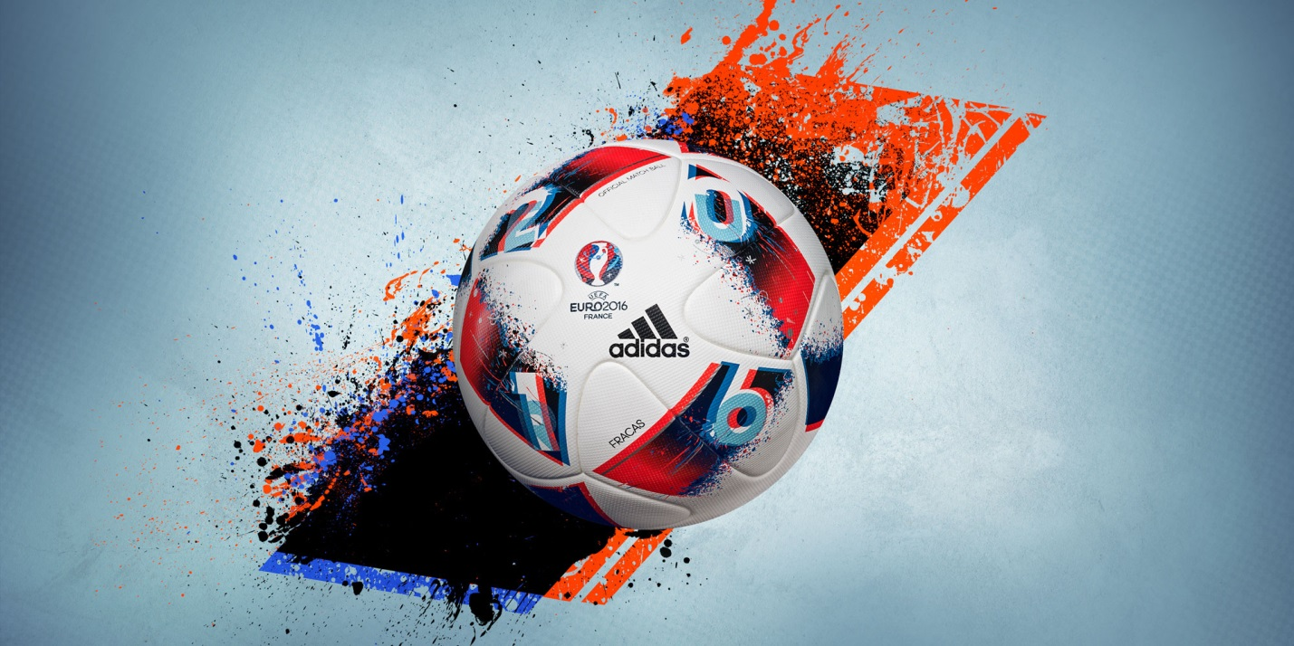

Paris, 20th June – Today adidas launched Fracas, the Official Match Ball of the UEFA EURO 2016TM knock-out phase and the ball that will be used during the tournament final on 10th July.

Some of Paris’ biggest talent from music, popular culture and fashion have worked with adidas to help with the naming of the ball. The name – which translates to ‘clamour’ in French – was chosen to encapsulate the drama and excitement associated with knock-out games. The unpredictability of the latter stages of a major tournament is also captured in the dynamic red and black design of Fracas.

Sam Handy, Vice President of Design, explained the thinking behind the new design: “For Fracas, we wanted to be bold with our design direction and create something that incorporated the emotions felt during the latter stages of tournament football. Beau Jeu was all about tactical football; doing what you had to do in order to get to the knock-out stages. Fracas is a more disruptive design. It represents the noise of the crowd and the excitement around a winner-takes-all mentality on the pitch.”

The structure which underpins both Fracas and Beau Jeu has been in development for over 18 months and takes the best elements of the Brazuca FIFA World Cup Official Match Ball, including the innovative panel shape. The two balls, which together will decide the winners of UEFA EURO 2016TM, feature improved surface structure and blocking, offering enhanced grip and in-flight visibility. During this development process, both balls have been tested independently by top players such as Gareth Bale and Iker Casillas.

To view the Fracas film, visit https://youtu.be/Vjby55BQD9Q

For further information please visit adidas.com/football or go to facebook.com/adidasfootball or follow @adidasfootball on twitter to join the conversation.

- END –

For further media information please visit http://news.adidas.com/GLOBAL/PERFORMANCE/FOOTBALL or contact:

Simon Bristow  PR Director – Herzo Newsroom  Email: simon.bristow@adidas.com  Tel: +49/9132/84-73 703 | Alan McGarrie  Global Director PR & Social Media, adidas Football  Email: alan.mcgarrie@adidas.com  Tel: +49/9132/84-4686
Notes to editors:
About adidas Football
adidas is the global leader in football. It is the official sponsor / official supplier partner of the most important football tournaments in the world, such as the FIFA World Cup™, the FIFA Confederations Cup, the UEFA Champions League, the UEFA Europa League and the UEFA European Championships. adidas also sponsors some of the world’s top clubs including Manchester United, Real Madrid, FC Bayern Munich, Juventus, Chelsea and AC Milan. Some of the world’s best players also on the adidas roster are Leo Messi, Paul Pogba, Gareth Bale, Thomas Müller, Luis Suárez, James Rodríguez, Diego Costa and Mesut Özil.

