Wales star Gareth Bale ready to inspire his nation ahead of crucial UEFA EURO 2016TM match in latest First Never Follows film

- adidas launches First Never Follows film dedicated to Wales’ driving force -
- Young football fans celebrate Bale’s speed and power -
- Bale set for one of the biggest games in the country’s history -

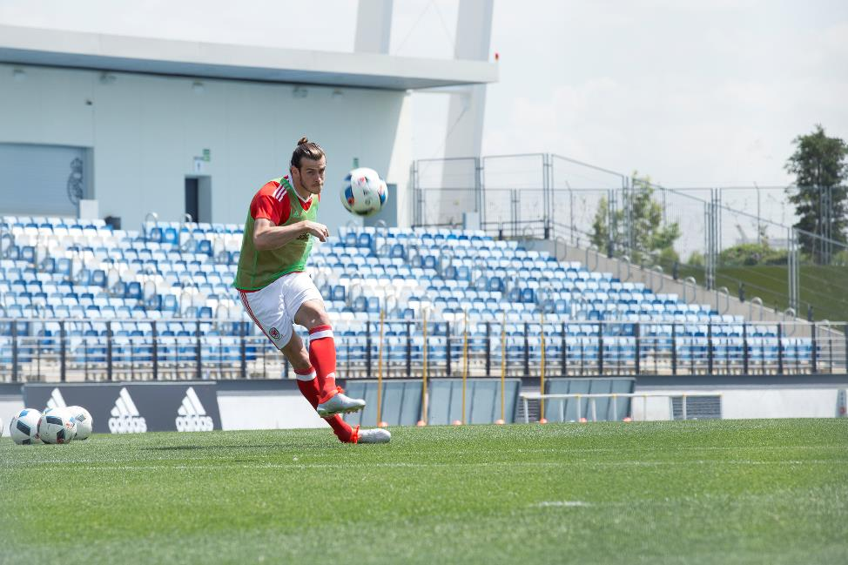

Herzogenaurach, 15th June 2016 – Two-time UEFA Champions League winner and Welsh star man Gareth Bale is the latest player from adidas to feature in his own First Never Follows film, which was launched today ahead of Wales’ key clash with bitter rivals, England.

The film is narrated by a young football fan, who describes how Bale’s speed, power and swerve have made him one of the most revered talents in the modern game. Bale was instrumental in helping Wales qualify for their first UEFA European Championships and played a starring role in Real Madrid securing La Undecima last month.

In the film, Bale can be seen wearing the new X 16+ PURECHAOS, the boots that he’ll be wearing as he looks to help his team progress to the knockout stages of the UEFA EURO 2016TM.

To view the film, visit https://youtu.be/JGQvMODVloI

For further information please visit adidas.com/football or go to facebook.com/adidasfootball or follow @adidasfootball on twitter to join the conversation.

- END -

For further media information please visit http://news.adidas.com/GLOBAL/PERFORMANCE/FOOTBALL or contact:

Simon Bristow  PR Director – Herzo Newsroom  Email: simon.bristow@adidas.com  Tel: +49/9132/84-73 703 | Alan McGarrie  Global Director PR & Social Media, adidas Football  Email: alan.mcgarrie@adidas.com  Tel: +49/9132/84-4686
Notes to editors:
About adidas Football
adidas is the global leader in football. It is the official sponsor / official supplier partner of the most important football tournaments in the world, such as the FIFA World Cup™, the FIFA Confederations Cup, the UEFA Champions League, the UEFA Europa League and the UEFA European Championships. adidas also sponsors some of the world’s top clubs including Manchester United, Real Madrid, FC Bayern Munich, Juventus, Chelsea and AC Milan. Some of the world’s best players also on the adidas roster are Leo Messi, Paul Pogba, Gareth Bale, Thomas Müller, Luis Suárez, James Rodríguez, Diego Costa and Mesut Özil.

