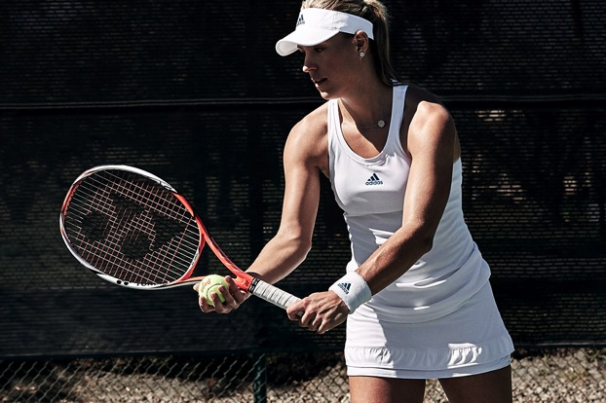
adidas Tennis stars take to Wimbledon in high performance CLIMACHILL outfits

- As things heat up on the sacred lawns of Wimbledon, Angelique Kerber, Tomàš Berdych and Alexander Zverev play it cool with the revolutionary CLIMACHILL apparel.

15-06-2016 – Herzogenaurach, Germany

With the Wimbledon Tennis Championships set to commence, adidas Tennis has today unveiled the outfits that its star players – including the likes of Angelique Kerber, Tomàš Berdych and Alexander Zverev – will wear when they take to the court.

Designed for optimal performance in sweltering conditions, the CLIMACHILL collection incorporates innovative fabrics and active cooling technology that provides an instant chilling sensation and lowers the body temperature, so players can keep cool on the court when temperatures soar.

The CLIMACHILL collection has a uniquely engineered design profile, combining a trio of leading apparel technologies:

- Industry-first 3D aluminium-cooling spheres strategically located on the back and neck to correspond with the warmest areas of the body; providing an instant cooling sensation on contact.
- Mesh-like micro fibres that transport excess moisture away from your skin.
- Revolutionary SubZero flat yarns containing titanium to maximise surface contact with the skin, to transfer heat away from the body.

At Wimbledon 2016 Angelique Kerber, Tomàš Berdych and Alexander Zverev will compete in pristine white CLIMACHILL apparel. Combining traditional Wimbledon aesthetics with innovative technology, the 2016 adidas Wimbledon CLIMACHILL collection is set to keep adidas’ finest cool under pressure and the scorching sun.

The 2016 adidas Wimbledon CLIMACHILL line is available now on adidas.com and adidas stores worldwide.

– END –

For further information please contact:
Matthias Fischer
Communication Manager Tennis
Germany
Matthias.Fischer@adidas.com
+ 49 9132 84 6847

Notes to editors:
About adidas Tennis
adidas Tennis is represented by top players such as Angelique Kerber , Ana Ivanovic, Garbiñe Muguruza, Caroline Wozniacki, Simona Halep, Tomas Berdych, Jo-Wilfried Tsonga, Sascha Zverev and Novak Djokovic (Footwear Only). For more information on adidas Tennis, please visit www.adidas.com/tennis. For additional images please visit our media news room on news.adidas.com and follow us on Twitter or on Instagram under @adidasTennis.

About adidas
The adidas Group is a global leader in the sporting goods industry, offering a broad portfolio of footwear, apparel and hardware for sport and lifestyle around the core brands adidas, Reebok, TaylorMade and CCM Hockey. Headquartered in Herzogenaurach, Germany, the Group employs more than 55,000 people across the globe and generated sales of around € 17 billion in 2015.

