adidas Launches First Film in Series Featuring Global Superstars

- Paul Pogba, Luis Suarez and Mesut Ozil star in new First Never Follows film series -
- Each player will have his own unique video as part of the series -
- Launch video celebrates players’ drive to be the first – on and off the pitch -
- First Never Follows film announces arrival of adidas’ Mercury Pack boot collection -

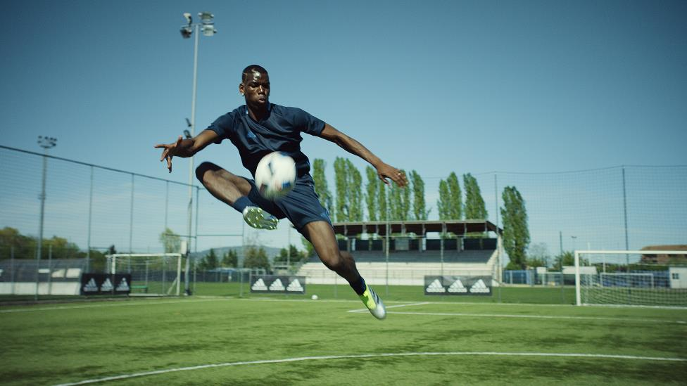

Herzogenaurach, 20th May 2016 – adidas Football today launched the first video of its First Never Follows film series, which will feature global superstars including Paul Pogba, Luis Suarez and Mesut Ozil, and will celebrate the unique drive of the worlds best players to be number one – on and off the pitch.

The film sees the players showcase the attributes that inspire their mind-set of finishing first being everything – from incredible speed, control, flair and power on the pitch to a unique level of swagger off it.

The first film has been released to coincide with the unveiling of adidas’ striking new Mercury Pack boot collection. The boots will take to the field for the first time during 2016 UEFA Champions League final then for the Copa America Centenario and the UEFA EURO 2016TM this summer, as the likes of Pogba, Suarez and Ozil aim to finish first and claim the biggest trophies in football.

Paul Pogba said:
“I always aim to be a leader - by being the first in everything I do - on and off the pitch. From being the first to try new skills to the first to showcase a fresh new style, being first is what inspires me and drives me to create moments that everyone remembers.”

As the First Never Follows series develops, adidas will release a number of individual videos for each of the star players wearing the new Mercury Pack boots. Each film will showcase the inimitable drive of the players to be first. Paul Pogba will demonstrate the style that has made him one of the most exciting players to watch on and off the pitch, whilst Luis Suarez will show how he fights – literally – to win as he takes to the punch bag.

Luis Suarez said:
“Being first is all that matters in football and this is what inspires me every day – in training, during moments of focus and when I take to the pitch. Creating the moments that people remember you for is what drives players and to achieve that, you have to show huge levels of commitment and fight.”

During this first film, Pogba and Ozil can be seen wearing the fresh new ACE16+ PURECONTROL, the boots they will wear during the UEFA EURO 2016TM this summer. Suarez, on the other the hand, can be seen in the new X16+ PURECHAOS, which he will wear as he aims to become the first Uruguayan to score 50 goals for his country at the Copa America Centenario in June.

To view the film, visit https://youtu.be/ph8rcsuaFt0

The X16+ PURECHAOS and the new ACE16+ PURECONTROL will be worn on pitch for the first time at the 2016 UEFA Champions League final, while the final boot in the Mercury Pack collection – the MESSI16+ PUREAGILITY – will be seen on pitch for the first time on the feet of the greatest player of all time, Leo Messi, at Copa America Centenario.

For further information please visit adidas.com/football or go to facebook.com/adidasfootball or follow @adidasfootball on twitter to join the conversation.

- END -

For further media information please visit http://news.adidas.com/GLOBAL/PERFORMANCE/FOOTBALL or contact:

Simon Bristow  PR Director – Herzo Newsroom  Email: simon.bristow@adidas.com  Tel: +49/9132/84-73 703 | Alan McGarrie  Global Director PR & Social Media, adidas Football  Email: alan.mcgarrie@adidas.com  Tel: +49/9132/84-4686
Notes to editors:
About adidas Football
adidas is the global leader in football. It is the official sponsor / official supplier partner of the most important football tournaments in the world, such as the FIFA World Cup™, the FIFA Confederations Cup, the UEFA Champions League, the UEFA Europa League and the UEFA European Championships. adidas also sponsors some of the world’s top clubs including Manchester United, Real Madrid, FC Bayern Munich, Juventus, Chelsea and AC Milan. Some of the world’s best players also on the adidas roster are Leo Messi, Paul Pogba, Gareth Bale, Thomas Müller, Luis Suárez, James Rodríguez, Diego Costa and Mesut Özil.

