DAVID BECKHAM IS UNITED WITH FAMOUS FAN STORMZY
AT NEW-LOOK ADIDAS STORE ON OXFORD STREET
- Flagship adidas store on Oxford Street has been given complete makeover
- adidas reveal new Manchester United away shirt
- Grime music artist Stormzy meets his idol David Beckham
- More than 100 hand-picked football fans were in-store for David Beckham’s surprise appearance
- Oxford Street shoppers will have the chance to win shirts signed by David Beckham
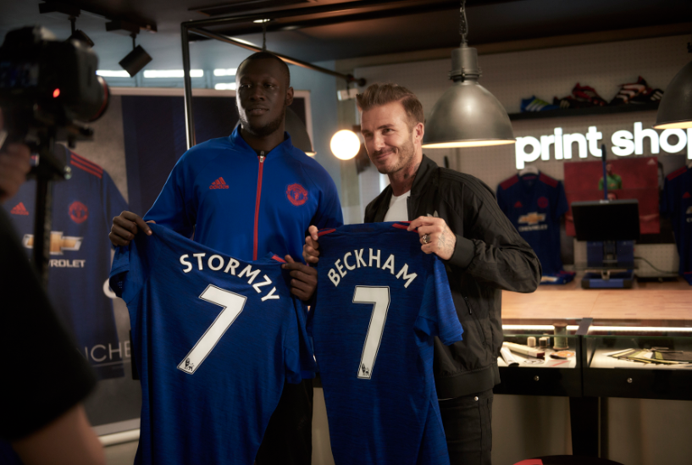

London, UK (May 11, 2016) – Crowds gathered on Oxford Street as football icon David Beckham dropped by the newly re-opened adidas store to surprise more than 100 waiting Manchester United fans – including London-based grime hit-maker Stormzy.
The Old Trafford hero was celebrating the launch of the new Manchester United away shirt for 2016/17. Shoppers who visit the adidas store on Oxford Street in the next seven days [before Wednesday May 18] will have the chance to win a shirt signed by David Beckham.
At the event, Stormzy named Beckham in his all-time Manchester United XI before the footballer stunned the musician and awestruck audience by entering the stage.
David Beckham signed a new Manchester United shirt for Stormzy, whilst Stormzy returned the favour by signing a photograph for David’s son Brooklyn.
A crowd of more than 100 football fans – including players from the adidas 4-a-side Tango League [in London] had been invited to the store to pick up their new Manchester United shirts and meet special guests.
The lucky fans then had the opportunity to ask questions of midfielder Beckham as the refurbished adidas store played host to an exclusive version of YouTube channel Copa 90’s talkshow ‘Comments Below’, hosted by Poet & Vuj.
David Beckham said: “It’s a fantastic feeling to be back in London. It is my home and I love this city. It has been great to spend time meeting Man Utd fans at the adidas store – in particular Stormzy – whose music I enjoy and know well – as it is always pumping out from Brooklyn’s bedroom!”
Stormzy added: “It has been my dream to meet David Beckham since I was a youngster. He is a gentleman and hasn’t disappointed. I hope I wasn’t too fanboy around him – but he gave me a signed Manchester United shirt and that will be framed and going up on the studio wall ASAP.”
Omar Fatti, an 18-year-old student from Wembley said: “When I saw David Beckham at the adidas store on Oxford street I was pretty shocked. Someone was saying it’s not real, it’s a hologram. It was amazing and pretty surreal at the same time. It was amazing to watch him and Stormzy chat on stage!”
The new Manchester United away shirt, by adidas, includes recycled materials and Climacool technology to keep players cool and dry for optimum comfort and performance. It is available to buy now from all adidas stores and www.adidas.co.uk
ENDS
Suggested picture captions:
- BECK IN TOWN: David Beckham meets fans outside the newly re-opened adidas store on Oxford Street. The Man Utd legend launched the club’s new away shirt, available online and in-store now (Credit: Ben Duffy / adidas UK)

- GRIME OF HIS LIFE: David Beckham and grime musician Stormzy show off the new Man Utd Away kit at the refurbished adidas Store on Oxford Street (Credit: Ben Duffy / adidas UK)

- SURPRISE IN STORE: Lifelong Man Utd fan Stormzy meets his idol David Beckham on stage in the newly re-opened adidas store on Oxford Street (Credit: Ben Duffy / adidas UK)

For further information please visit adidas.com/football or go to facebook.com/adidasfootball or follow @adidasfootball on twitter to join the conversation.

- END -

For further media information please visit http://news.adidas.com/GLOBAL/PERFORMANCE/FOOTBALL or contact:

Simon Bristow  PR Director – Herzo Newsroom  Email: simon.bristow@adidas.com  Tel: +49/9132/84-73 703 | Alan McGarrie  Global Director PR & Social Media, adidas Football  Email: alan.mcgarrie@adidas.com  Tel: +49/9132/84-4686
Notes to editors:
About adidas Football
adidas is the global leader in football. It is the official sponsor / official supplier partner of the most important football tournaments in the world, such as the FIFA World Cup™, the FIFA Confederations Cup, the UEFA Champions League, the UEFA Europa League and the UEFA European Championships. adidas also sponsors some of the world’s top clubs including Manchester United, Real Madrid, FC Bayern Munich, Juventus, Chelsea and AC Milan. Some of the world’s best players also on the adidas roster are Leo Messi, Paul Pogba, Gareth Bale, Thomas Müller, Luis Suárez, James Rodríguez, Diego Costa, Mesut Özil and Dele Alli.

