ADIDAS RELEASE New Manchester United away jersey FOR FORTHCOMING SEASON
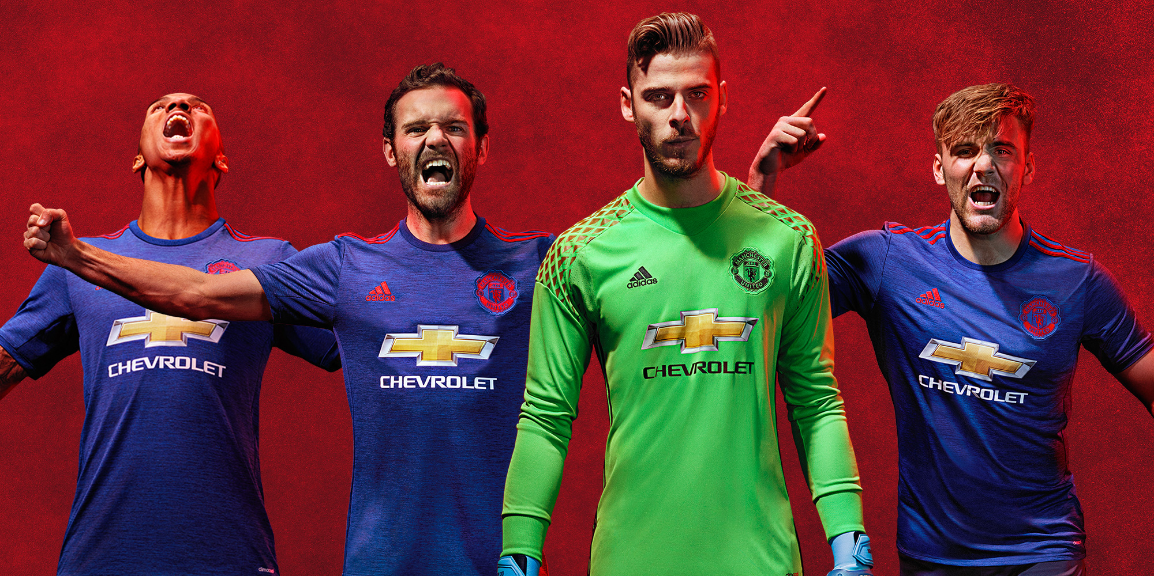

HERZOGAUNAURACH/Manchester, 11th May 2016: adidas and Manchester United have launched the club’s new away jersey for the 2016/17 season.
The jersey has a base colour of collegiate blue, and has been launched ahead of the home shirt, which is yet to be released. It includes a distinct dark blue mélange detail, with red accents of the adidas performance logo, three stripes on the shoulders and a red Manchester United crest.

There is also a 'Red Devils' detail visible on the inside of the jersey.

Alongside the replica jersey, there is also an authentic shirt available – as worn by the players, a long-sleeved version, and shirts specifically for children and women. It is accompanied by dark blue shorts, and socks with the same mélange detail.

For further information please visit adidas.com/football or go to facebook.com/adidasfootball or follow @adidasfootball on twitter to join the conversation.

- END -

For further media information please visit http://news.adidas.com/GLOBAL/PERFORMANCE/FOOTBALL or contact:

Simon Bristow  PR Director – Herzo Newsroom  Email: simon.bristow@adidas.com  Tel: +49/9132/84-73 703 | Alan McGarrie  Global Director PR & Social Media, adidas Football  Email: alan.mcgarrie@adidas.com  Tel: +49/9132/84-4686

Notes to editors:

About adidas Football
adidas is the global leader in football. It is the official sponsor / official supplier partner of the most important football tournaments in the world, such as the FIFA World Cup™, the FIFA Confederations Cup, the UEFA Champions League, the UEFA Europa League and the UEFA European Championships. adidas also sponsors some of the world’s top clubs including Manchester United, Real Madrid, FC Bayern Munich, AC Milan, Flamengo and Chelsea. Some of the world’s best players also on the adidas roster are Leo Messi, Gareth Bale, Ander Herrera, Bastian Schweinsteiger, Thomas Müller, Luis Suárez, James Rodríguez, Diego Costa and Mesut Özil.

About Manchester United
Manchester United is one of the most popular and successful sports teams in the world, playing one of the most popular spectator sports on Earth. Through our 138-year heritage we have won 62 trophies, enabling us to develop the world’s leading sports brand and a global community of 659 million followers. Our large, passionate community provides Manchester United with a worldwide platform to generate significant revenue from multiple sources, including sponsorship, merchandising, product licensing, new media & mobile, broadcasting and match day.

