BACK WITH A ROAR

ADIDAS REVEAL NEW CHELSEA HOME KIT FOR THE 2016/17 SEASON THEMED AROUND THE CLUB’S FIGHTING SPIRIT
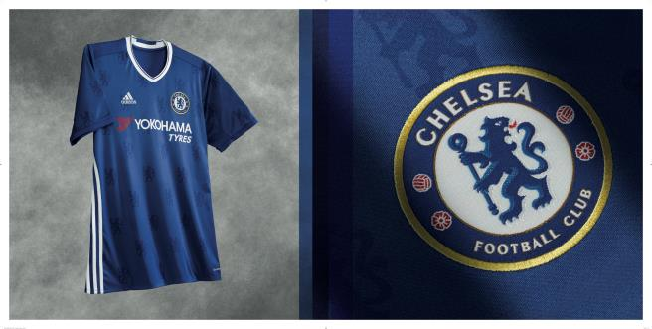

London/Herzogenaurach, 4th May 2016 – Chelsea Football Club and adidas Football today unveil the new home kit for the 2016/17 season.

Showing the two facets of the club, the new kit presents the proud traditions of the club’s heritage and on the other a determined mission to strive to be the best.
With a focus on simple elegance and tradition, the new home shirt remains in a classic blue with white detailing; featuring a new side adidas three stripe execution and a classic V-neck collar with a fitted collar tape. The lead design feature takes its inspiration from the heart of the club crest with tonal lions adorning the sleeves and jersey front.

The new kit will make its debut in the FA Women’s Cup final at Wembley on 14 May when Chelsea take on Arsenal, with its first appearance at Stamford Bridge a day later in the final game of the Premier League season when we host Leicester City.

You can pre-order now to receive the kit when it launches on 11 May through www.adidas.com/Chelsea_fc and through www.chelseamegastore.com

For further information please visit www.chelseafc.com/shopping and follow @adidasuk and @ChelseaFC on Twitter and Facebook to join the conversation.

In a first for the club, the new kit will be officially was officially revealed this morning via Facebook, in a live Q&A with first team players Eden Hazard and Ruben Loftus-Cheek.

- END -

For further media information please visit http://news.adidas.com/GLOBAL/PERFORMANCE/FOOTBALL or contact:

Ben Goldhagen
Senior PR Manager – adidas football
Email: ben.goldhagen@adidas.com
Tel: 07861 182501

Notes to editors:

About adidas Football

adidas is the global leader in football. It is the official sponsor / official supplier partner of the most important football tournaments in the world, such as the FIFA World Cup™, the FIFA Confederations Cup, the UEFA Champions League, the UEFA Europa League and the UEFA European Championships. adidas also sponsors some of the world’s top clubs including Manchester United, Real Madrid, FC Bayern Munich, Juventus, Chelsea and AC Milan. Some of the world’s best players also on the adidas roster are Leo Messi, Paul Pogba, Gareth Bale, Thomas Müller, Luis Suárez, James Rodríguez, Diego Costa and Mesut Özil.

About Chelsea Football Club

Chelsea Football Club is one of the world’s top football clubs. Chelsea were UEFA Champions League winners in 2012, following that success by lifting the UEFA Europa League trophy in 2013. Founded in 1905, Chelsea is London’s most central football club, based at the iconic 42,000-capacity Stamford Bridge stadium.

Nicknamed ‘The Blues’, Chelsea are four-time English Premier League champions and have also lifted the FA Cup seven times, the Football League Cup five times, the UEFA Cup Winners’ Cup twice, the UEFA Super Cup once and the Football League Championship once, in 1955. The Europa League triumph saw Chelsea become the first English club to win all three major UEFA competitions, and the first club ever to hold both the Champions League and Europa League at the same time.

In addition to possessing some of the world’s most recognisable players, Chelsea has also invested in its future with a state-of-the-art Academy and training centre in Cobham, Surrey. Since its opening in 2007, the club has lifting the FA Youth Cup trophy five times and the UEFA Youth League twice. The Chelsea Ladies team also won the FA Women’s Super League and FA Women’s Cup double in 2015.

Additionally, the Chelsea Foundation boasts one of the most extensive community initiatives in sport, working in 30 countries around the world, helping improve the lives of more than 900,000 children and young people each year.

