Real Madrid superstars play leading role in latest instalment of UEFA Champions League access-all-areas show

- Bale, Marcelo, James, Navas and Vazquez feature in latest episode -
- Bale takes viewers behind-the-scenes at club’s training ground -
- Navas, James and Vasquez give adidas Gamedayplus footballing masterclasses -

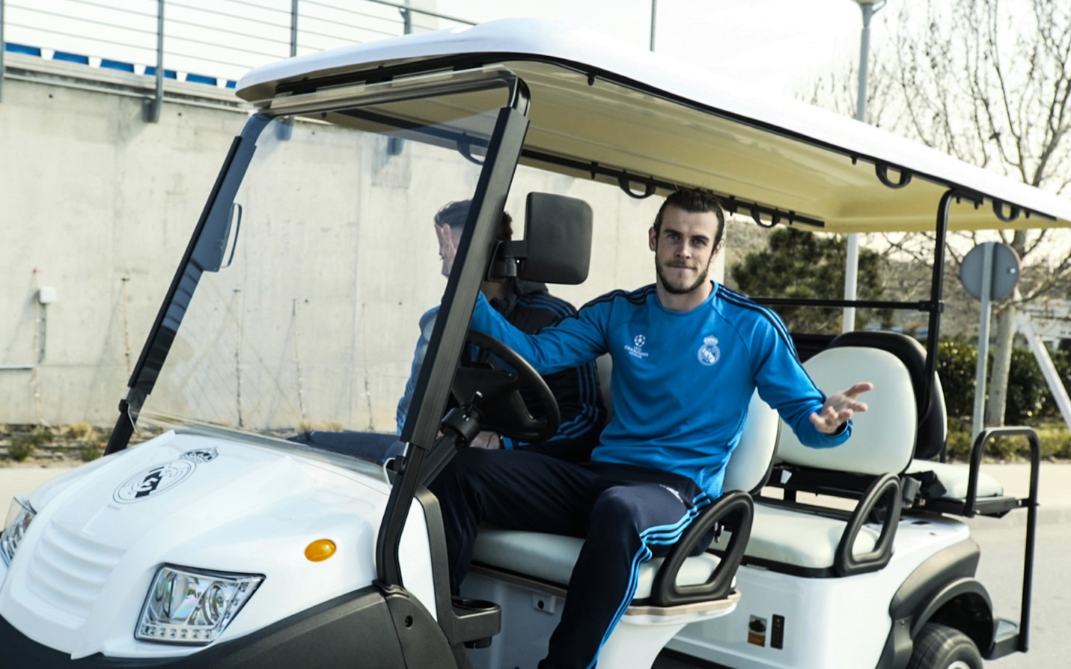

Herzogenaurach, Monday 4th April – Ahead of their crunch UEFA Champions League quarter-final tie against Wolfsburg, adidas Gamedayplus were taken behind-the-scenes by some of Real Madrid’s biggest names in the latest episode of the access-all-areas show.

The episode kicks off with adidas Gamedayplus riding shotgun in a golf buggy with UEFA Champions League final goal scorer, Gareth Bale.

Keylor Navas then gives viewers a goalkeeping masterclass with the help of Brazilian full-back and club legend Marcelo. Madrid’s no.1 shot-stopper shows why he’s one of the best in the world with an audacious Scorpion Kick before telling adidas Gamedayplus what it’s like to be part of one of the world’s greatest defences.

Next to feature is Columbian superstar James Rodriguez, scorer of that World Cup goal, giving a volleying masterclass. The Madrid playmaker talks viewers through the correct technique to boss the perfect volley before showing them how it’s done.

The star-studded line-up continues with a striking masterclass from forward Lucas Vazquez, demonstrating how to make it count in front of goal with a series of shooting drills.

Finally, adidas Gamedayplus gives viewers the chance to win their very own Finale Milano, the official match ball of the UEFA Champions League knock out stages, signed by Gareth Bale.

Watch Gamedayplus at – https://www.youtube.com/watch?v=rESO8hczVv0&feature=youtu.be

About adidas Gamedayplus:
- New episodes of Gamedayplus will be released every UEFA Champions League match week this season
- Subscribe to adidas football on Youtube to ensure you never miss an episode. To join the conversation, visit facebook.com/adidasfootball or follow @adidasfootball on twitter.

- END -

For further media information please visit http://news.adidas.com/GLOBAL/home/FOOTBALL or contact:

Simon Bristow
Global PR Director
Email: simon.bristow@adidas.com
Tel. +49 160 485 1388

Alan McGarrie
Global Football PR Manager
Email: http://alan.mcgarrie@adidas.com
Tel: +49/9132/84-4686

Notes to Editors:

About adidas Football:

adidas is the global leader in football. It is the official sponsor / official supplier partner of the most important football tournaments in the world, such as the FIFA World Cup™, the FIFA Confederations Cup, the UEFA Champions League, the UEFA Europa League and the UEFA European Championships. adidas also sponsors some of the world’s top clubs including Real Madrid, FC Bayern Munich, AC Milan, Flamengo and Chelsea. Some of the world’s best players also on the adidas roster are Leo Messi, Paul Pogba, Gareth Bale, Thomas Müller, Arjen Robben, James Rodriguez, Karim Benzema and Bastian Schweinsteiger.

