Stars of the future discuss their biggest inspirations in Episode 5 of Backed by Messi

- Messi explains what motivated him to be the best since arriving at La Masia -
-Young stars tell adidas their biggest motivations and desire to succeed -

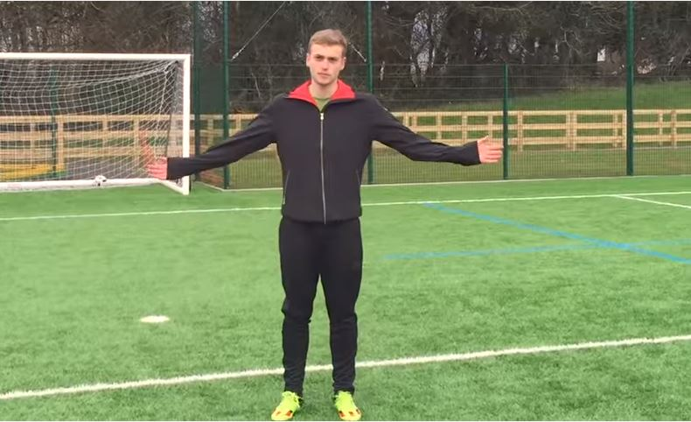

Herzogenaurach, 18th March 2016 – Today, adidas launched ‘Inspiration and Motivation’, the latest episode of Backed by Messi – a series of videos following the development of ten young stars of the future, handpicked to join Team Messi.

The episode is the fifth in the series and focuses on how young stars James Wilson, Rony Lopes, Accursio Bentivegna and Maxwel Cornet have been inspired and motivated throughout their short careers.

The episode kicks off with AS Monaco forward, Rony Lopes, discussing how Messi is his biggest inspiration before the man himself tells adidas how he tried to do everything right from a young age to help fulfil his dream of being the greatest player in the world.

Manchester United forward, James Wilson, offers viewers a glimpse of his training regime as he bosses a sprint race before talking about how a tour of the club’s trophy museum inspired him to want to play for one of the biggest clubs in the world. The young star also shows of his skills and deadly accuracy by performing a brilliant cross-bar trick shot.

Maxwell Cornett and Accursio Bentivegna pay homage to their childhood, explaining how playing football on the streets honed their skills and gave them the desire to make it to the top.

The episode continues with some original footage of a 5-year-old Rony Lopez taking on kids three years older than him in a competitive game, before his dad tells adidas how football was an escape mechanism from school.

Episode 5 concludes with the players talking about how they are constantly inspired and motivated by the sacrifices made by their families.

Watch Episode 5 at: https://youtu.be/-Jt9PLPLQns

The ten players recruited to Team Messi are:
• Robert Kenedy (Chelsea FC, Brazilian)
• Maxwel Cornet (Lyon, French)
• Jeremie Boga (Rennes [on loan from Chelsea FC], French)
• Accursio Bentivegna (Como [on loan from Palermo], Italian)
• James Wilson (Manchester United, English)
• Timo Werner (VFB Stuttgart, German)
• Aleksey Miranchuk (Lokomotiv Moscow, Russian)
• Gyasi Zardes (LA Galaxy, American)
• Marcos Lopes (AS Monaco FC, Portuguese)
• Khiry Shelton (New York City FC, American)

These players have been bossing pitches all season in Leo’s signature boot, the Messi15. To follow Team Messi subscribe to the adidas Football YouTube channel at youtube.com/adidasfootball, go to facebook.com/TeamMessi or follow @TeamMessi on twitter to join the conversation.

- END -

For further media information please visit http://news.adidas.com/GLOBAL/PERFORMANCE/FOOTBALL or contact:

Simon Bristow  PR Director - Herzo Newsroom  Email: Simon.Bristow@adidas.com | Alan McGarrie  adidas Senior Global Football PR Manager  Email: alan.mcgarrie@adidas.com  Tel: +49/9132/84-4686

Notes to editors:
About adidas Football
adidas is the global leader in football. It is the official sponsor / official supplier partner of the most important football tournaments in the world, such as the FIFA World Cup™, the FIFA Confederations Cup, the UEFA Champions League, the UEFA Europa League and the UEFA European Championships. adidas also sponsors some of the world’s top clubs including Manchester United, Real Madrid, FC Bayern Munich, Juventus, Chelsea and AC Milan. Some of the world’s best players also on the adidas roster are Leo Messi, Paul Pogba, Gareth Bale, Thomas Müller, Luis Suárez, James Rodríguez, Diego Costa and Mesut Özil.

