MADISON WILSON JOINS ADIDAS AND MOVES INTO THE FAST LANE FOR RIO

- Australian backstroke specialist becomes the latest athlete to sign up with the world’s biggest sportswear brand
- Wilson, who secured a silver medal at the 2015 World Championships in Kazan, will be a leading medal hope in Rio
- Wilson will wear adidas’ fastest ever swimsuit, the revolutionary new adizero XVI

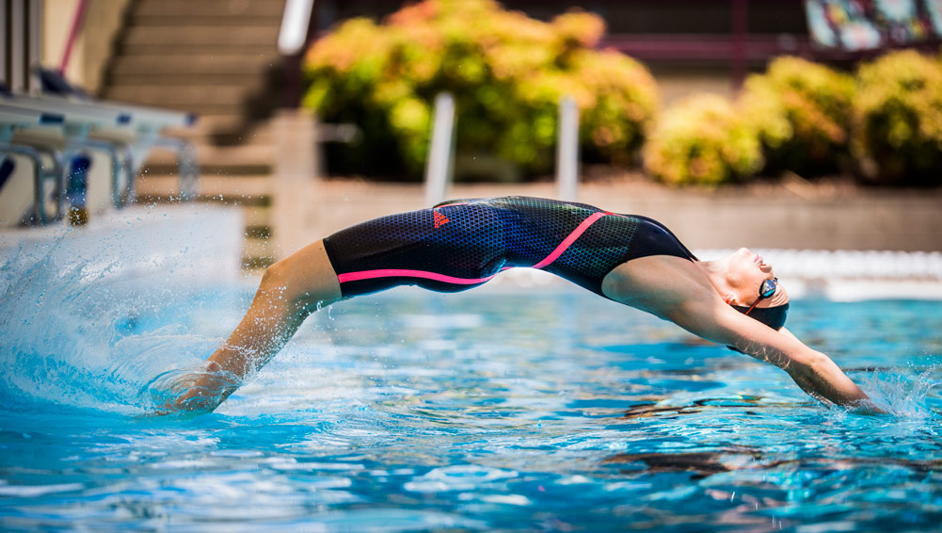

HERZOGENAURACH, MARCH 2nd 2016 – In 2016, every millisecond counts for the world’s best swimmers. That’s why Australian medal hopeful Madison Wilson has today joined leading sportswear brand adidas, choosing the best in cutting edge swimming technology.

Currently ranked no.1 in the world for the 200m backstroke, Wilson is set to be one of the biggest stars in Rio this summer. The former silver medal winner from 2015’s World Championships in Kazan will again challenge for glory against the best in the world.

Madison Wilson will wear the recently launched adizero XVI, adidas’ fastest ever swimsuit that combines intelligent materials and intuitive fit. adidas worked with biomechanics, physiologists, fabric and pattern experts, plus a global pool of elite athletes to create the game-changing swimsuit, enabling swimmers to achieve their maximum speed. The ground-breaking technology features three advancements; energy optimisation (X-TRA ENERGY), intelligent materials (X-TRA FLOW) and a stroke-specific biometric fit (X-TRA FIT).

Madison Wilson said of the announcement: “At the top of competitive swimming the standard is incredibly high and the margins incredibly small. This year is the most important of my career so far, particularly with the opportunity that presents itself in Rio. I am really excited to be working with adidas and to take advantage of their unparalleled sporting expertise to help me reach my absolute best.”

Christine Barth-Darkow, Category Director of adidas swim said: “We are delighted that Madison has chosen to join team adidas in such an important year for her. We take great pride in pushing the boundaries of the sport of swimming with our athletes and we can do so by constantly working with the best sportspeople on the planet. To team up with one of the fastest athletes in the world is hugely exciting and we hope she can inspire a generation of youngsters to take up this incredible sport”.

Madison joins adidas elite swimmers Cesar Cielo, Michael Andrew, Allison Schmitt, Fernanda Gonzalez, Coralie Balmy, Chris Walker-Hebborn and Kyle Chalmers, as well as the global pool of adidas athletes including Leo Messi, Jessica Ennis-Hill, James Harden and Caroline Wozniacki.

Follow the progress of Madison Wilson at @adidas_swim on Twitter and Instagram and join the conversation with #TakeTheLane.

- END -

NOTE TO THE EDITOR

About adidas Swimming:
adidas is the global sports brand leading the charge in swimming’s technological revolution. Faster, smarter, better; the adidas swimwear range allows the best in the world to reach unparalleled times. Some of the world’s best athletes - Cesar Cielo, Michael Andrew, Madison Wilson and Allison Schmitt - wear adidas to reach their best, enabled by ground-breaking products such as the adidas adizero XVI swimsuit.

Media relations:

Bastian Jung
Brand Communications, Swim
+49.9132.84.75462
Bastian.jung@adidas.com

Robert Hughes
Managing Editor, Herzo Newsroom
+49.1608.84.6856
Robert.Hughes@adidas.com

