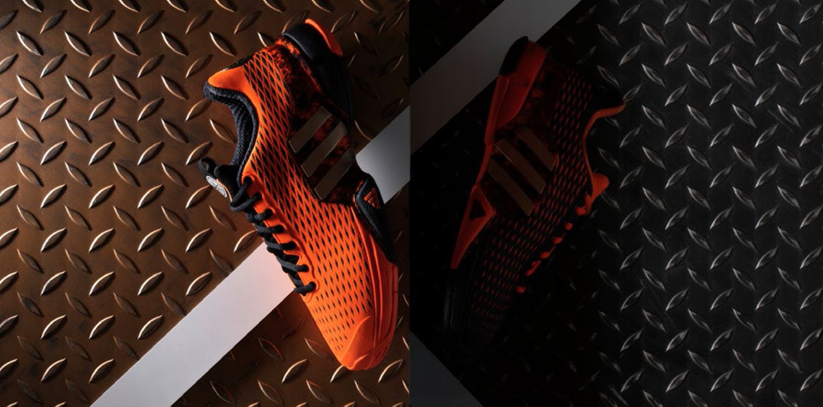

adidas Tennis Releases The Barricade 2016 Alexander.

Adidas expands its SS16 Energy Pack limited edition series of tennis footwear with the Barricade 2016 Alexander. Made to create greatness, the Barricade 2016 Alexander delivers superior stability and durability to win the toughest of on-court battles.

1-03-2016 – Herzogenaurach, Germany

The adidas SS16 Energy Pack is inspired by goddesses and conquerors. After the release of the adizero Ubersonic Aphrodite for women, this unique limited edition collection now gets a mighty reinforcement with the Barricade 2016 Alexander for men. The Barricade Alexander proudly carries the name of one of history’s most extraordinary commanders: Alexander the Great. Unstoppable, formidable and victorious in the face of even the most overwhelming odds.

The Barricade 2016 Alexander is the weapon of choice for players who want to intimidate their opponents with superior maneuverability and fearsome looks. From across the court, its bright orange color way breathes pure fire. Up close, the Barricade 2016 Alexander is decked out with details inspired by the Macedonian born Alexander and his countless conquests. The left and right shoe are color blocked differently for instance, based on the fact that Alexander’s eyes weren’t the same color. Its striking appearance aside, a lightweight TPU mesh upper and an exceptionally durable sole make the Barricade 2016 Alexander the perfect choice for hours of relentless training and grueling five-set victories.

Find your strategy with the Barricade 2016 Alexander, available from March 1st, 2016. Next release in the SS16 Energy Pack is the Barricade 2016 Hannibal for the men, while the women can look forward to the adizero Ubersonic Artemis to supplement the collection.

– END –

For further information please contact:

Matthias Fischer
Communication Manager Tennis
Germany
Matthias.Fischer@adidas.com
+ 49 9132 84 6847

Notes to editors:
About adidas Tennis
adidas Tennis is represented by top players such as Tomas Berdych, Ana Ivanovic, Garbiñe Muguruza, Caroline Wozniacki, Angelique Kerber, Simona Halep, Jo-Wilfried Tsonga and Novak Djokovic (Footwear Only). For more information on adidas Tennis, please visit www.adidas.com/tennis. For additional images please visit our media news room on news.adidas.com and follow us on Twitter or on Instagram under @adidasTennis.

About adidas
adidas is a global designer, developer and marketer of athletic footwear, apparel and accessories with the mission to be the leading sports brand in the world. Brand adidas is part of the adidas Group, a corporation that includes brands such as Reebok, TaylorMade and Rockport.

