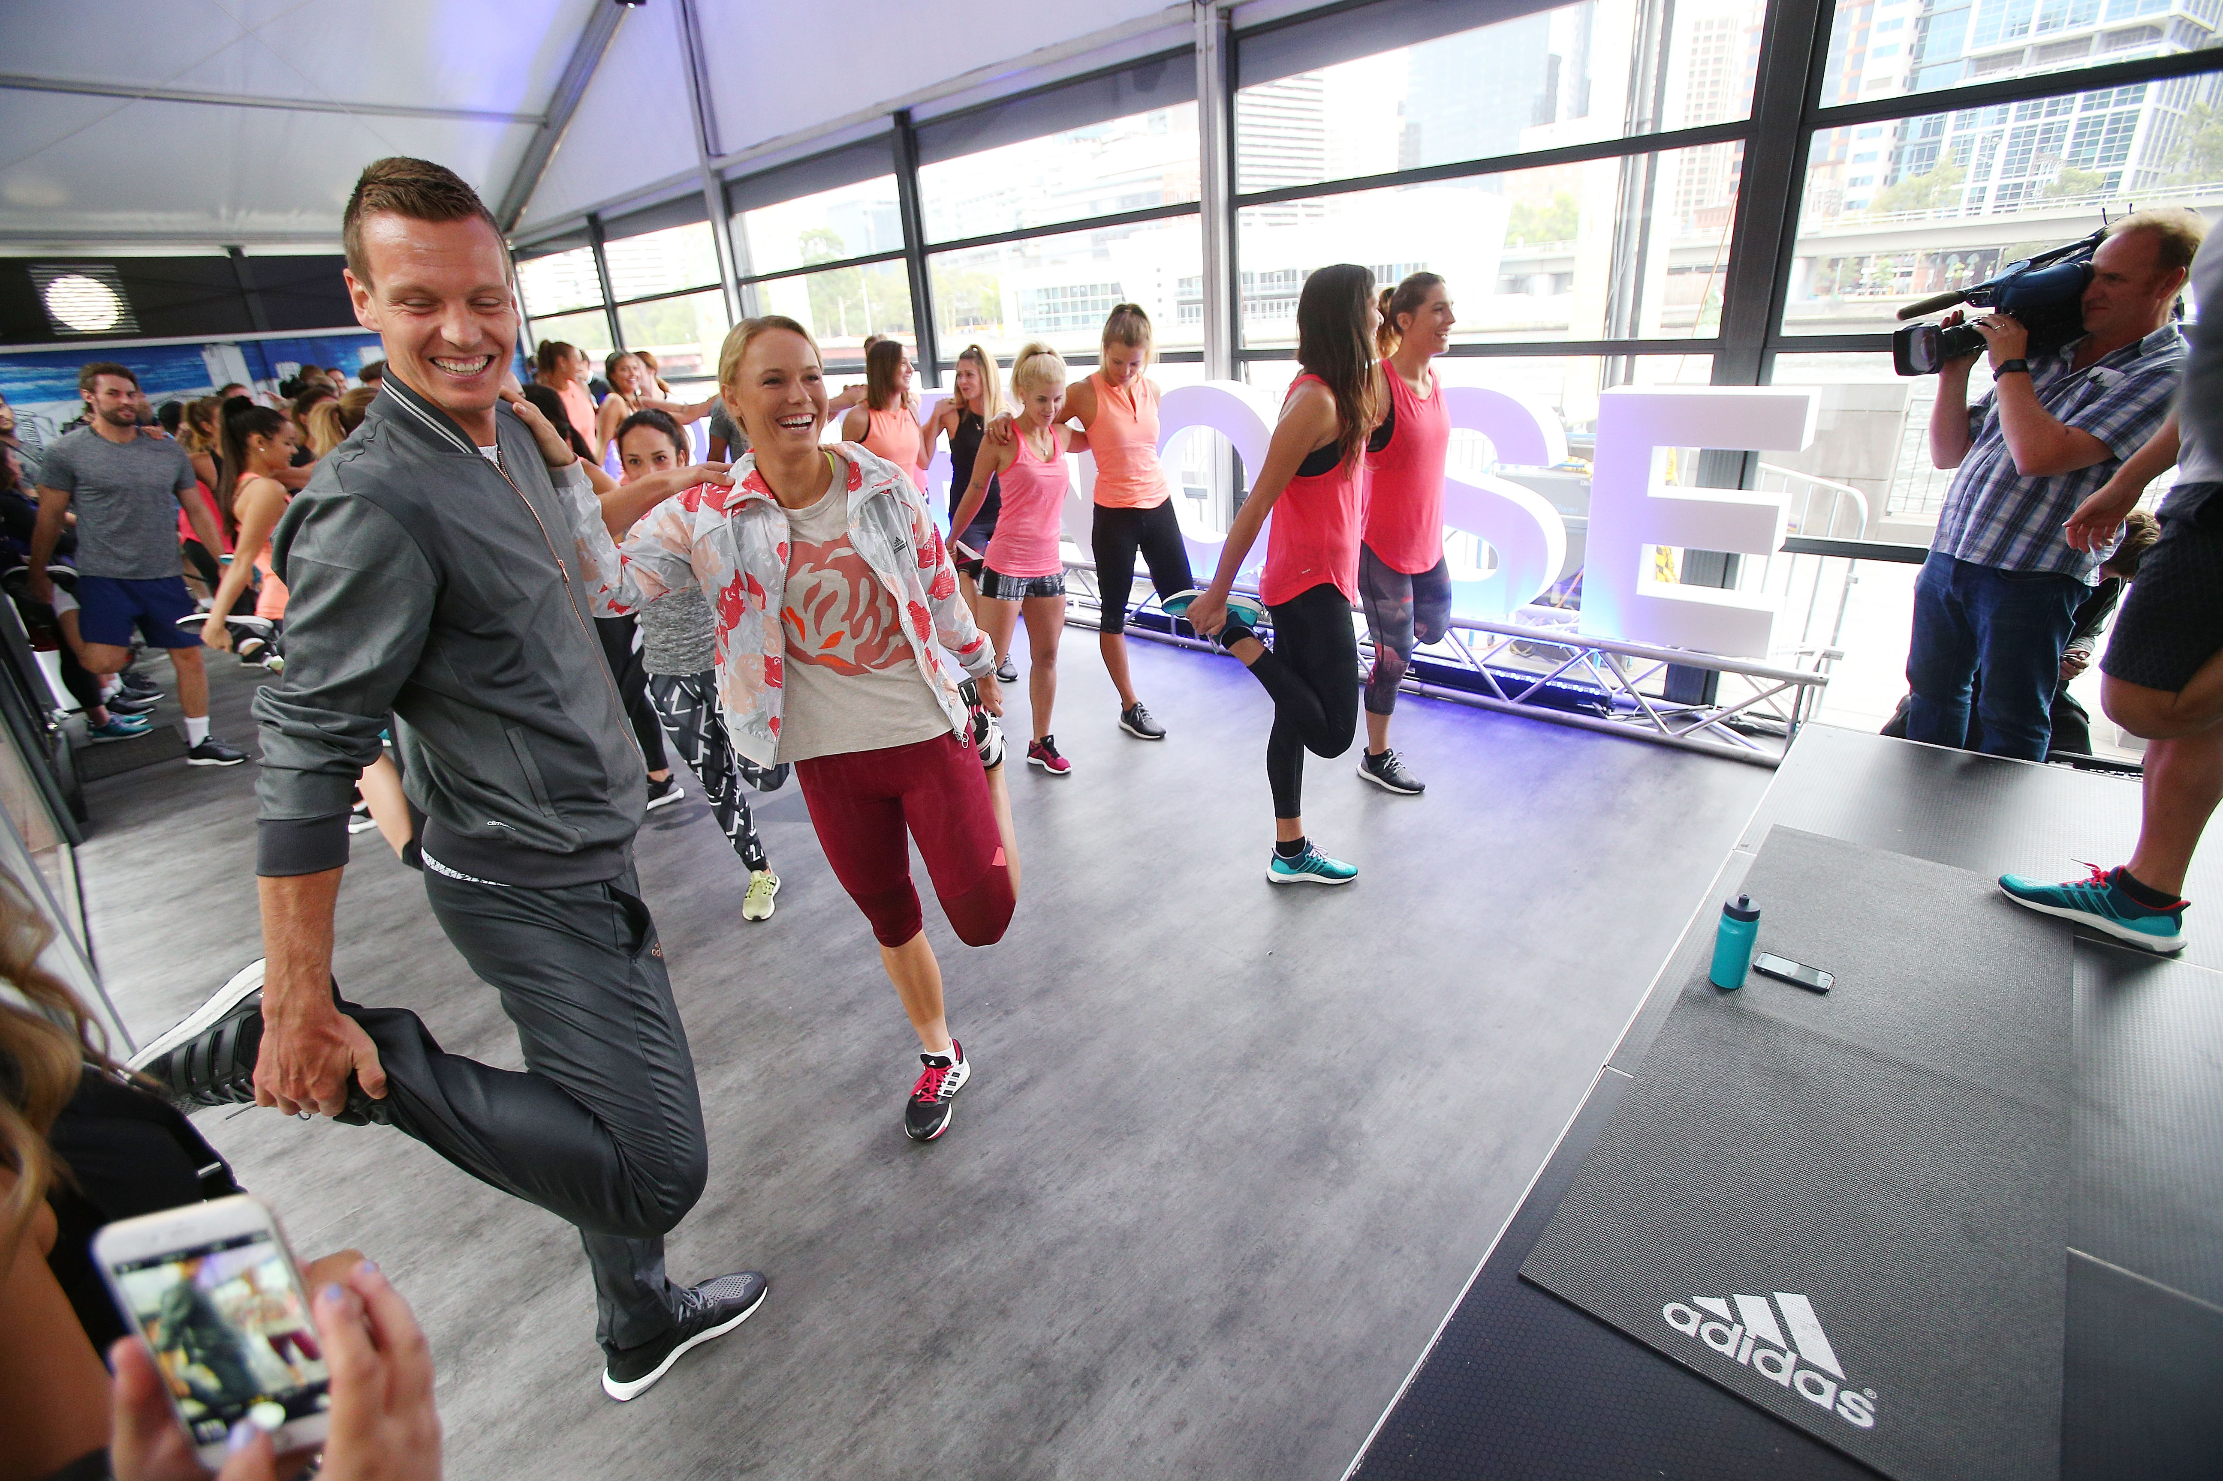
Tomáš Berdych, Caroline Wozniacki, Ana Ivanovic and Andrea Petkovic warm up with stretches.

adidas Tennis Stars Launch Innovative Tennis Inspired HIIT Sessions

1-14-2016 – Herzogenaurach, Germany

With tennis fever sweeping Melbourne, adidas tennis stars Ana Ivanovic, Caroline Wozniacki, Andrea Petkovic and Tomas Berdych launched the adidas Ace Case workout facility outside Crown Melbourne, offering tennis-inspired group fitness sessions for the next ten days.

The adidas Ace Case will be open to the public from Thursday 14 January through to Saturday 23 January, offering free, tennis-themed HIIT (High Intensity Interval Training) workouts led by Australia’s best personal trainers, including Christian Miranda, Dan Adair, Michael Ramsey, Lauryn Eagle and Britt Cutts.

Each session will be customised to help participants improve in key areas of tennis performance: strength, stretch and speed.

The tennis stars were joined by AFL players Isaac Smith, Bryce Gibbs, Darcy Moore and Australian 400m runner, Morgan Mitchell at the event.

Ahead of her 12th Australian Open, Ana Ivanovic said it’s very important to have a healthy lifestyle and encouraged tennis fans to join in the adidas Ace Case workouts.

"Every time I come to Australia I'm so inspired by how fit and healthy the people are. I haven't seen a nation as fit as the Aussies and I know they'll be really into these tennis inspired workouts for the next ten days."

Denmark’s Caroline Wozniacki said: “This is such a great tournament and a great city, I’m very excited for next two weeks. I hope everyone has fun while they’re working out at this adidas event.”

Czech star Tomas Berdych, making his first Australian appearance for adidas, having just completed a multi-year head to toe deal with the brand, said: “I've always been a fan of adidas and admire their dedication to tennis. I'm very excited to now be part of one of the most iconic brands in sports history and look forward to putting in a performance worthy of the three stripes”.

Berdych joins Ivanovic, Wozniacki, Petkovic and other marquee adidas players such as Jo-Wilfried Tsonga, Novak Djokovic (footwear only), Simona Halep and Garbine Muguruza competing at the 2016 Australian Open.

For more information about the session times and detail on how to register, please go to: http://www.adidascreatenoise.com

- END -

For further information please contact:

Matthias Fischer
Communication Manager Tennis
Germany
Matthias.Fischer@adidas.com
+ 49 9132 84 6847

Notes to editors:
About adidas Tennis
adidas Tennis is represented by top players such as Tomas Berdych, Ana Ivanovic, Gabrine Muguruza, Caroline Wozniacki, Simona Halep, , Jo-Wilfried Tsonga and Novak Djokovic (Footwear Only). For more information on adidas Tennis, please visit www.adidas.com/tennis. For additional images please visit our media news room news.adidas.com and follow us on Twitter or on Instagram under @adidasTennis.

About adidas
adidas is a global designer, developer and marketer of athletic footwear, apparel and accessories with the mission to be the leading sports brand in the world. Brand adidas is part of the adidas Group, a corporation that includes brands such as Reebok, TaylorMade and Rockport.

