BOSS THE CAGE WITH ACE 16+ TKRZ
adidas launch new boots, just for the small sided game

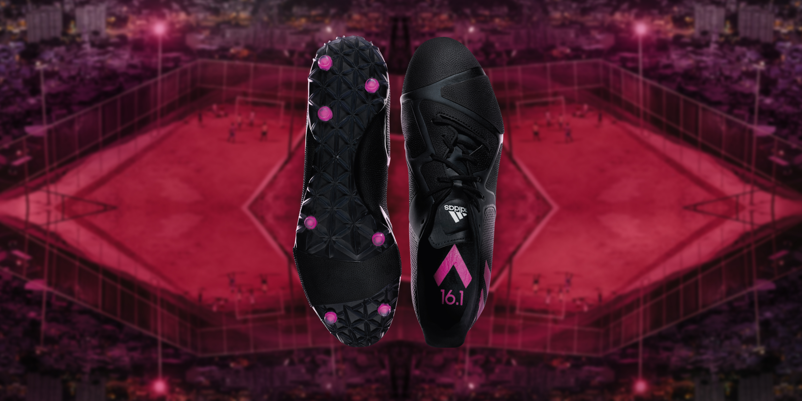
Herzogenaurach, 27th November 2015 – The ACE player is known for controlling everything. Now, with the ACE 16+ TKRZ, they can take that control off the eleven-a-side pitch to dominate the small sided game.

The ACE 16+ TKRZ is the first high performance shoe designed for the elite street footballer. Just as the eleven-a-side player craves goals or assists, the small sided player lives for pannas and akkas. This is the shoe to master the tricks needed to boss the streets, and the shoe to invent new skills for others to copy.

ACE 16+ TKRZ features a revolutionary TKRZ CTRL/FRAME outsole which brings total control to the cage. The outsole is designed for acceleration, braking and changing direction, all the tools needed to humiliate defenders.

The TKRZ skin upper offers a truer touch and purer ball connection, and uniquely wraps around the outsole for total 360 control when rolling your foot over the ball. That combined with the TKRZ compression tongue provides a lockdown fit completes the shoe, with maximum stability and comfort.

Everything from the shorter studs to the stealth launch colourway has been designed for the needs and attitudes of the player who owns the streets. ACE 16+ TKRZ was designed in collaboration with the best of the best small-sided footballers in Paris, Berlin and London, and rigorously tested to make sure it could cope with the demands of urban football.

For further information please visit adidas.com/football or go to facebook.com/adidasfootball or follow @adidasfootball on twitter to join the conversation.

- END -

For further media information please visit http://news.adidas.com/GLOBAL/PERFORMANCE/FOOTBALL or contact:

Robert Hughes  Managing Editor – Herzo Newsroom  Email: robert.hughes@adidas.com  Tel: +49/9132/84-6856 | Alan McGarrie  adidas Senior Global Football PR Manager  Email: alan.mcgarrie@adidas.com  Tel: +49/9132/84-4686
Notes to editors:
About adidas Football
adidas is the global leader in football. It is the official sponsor / official supplier partner of the most important football tournaments in the world, such as the FIFA World Cup™, the FIFA Confederations Cup, the UEFA Champions League, the UEFA Europa League and the UEFA European Championships. adidas also sponsors some of the world’s top clubs including Manchester United, Real Madrid, FC Bayern Munich, Juventus, Chelsea and AC Milan. Some of the world’s best players also on the adidas roster are Leo Messi, Gareth Bale, Thomas Müller, Luis Suárez, James Rodríguez, Diego Costa and Mesut Özil.

