EMBARGOED UNTIL TIME TBC FRIDAY 25th SEPTEMBER
BACKED BY MESSI

adidas Football looks to the future as ten of world’s best young footballers are recruited to join Team Messi

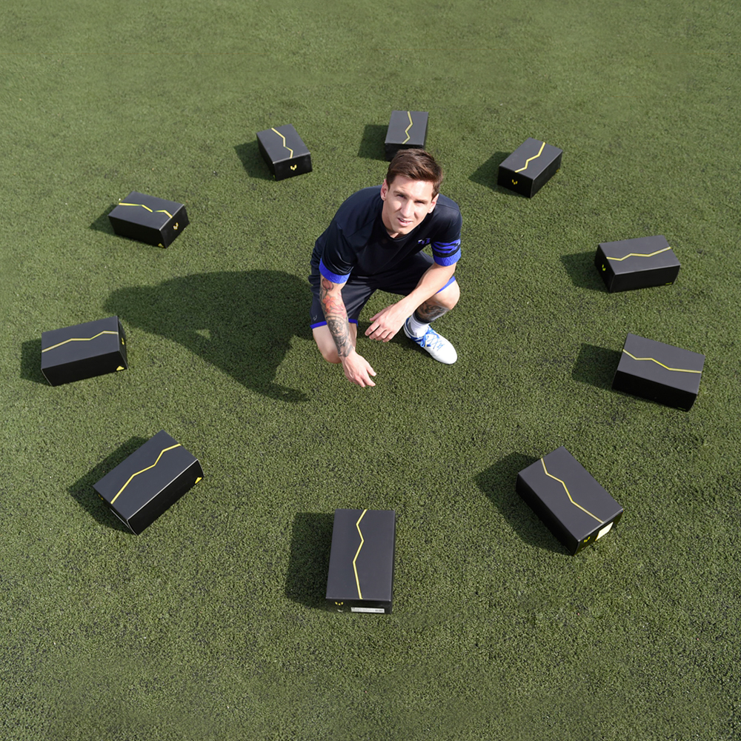

Herzogenaurach, 25th September – 2015 was a year that Leo Messi established his position as the greatest player of all time. He won the treble for the second time during his trophy laden career at Barcelona and is now widely expected to pick up the Ballon d’Or for the fifth time.

adidas, the leading brand in world football, also celebrated the magical Argentinian in 2015 by making him the first player to receive his very own boot, the Messi15. The best player of all time had the ultimate weapons, designed for his own unique style and talent.

Messi has inspired an entire generation of talented young footballers and adidas Football can today announce that ten stars of the future, playing in countries across the world have been ‘BACKED’ by Messi to become the first players to be part of Team Messi.

Team Messi is a global fan movement founded by adidas Football to celebrate Leo Messi and his standing as the greatest footballer to ever grace this planet. As part of the ‘BACKED BY MESSI’ campaign, these ten players will update the world on their progress by filming their own content for a series of episodes on the adidas Football YouTube channel.

The ten players recruited to Team Messi are:

• Robert Kenedy (Chelsea FC, Brazilian)
• Maxwell Cornet (Lyon, French)
• Jeremie Boga (Rennes [on loan from Chelsea FC], French)
• Accursio Bentivegna (Como [on loan from Palermo], Italian)
• James Wilson (Manchester United, English)
• Timo Werner (VFB Stuttgart, German)
• Aleksey Miranchuk (Lokomotiv Moscow, Russian)
• Gyasi Zardes (LA Galaxy, American)
• Marcos Lopes (AS Monaco FC, Portuguese)
• Khiry Shelton (New York City FC, American)

These players will wear Messi’s signature boot, the Messi15, in all competitions this season. To follow Team Messi subscribe to the adidas Football YouTube channel at youtube.com/adidasfootball, go to facebook.com/TeamMessi or follow @TeamMessi on twitter to join the conversation.

- END -

For further media information please visit http://news.adidas.com/GLOBAL/PERFORMANCE/FOOTBALL or contact:

Robert Hughes  Managing Editor – Herzo Newsroom  Email: robert.hughes@adidas.com  Tel: +49/9132/84-6856 | Alan McGarrie  adidas Senior Global Football PR Manager  Email: alan.mcgarrie@adidas.com  Tel: +49/9132/84-4686

Notes to editors:
About adidas Football
adidas is the global leader in football. It is the official sponsor / official supplier partner of the most important football tournaments in the world, such as the FIFA World Cup™, the FIFA Confederations Cup, the UEFA Champions League, the UEFA Europa League and the UEFA European Championships. adidas also sponsors some of the world’s top clubs including Manchester United, Real Madrid, FC Bayern Munich, Juventus, Chelsea and AC Milan. Some of the world’s best players also on the adidas roster are Leo Messi, Gareth Bale, Thomas Müller, Luis Suárez, James Rodríguez, Diego Costa and Mesut Özil.

