EMBARGOED UNTIL 10am (CET), THURSDAY 20TH AUGUST
adidas CHALLENGES CREATORS to ‘UNFOLLOW’ MESSI

Four time Ballon d’Or winner stars in new film to inspire the creators of today

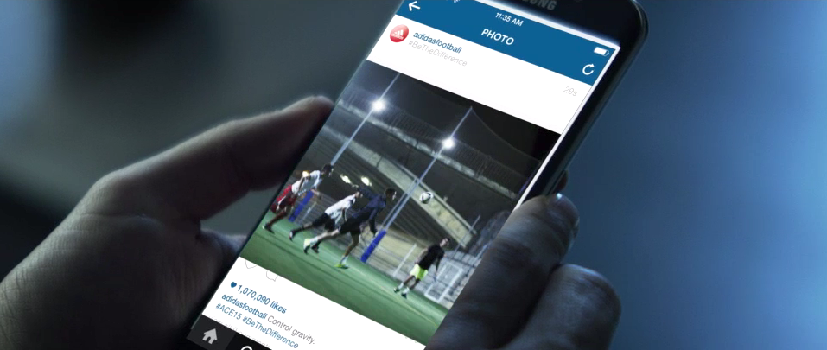

Herzogenaurach, Thursday 20th August, 2015 – Leo Messi, arguably the greatest player in the history of football, today empowered creators to make their own path and no longer follow him. ‘Unfollow’ is a new 60 second film from adidas that builds on the recent launch of ‘Create Your Own Game.’

An incredible four time winner of the Ballon d’Or, Messi, adored and followed by fans all over the world, has received the highest accolades from those both inside and outside the game. But football has changed and this film sets the scene for Messi’s challenge to the next generation of creators. To them, he is no longer a hero – he is the competition.

‘Unfollow’ is the newest chapter of Sport15, which further represents the shift in how adidas communicates as a company. In a world that is full of followers, adidas is reaching out to those who can be bold enough to stand out. The film is a call to arms for those who defy the norm. To make a difference in the changing game of today, don’t be like Leo Messi, take from him and create something new.

Driven by the brand’s mission to be the world’s best sports brand, the film is additional proof of adidas’ continued desire to revolutionise the game around the world. Sport today isn’t about standing by and watching others people’s greatness. It’s finding your own path, and removing any obstacle in the way to reach it.

To experience the new, watch ‘Unfollow’ at: http://youtu.be/uA-_HGiV6eM.

Follow youtube.com/adidas and join the conversation on Twitter @adidas or on facebook.com/adidas.

To join the football revolution visit facebook.com/adidasfootball or follow @adidasfootball #BETHEDIFFERENCE on twitter or instagram.

- END -

For further media information please visit http://news.adidas.com/GLOBAL/PERFORMANCE/FOOTBALL or contact:

Robert Hughes  Managing Editor – Herzo Newsroom  Email: robert.hughes@adidas.com  Tel: +49/9132/84-6856 | Alan McGarrie  adidas Senior Global Football PR Manager  Email: alan.mcgarrie@adidas.com  Tel: +49/9132/84-4686

Notes to editors:
About the adidas Group

The adidas Group is a global leader in the sporting goods industry, offering a broad portfolio of footwear, apparel and hardware for sport and lifestyle around the core brands adidas, Reebok, TaylorMade and Reebok-CCM Hockey. Headquartered in Herzogenaurach/Germany, the Group generated sales of € 14.5 billion in 2013 and currently employs 54,000 people across the globe, including 5,472 in Germany (as at December 31, 2014).

