adidas Outdoor footwear news spring/summer ‘16

Every terrex piece is designed without compromise and with the purpose to support athletes in order to enable them to reach their goals. The adidas Outdoor designers used the best technologies and finest materials on the market and created a range of versatile and lightweight products. Many little details and a progressive, modern look make each product stand out. The terrex range is made for everyone with unlimited imagination who wants to redefine his or her personal limits and reach new goals, no matter what he or she does – be it climbing, trail running, mountain biking, flying, kayaking or combining several activities.
#livewithoutlimits.

terrex X-KING

Mountain bike tires for your feet. Engineered together with the Continental® wheel experts, the terrex X-KING offers the ultimate grip to run on the same trails where you ride your mountain bike. Manufactured just like a tire, the Continental® rubber compound is heat-pressed directly into the upper material. Weight is reduced and you get lower to the ground. The terrex
X-KING offers everything for your perfect mountain run: light weight, protection and extraordinary grip through Continental® rubber.

Features & Benefits:

- Upper: sustainable dope-dyed mesh, colored fabric using less water, less energy and fewer chemicals than non-dope-dyed mesh
- Speed lacing construction for fast and snug lacing
- Midsole: EVA midsole for long-term cushioning
- Outsole: the Continental® rubber compound is directly molded to the upper; the lug profile design is inspired by the MTB Continental® tire X-KING
- Constructed like a mountain bike tire: lightweight, stable and with ultimate grip
- Guarantees perfect ground penetration for grip at full speed

Weight: 305g (UK 8.5)

Colors: black

Prize: € 150 (RRP)

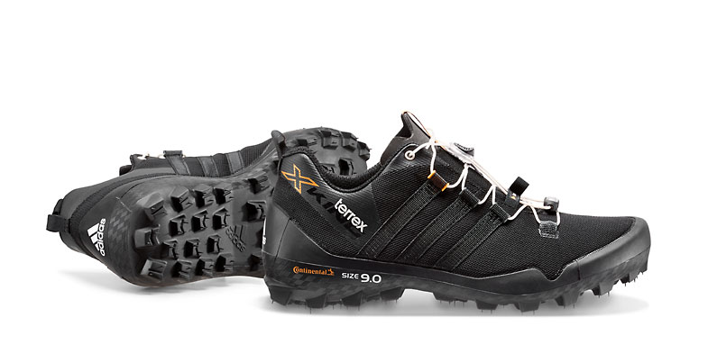
terrex Agravic
The design of the terrex Agravic is driven by pure functionality. It weighs only 315 grams for men and 275 grams for women and still offers great stability and protection for trail running. An incredible mix of several high-end technologies makes this shoe a must-have for everyone who loves to run in the mountains: The revolutionary BOOST™ cushioning technology provides more energy return than any other cushioning material in the industry. The breathable EVA tongue is part of the minimalistic and reduced design for achieving a lightweight look and feel. In addition, the Continental® rubber outsole ensures excellent grip even at the highest speeds – on dry as well as on wet ground. Another nice little detail: The lug profile was inspired by the Continental® mountain bike tire ‘Der Kaiser 2,4 Projekt’, offering optimal balance between friction and penetration.

Features & Benefits:
- Upper: Abrasion-resistant TPU-weldings for protection and single-layer EVA tongue for light weight and comfort
- Midsole: BOOST™ offers endless energy in the mountains and high adaptability on rocky surfaces, with outdoor-adjusted EVA frame for stabilizing the tooling while traversing
- Outsole: Continental® rubber for extraordinary grip
- Lug profile for optimal balance between friction and penetration: longer lugs for optimal grip on loose ground, dynamic profile for great acceleration
- Lug profile design inspired by the MTB Continental® tire ‘Der Kaiser 2,4 Projekt’

Colors men: grey/black/red // green/black // orange/black
Weight: 315g (size UK 8 1/2)

Colors women: green glow/black // blush pink/black
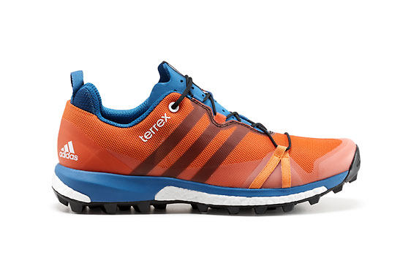
Weight: 275g (size UK 5 1/2)

Price: € 130 (RRP)
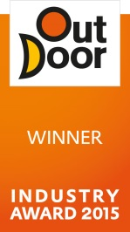
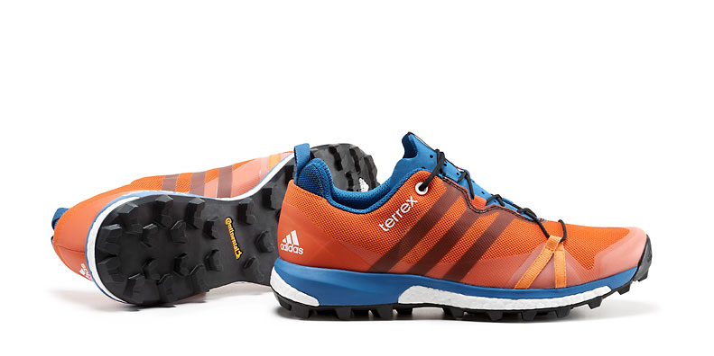
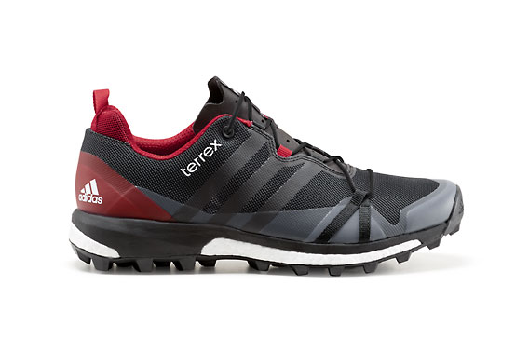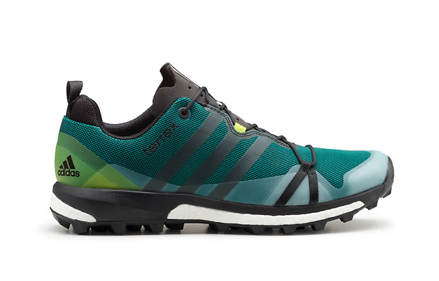
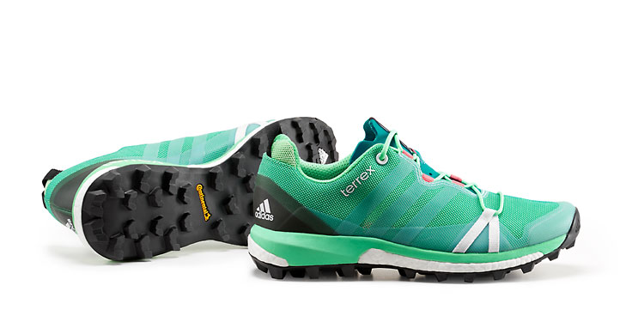
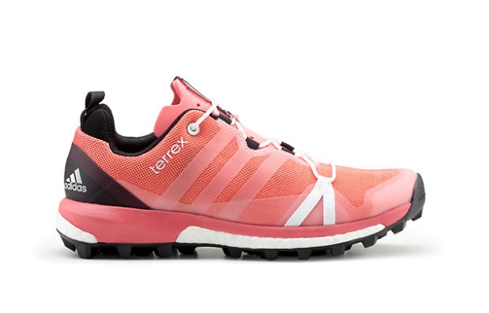
terrex Solo

The successful approach shoe terrex Solo will become more flexible and more versatile in spring/summer ‘16. The new terrex Solo keeps its Stealth® rubber outsole – the unique rubber compound that offers unbeatable grip. Its new flexibility makes the terrex Solo a great shoe for various situations such as climbing, short runs and moving fast in the mountains. One of many small details: Asymmetrical loops are fitted to the heel so that these lightweight shoes can easily be attached with a carabiner to your backpack or climbing harness to hang parallel to each other.

Features & Benefits:
- Upper: Abrasion-resistant TPU-weldings for protection and open mesh for breathability and comfort
- Lacing: Climbing-inspired lacing goes all the way back to the front for stability; lace bungee avoids the laces from getting caught on sticks and stones
- Outsole: STEALTH® rubber outsole for unbeatable grip
- Sockliner: Molded Ortholite® sockliner
- Midsole: Full forefoot adiPRENE+ for forefoot cushioning
- Asymmetric heel loop: For hanging the shoes on the harness during a climb

Colors men: blue/black // black/grey/white // green/black/orange
Weight: 335g (size UK 8 1/2)

Colors women: mineral red/black/pink // mint/black/green
Weight: 285g (size UK 5 1/2)

Price: € 120 (RRP)
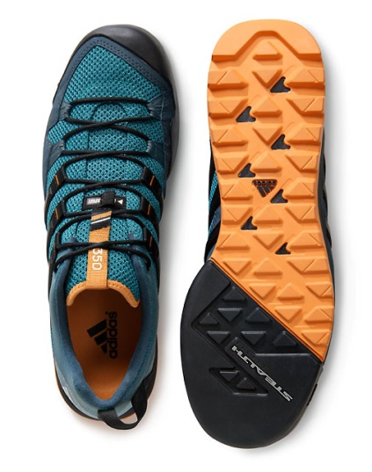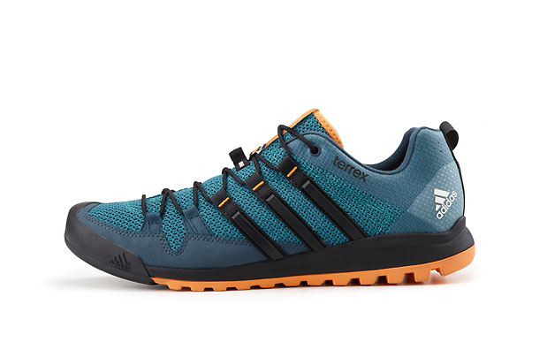
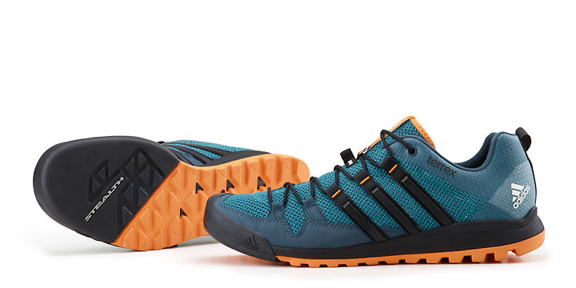
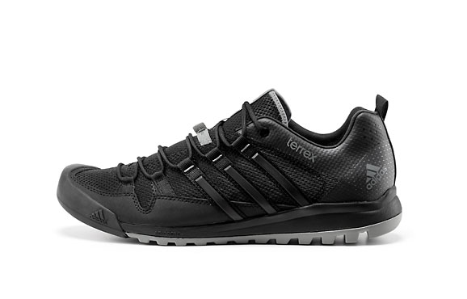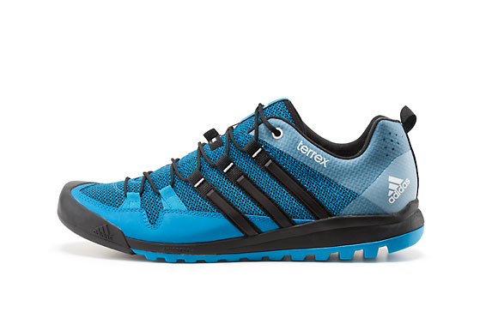
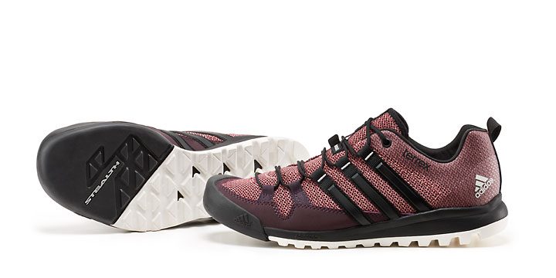
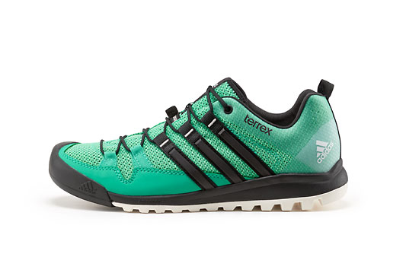

***

All images and texts will be available for free download as of July 15th 2015:
http://news.adidas.com/Global/home/OUTDOOR

For regular updates, videos and stories please follow:
www.facebook.com/adidasoutdoor
www.instagram.com/adidasoutdoor
www.youtube.com/adidasoutdoortv

Media contact:

Lena Hackforth
adidas Outdoor
Global Senior PR & Social Media Manager
+49 9132 84 4380
+49 160 884 4380 (mobile)
lena.hackforth@adidas.com

