adidas Outdoor apparel news spring/summer ‘16

Every terrex piece is designed without compromise and with the purpose to support athletes in order to enable them to reach their goals. The adidas Outdoor designers used the best technologies and finest materials on the market and created a range of versatile and lightweight products. Many little details and a progressive, modern look make each product stand out. The terrex range is made for everyone with unlimited imagination who wants to redefine his or her personal limits and reach new goals, no matter what he or she does – be it climbing, trail running, mountain biking, flying, kayaking or combining several activities.
#livewithoutlimits.

terrex Agravic 3-Layer Jacket

This is the perfect jacket for everyone who is looking for minimal pack size and maximal weather protection at the same time. With its extremely low weight (186g/size 50) and its practical pack-it pocket, it is the perfect partner for every mountain sports activity. In action, it offers everything you need to be fully protected: waterproof and durable 3-layer material, an adjustable hood and a security chest pocket. One of the favorite pieces of our athletes.

Features & Benefits:

- climaproof®: water- and windproof material for use in extreme weather conditions; water column: 20,000mm
- Adjustable hood
- Elastic waist with drawcords for adjustability
- Pack-it pocket

Colors men: black // solar red // green
Weight: 186g (size 50)

Colors women: flash pink // mineral red
Weight: 159g (size 36)

Price: € 250 (RRP)

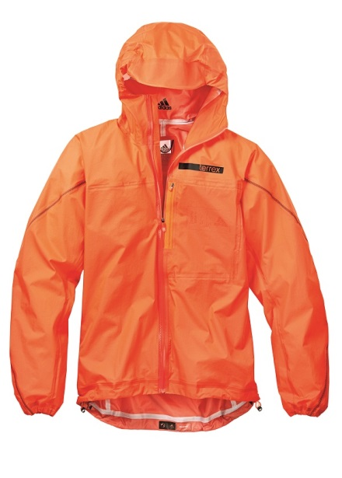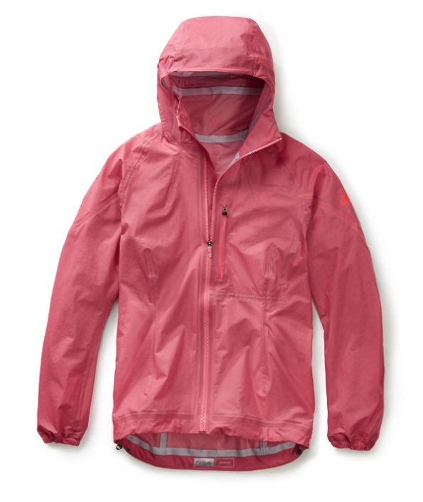
terrex Climaheat Agravic Down Jacket

The terrex Climaheat Agravic Down Jacket is an innovative insulation jacket providing best warmth to weight ratio. The highlight is the heat seal baffling construction where any other baffle is bigger ensuring the overlap of stitching lines to eliminate any cold spots. Additional heat seals at the cuffs and collar keep the warm air trapped inside the jacket. The RDS certified down filling and the Pertex Quantum® GL fabric make the jacket as light as possible. Neatly packed into its pack-it chest pocket it is the perfect companion on any outdoor activity on colder days.

Features & Benefits:

- Heat seal baffling: every other baffle covers stitching lines, eliminating cold spots through overlap
- Heat seals: at the cuffs, collar and hem to keep the warmth inside the jacket
- Pertex Quantum® Gl: lightweight and strong while offering good Durable Water Repellency (DWR)
- RDS certified filling: 90/10 goose down with 800 fillpower
- Adjustable hood
- Elastic waist with drawcords for adjustability
- Pack-it pocket

Colors men: clear grey // night cargo
Weight: 305g (size 50)

Colors women: raw ochre // clear grey

Weight: 285g (size 36)

Price: € 300 (RRP)
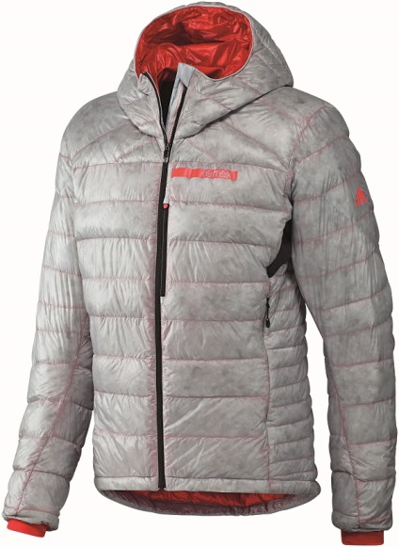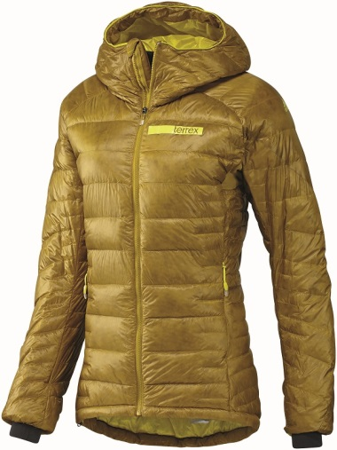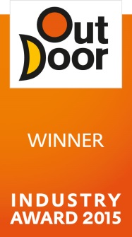
terrex Agravic Hybrid Softshell Jacket

The terrex Agravic Hybrid Softshell Jacket is a light and versatile newcomer in the spring/summer 2016 terrex range. It offers good protection in windy and light rainy conditions thanks to the Gore WINDSTOPPER® active shell. Its hybrid construction with Pertex® Equilibrium at the areas of the body producing the most heat ensures great breathability and excellent moisture transport away from the skin. Its adjustable hood and elastic sleeve cuffs guarantee a perfect fit and great comfort. One of many small details: you can store the jacket in its pack-it chest pocket.

Features & Benefits:

- Gore WINDSTOPPER® active shell: 100% windproof fabric offers maximum breathability and water resistance for high-intensity activities
- Pertex® Equilibrium: fabric that transports moisture mechanically away from the skin to the environment, where it evaporates
- Adjustable hood
- Adjustable hem and elastic sleeves: for light weight and great comfort
- Pack-it pocket

Colors men: black // midnight blue // ochre
Weight: 210g (size 50)

Colors women: black // green
Weight: 200g (size 36)

Price: € 220 (RRP)

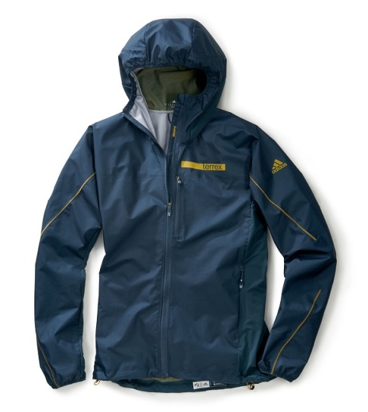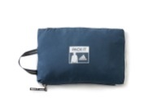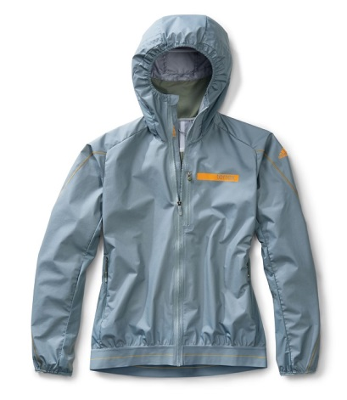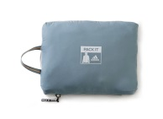
terrex Skyclimb Alpha Jacket

The terrex Skyclimb Alpha Jacket is an active insulation jacket offering the advantages of Polartec® Alpha® technology. While keeping you warm like a thick fleece when you are not in motion, it won’t let you overheat during high-pulse activities. It provides an extremely good body climate through breathability and moisture management and at the same time keeps you warm when needed. With this piece you don’t need to change clothes during on and off activities, which means less weight and less to carry while ski touring or mountaineering.

Features & Benefits:

- Polartec® Alpha®: provides warmth while remaining lightweight; offers superior body climate regulation
- Raglan sleeve construction: guarantees maximum comfort and freedom of movement; moisture wicking mesh lining offers a pleasant next-to-skin feeling
- Pre-shaped sleeves
- Printed padding with translucent overlay creates unique optic

Colors men: orange // grey // black
Weight: 438g (size 50)

Color women: grey
Weight: 407g (size 36)

Price: € 200 (RRP)

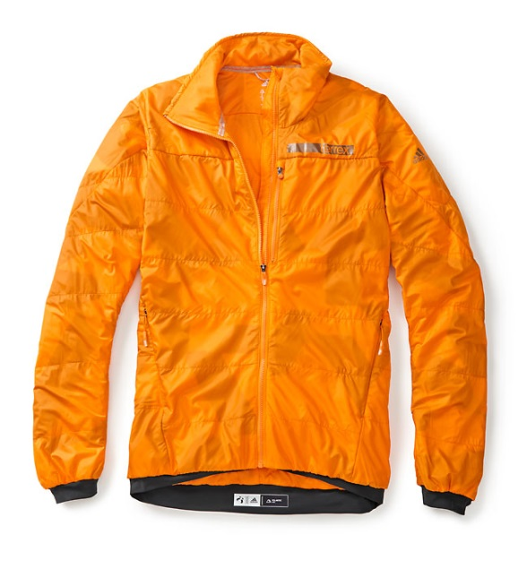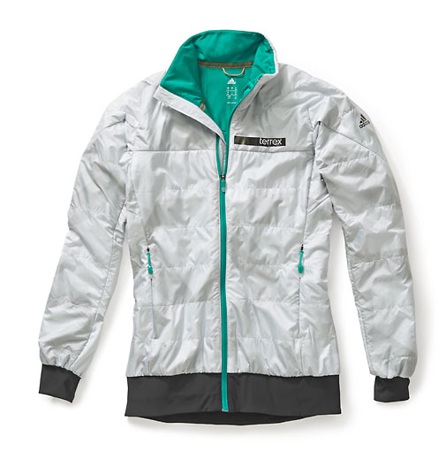
terrex Agravic PrimaLoft Jacket

Looking for a light, easy-care and packable all-year insulation jacket? Then this is your jacket of choice. It’s the ideal companion for ski touring, mountaineering and biking. The special highlight: a stitched pattern with reflective yarn that gives you 360° visibility in the dark. It soon became one of the favorite pieces of our athletes and product testers.

Features & Benefits:

- Primaloft® Gold: ultra-fine microfiber insulation that is warm, soft and lightweight in combination with superior water resistance
- Pertex Quantum® Gl: lightweight and strong while offering good Durable Water Repellency (DWR)
- Pertex Microlight®: soft and lightweight fabric guarantees high resistance against abrasion
- Reflective all-over stitching: the special design and the reflective yarn guarantee better visibility of the jacket
- Pack-it pocket
- Stab stitch
- Elastic cuffs on sleeves and lower hem

Colors men: black // green
Weight: 315g (size 50)

Colors women: black // green
Weight: 260g (size 36)

Price: € 200 (RRP)
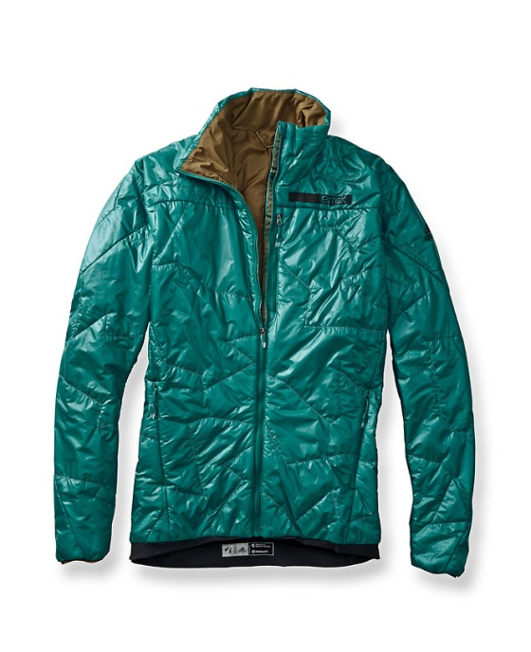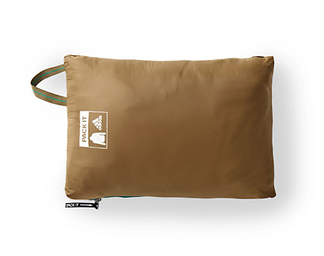

terrex Agravic Wind Jacket

A handful of jacket. It is super-small and it is super-light (105g). You don't even need a backpack to carry this jacket, it fits into every pocket. The terrex Agravic Wind Jacket is the ideal companion whenever the weather turns bad or you just need some more protection. It is minimalistic, but still offers everything you need to be well protected from wind and light rain. And for those who also want to look good and hang around in this jacket, it offers a silky soft material feel and has a modern, athletic look.

Features & Benefits:

- climastorm: provides protection in windy and light rain conditions
- Durable Water Repellency (DWR): sheds rain and snow, quick-drying
- Adjustable hood
- Zipped chest pocket
- Elastic parts at the hem for optimum comfort

Colors men: beige // black
Weight: 105g (size 50)

Colors women: gold // flower pink
Weight: 90g (size 36)

Price: € 150 (RRP)

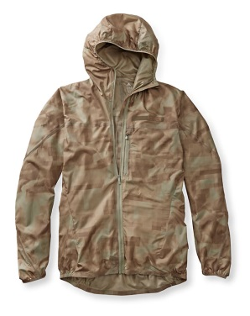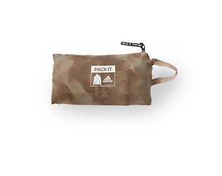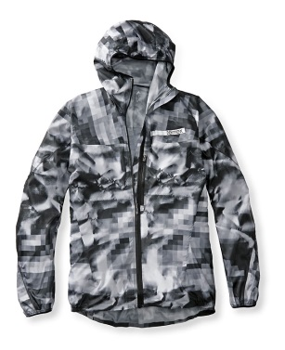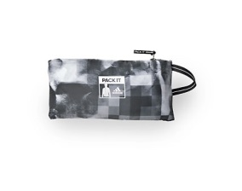
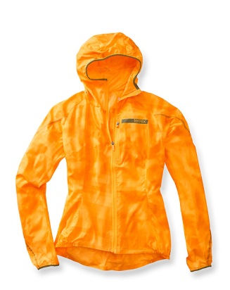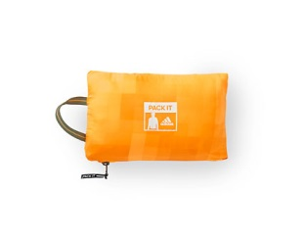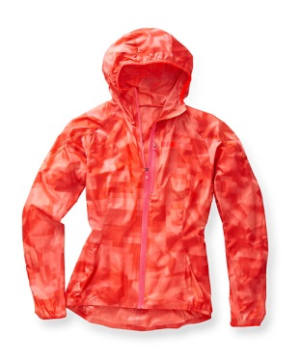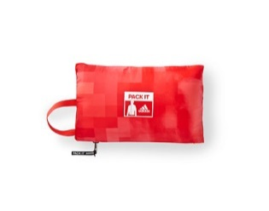
terrex Skyclimb Top

Do more with less. The terrex Skyclimb Top was created to do the job of three garments in just one piece. It is an ideal base layer, using the best-performing Polartec® Power Dry® High Efficiency fabric. It also functions as a mid-layer, using Polartec® Alpha® insulation, and it features an overlay of the lightest Pertex Equilibrium® adding the function of a windproof vest. All these fabrics have extraordinary mechanical wicking properties to ensure the highest level of comfort in a wide range of activities and weather scenarios. The placements of these fabrics make the top a perfect lightweight, versatile piece for fast-forward mountain sports activities.

Features & benefits:

- Polartec® Power Dry® High Efficiency: keeps your skin dry when sweating, dries quickly and feels comfortable next to the skin
- Polartec® Alpha®: combination of lightweight warmth and true breathability that provides warmth even when wet and dries quickly
- Pertex Equilibrium®: overlayer for additional wind protection. Moisture is transported away from the skin to the outside of the fabric where it evaporates
- Hybrid construction combining the advantages of different performance fabrics. It allows highest breathability and moisture management while offering warmth during low-activity times
- FORMOTION® cut: guarantees unrestricted freedom of movement and athletic fit at the same time
- ½ zip at front part of the mid-layer

Colors men: dark grey // raw ochre
Weight: 205g

Colors women: bright yellow // dark grey
Weight: 177g (size36)

Price: € 150.00 (RRP)

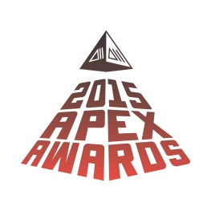
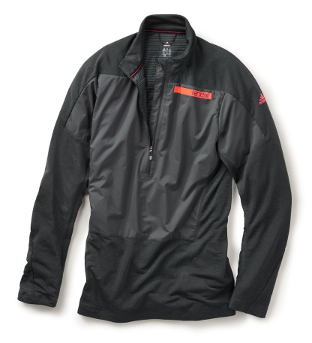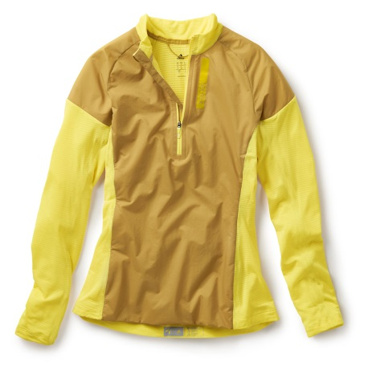
terrex Agravic Tee

Everybody who is into mountain running or other endurance mountain sports would most likely prefer a base layer with a pleasant skin feel that transports sweat away from the body and does not smell. The terrex Agravic Tee with a mix of 50% Merino wool and 50% ThermoCool polyester offers exactly that. The used raglan sleeve construction provides full freedom of movement. This makes this tee very comfortable also when wearing under a backpack.

Features & Benefits:

- Pontetorto® Merino Tecnowool: 50% Merino wool / 50% ThermoCool hollow-fiber polyester; finest, softest base layer fabric that absorbs moisture without a clammy feeling and insulates the body even when wet
- Light, seam-reduced base layer shirt with excellent next- to-skin feel

Colors men: midnight blue // ochre
Weight: 120g (size 50)

Colors women: earth // flower pink
Weight: 90g (size 36)

Price: € 80 (RRP)

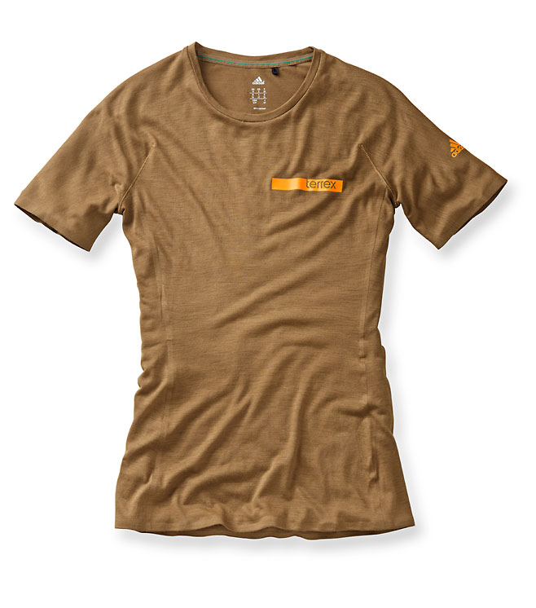
terrex Climachill Solo Bigwall Long Sleeve

The terrex Climachill Solo Bigwall Long Sleeve is inspired by our athletes and ideal for big-wall climbing. It has integrated techfit™ compression sleeves at the forearm that support the arm muscles and help them to regenerate faster. The other parts of this base layer are made out of climachill™ material. climachill™ ensures premium ventilation as well as great moisture and cooling management. This is achieved through 3-D cooling aluminum spheres on microfiber fabric and titanium yarns. They are positioned at the warmest areas of the body so the heat is drawn away faster.

Features & Benefits:

- climachill™: premium ventilation, moisture management and incredible cooling effect through 3-D aluminum spheres on microfiber fabric and titanium yarns.
- FORMOTION®: ultimate performance and comfort while in motion, guarantees unrestricted freedom of movement and an athletic fit at the same time
- Compression sleeves: for improved regeneration of forearm muscles
- Half-zip: provides adjustable ventilation during intense activities

Colors men: white-black // green-black
Weight: 215g (size 50)

Color women: white-black
Weight: 160g (size 36)

Price: € 70 (RRP)
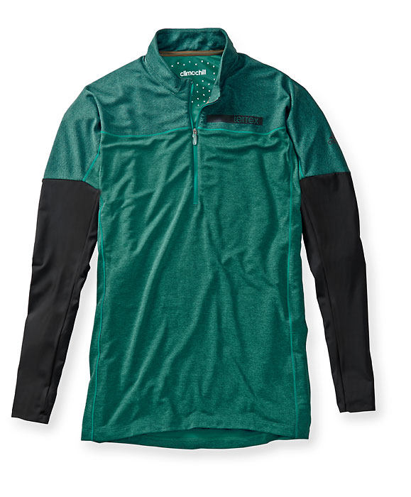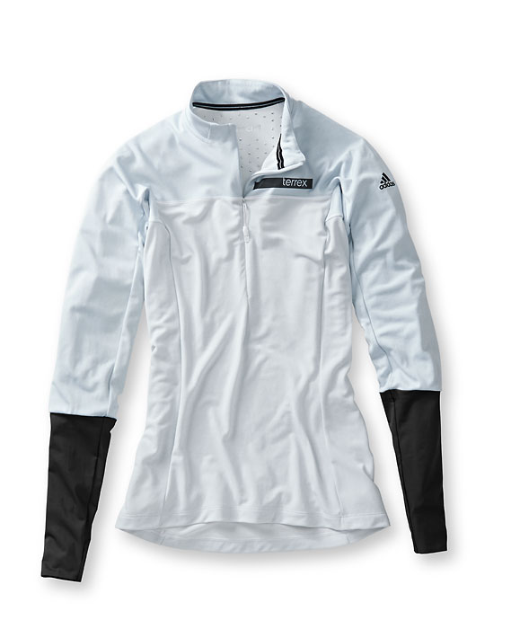
terrex Climachill Agravic ½ Zip Tee

The terrex Climachill Agravic ½ Zip Tee is made of climachill™ material that ensures premium ventilation as well as great moisture and cooling management. This is achieved through 3-D cooling aluminum spheres on microfiber fabric and titanium yarns. They are positioned at the warmest areas of the body so the heat is drawn away faster. This lightweight and highly functional tee is for those who are looking for a high-quality and high-performance base layer for outdoor activities.

Features & Benefits:

- climachill™: premium ventilation, moisture management and incredible cooling effect through 3-D aluminum spheres on microfiber fabric and titanium yarns
- Baby flatlock seams: seam-reduced base layer offers superior look and maximum comfort while moving
- Half-zip: provides adjustable ventilation during intense activities

Colors men: grey // green // white
Weight: 120g (size 50)

Colors women: white // dark red // green
Weight: 120g (size 36)

Price: € 60 (RRP)

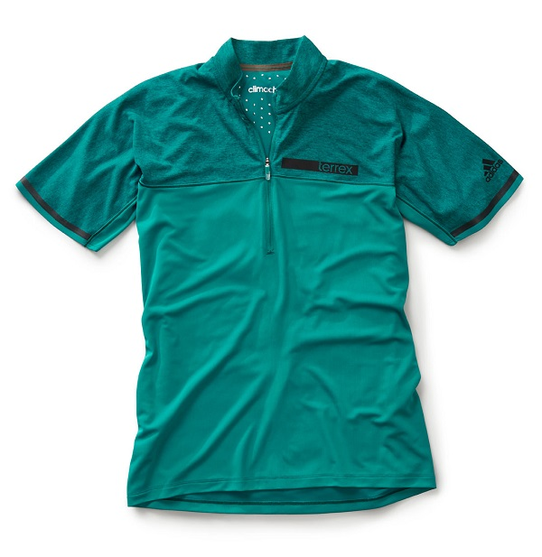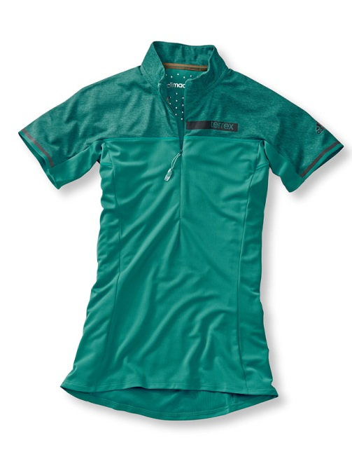
terrex Solo Tee

Combining comfort and functionality, the terrex Solo Tee is a versatile piece for any activities in the mountain, be it mountaineering, climbing or biking. The quick-drying tee is made of a Merino wool blend, which combines the natural advantages of Merino wool with the functionality of synthetic fibers.

Features & Benefits

- Baby flatlock seams: seam-reduced base layer offers superior look and maximum comfort while moving
- Bonded seams: sleeves and hem include 6mm soft tape for minimalistic look and to avoid irritation on skin
- Merino wool blend: combination of the natural advantages of wool with the functionality of synthetic fibers

Colors men: yellow-blue // earth // bright yellow-ochre
Weight: 130g (size 50)

Price: € 50 (RRP)

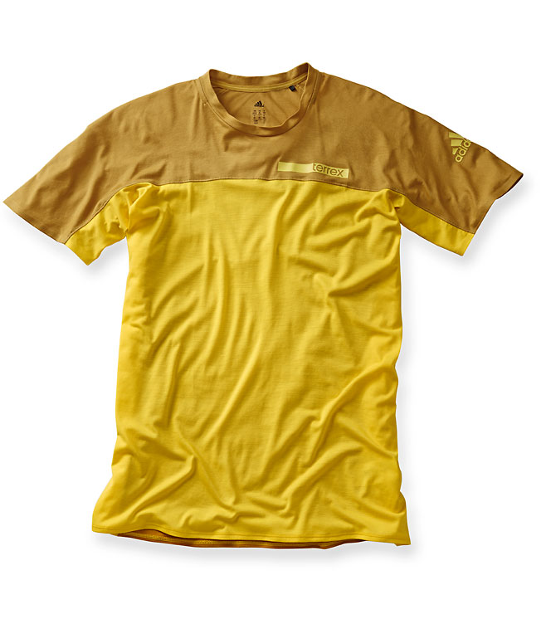
terrex W Solo Top

The terrex W Solo Top is a modern, lightweight and quick-drying top made of a Merino wool blend. This Merino wool blend combines the natural advantages of Merino wool with the functionality of synthetic fibers. The terrex W Solo Top is a must-have piece for active women in the mountains, combining comfort, style and functionality.

Features & Benefits:

- Baby flatlock seams: reduced base layer offers superior look and maximum comfort while moving
- Bonded seams: sleeves and hem incorporate 6mm soft tape for a minimalistic look and to avoid skin irritation
- Merino wool blend: combines the natural advantages of wool with the functionality of synthetic fibers

Colors: white // gold yellow
Weight: 88g (size 36)

Price: € 50 (RRP)

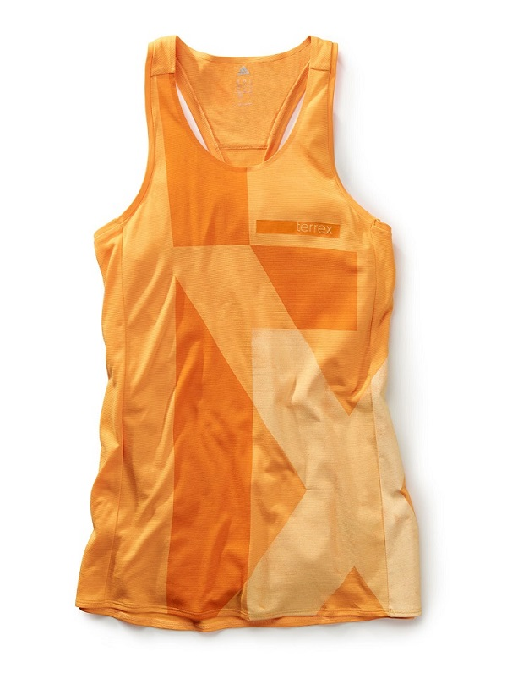
terrex Agravic 3-Layer Pants

The terrex Agravic 3-Layer Pants are extremely lightweight and waterproof mountain pants with great freedom of movement. Small and packable in the built-in pack-it pocket, they easily fit into every backpack. When the weather turns bad, they provide full rain and wind protection. Among their thought-through details are full-length zippers to ensure ease of entry and exit without the need of taking off your boots.

Features & Benefits:

- climaproof®: water- and windproof material for use in extreme weather conditions; water column: 20,000mm
- Full-length zippers to ensure ease of entry and exit
- Pack-it pocket
- Hook-and-loop adjustable waist

Color men: black
Weight: 229g (size 50)

Color women: black
Weight: 198g (size 36)

Price: € 200 (RRP)
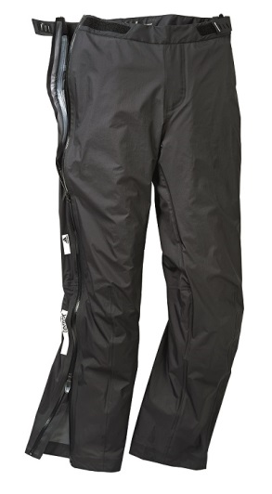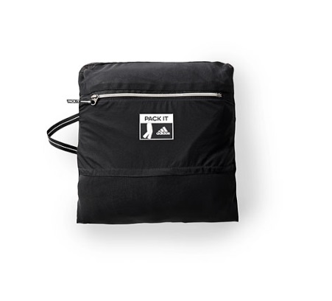
terrex TechRock Summer Pants

The terrex TechRock Summer Pants are made of wind resistant Softshell fabric with durable water-repellent finish. They are very abrasion-resistant and provide great freedom of movement when you are climbing, riding your bike, mountaineering or just taking an afternoon hike. The pre-shaped knees, the stretch gusset construction and the bum design make these pants a versatile item for all outdoor activities.

Features & Benefits:

- Pre-shaped knees and bum: guarantees great freedom of movement and less skin irritation
- Elastic waistband with belt loops: provides adjustable and comfortable fit
- Stretch gusset construction: offers enhanced freedom of movement
- Security thigh and back pocket: for safe storage of your belongings

Colors men: midnight blue // bright yellow
Weight: 410g (size 50)

Price: € 150 (RRP)

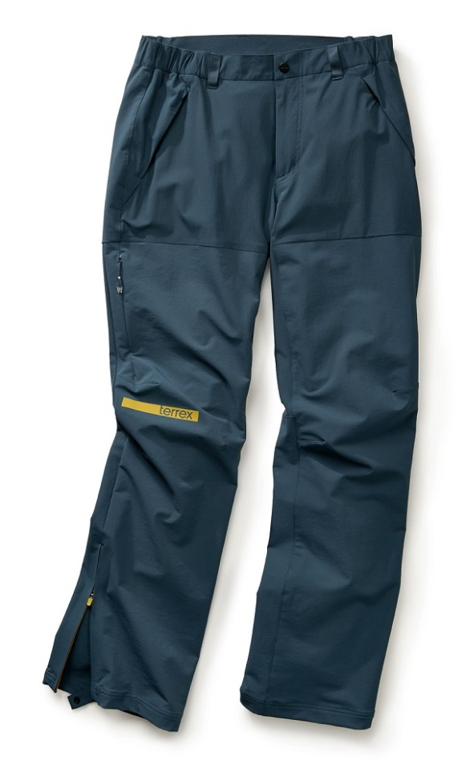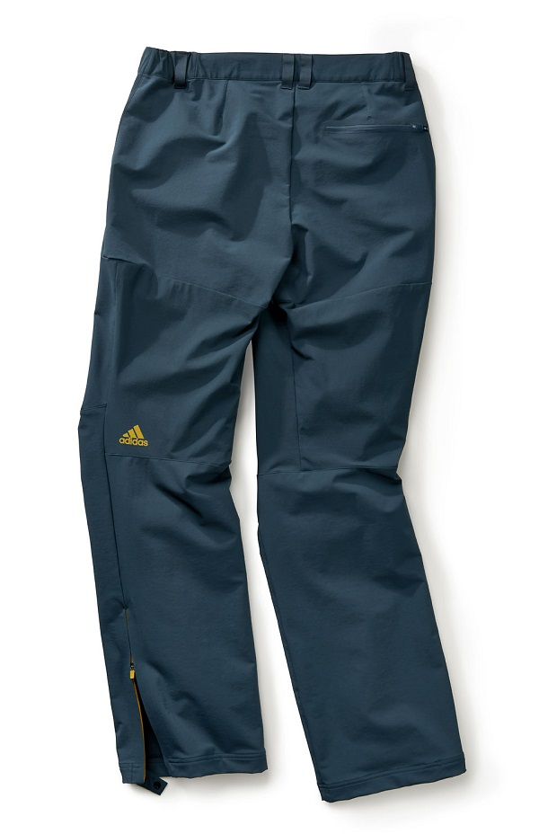
terrex Solo Pants

Looking for durable, good-looking climbing pants with great freedom of movement? Then the terrex Solo Pants with wind-resistant Softshell material are the right choice for you. The water-repellent finish will keep you dry in light rain conditions.

Features & Benefits:

- Elastic waistband: provides great freedom of movement and comfort
- Two hand pockets and two security back pockets: offer clean, casual look and keep your belongings safe during your activities
- Y-shape: elastic fabric at back for a superior fit

Colors men: beige // ochre
Weight: 325g (size 50)

Price: € 90 (RRP)

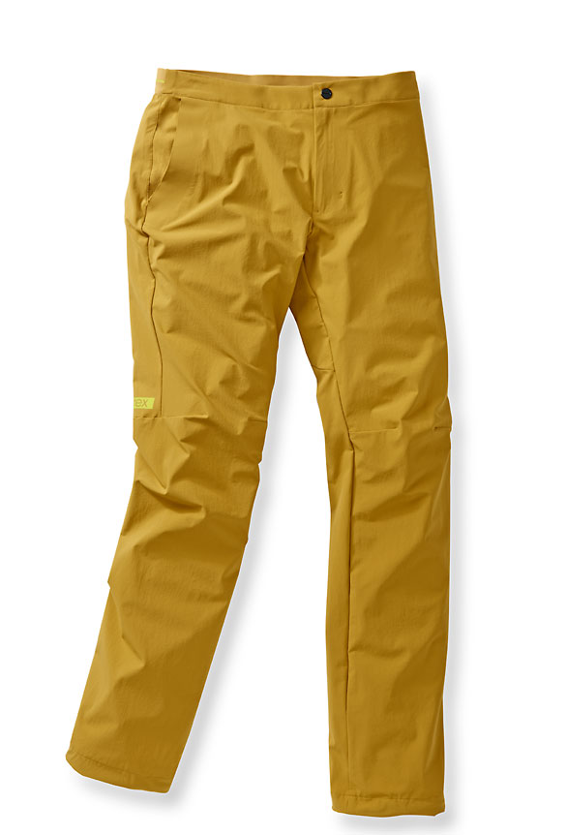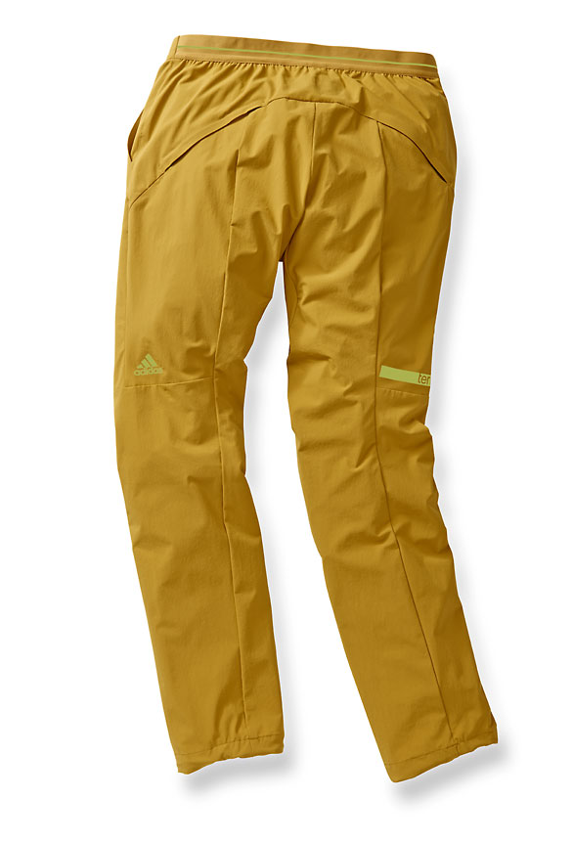

terrex Endless Mountain Bermudas

The terrex Endless Mountain Bermudas are lightweight and flexible Softshell shorts made out of recycled polyester. Created for various mountain and outdoor activities the shorts come along with a modern style.

Features & Benefits:

- climalite®: provides excellent breathability and comfort
- Durable Water Repellency (DWR): sheds rain and snow, quick-drying
- Elastic waist
- Zipped back pocket
- Mesh gel pocket in the back
- Recycled polyester
- Double-weave 4-way stretch
- Bonded seams

Colors men: black // white-black // yellow-ochre
Weight: 130g (size 50)

Colors women: white-black // gold // black
Weight: 117g (size 36)

Price: € 100 (RRP)

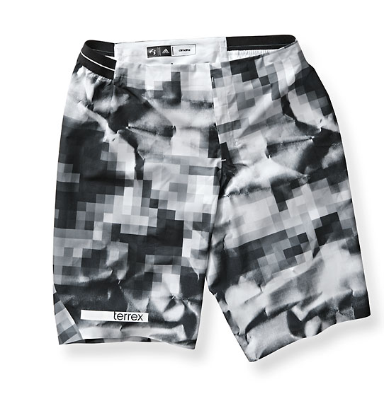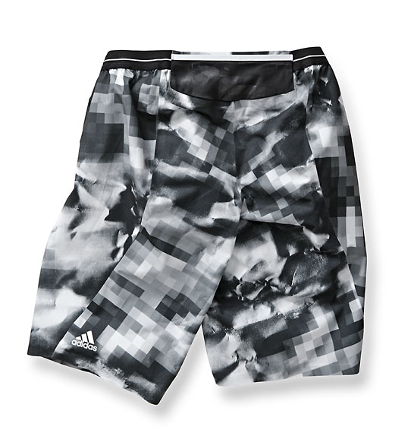
terrex Solo Shorts

The extremely comfortable terrex Solo Shorts are a new addition to the Solo family of terrex products. They are made of highly stretchable and wind-resistant Softshell fabric. Their well thought-through design ensures multi-purpose usage and allows perfect freedom of movement.

Features & Benefits:

- Elastic waistband: provides great freedom of movement and comfort
- Hidden zip back pocket: offers a clean, casual look and keeps your belongings safe during your activities
- Y-shape: elastic fabric at back for superior fit

Colors men: orange // midnight blue
Weight: 205g (size 50)

Colors women: green earth // mineral red
Weight: 150g (size 36)

Price: € 60 (RRP)
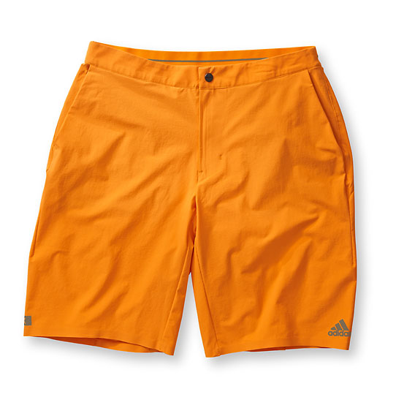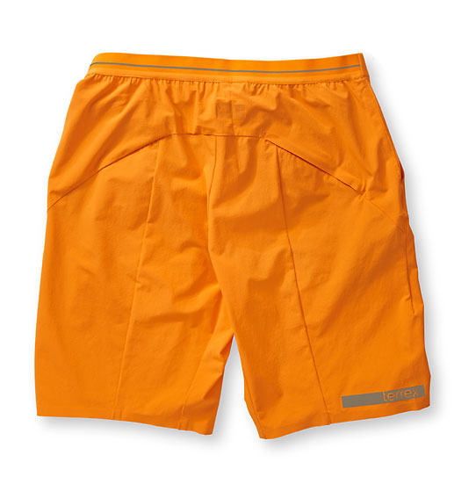
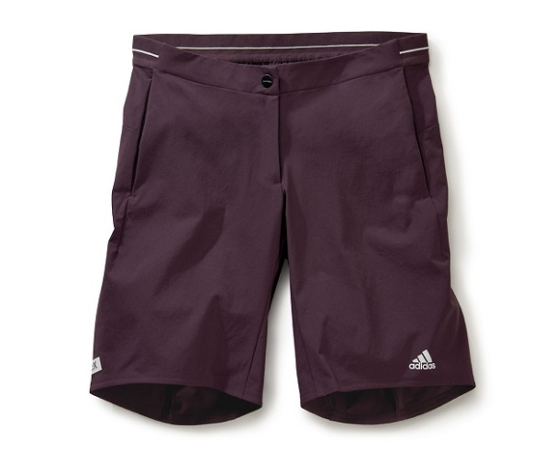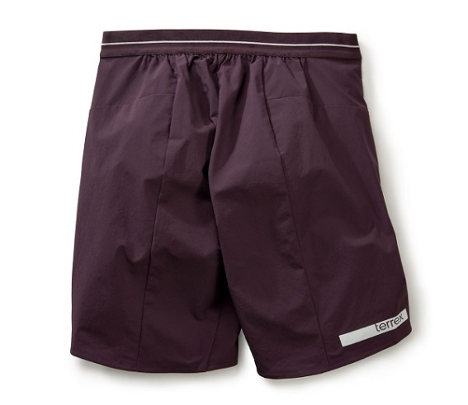

***

All images and texts will be available for free download as of July 15th 2015:
http://news.adidas.com/Global/home/OUTDOOR

For regular updates, videos and stories please follow:
www.facebook.com/adidasoutdoor
www.instagram.com/adidasoutdoor
www.youtube.com/adidasoutdoortv

Media contact:

Lena Hackforth
adidas Outdoor
Global Senior PR & Social Media Manager
+49 9132 84 4380
+49 160 884 4380 (mobile)
lena.hackforth@adidas.com

