EMBARGOED UNTIL 1600hrs CET, WEDNESDAY 3rd JUNE
ADIDAS REVEALS THE CONEXT15 FINAL VANCOUVER: THE OFFICIAL MATCH BALL FOR THE FINAL OF THE FIFA WOMEN’S WORLD CUP CANADA 2015™

Herzogenaurach / Vancouver, 3rd June – adidas has proudly revealed the key products set to grace women’s football this summer. As a leading supporter of the women’s game globally, adidas has for the first time produced a bespoke Official Match Ball to be used in the Final of the FIFA Women’s World Cup Canada 2015™. In addition, the brand has also unveiled a specially produced set of football boots to be unleashed on the field during the tournament.

The Conext15 Final Vancouver Official Match Ball

The Conext15 Final Vancouver Official Match Ball bears the vibrant red of tournament hosts Canada, combined with a gold trim representing the Final match to be held on Sunday 5th July in Vancouver.

The ball itself continues the same ground-breaking technology that was used so successfully in Brazuca, the Official Match Ball of the 2014 FIFA World Cup Brazil™. This technology went through a thorough testing process over a two and a half year period involving more than 600 of the world's top players and 30 teams in 10 countries across three continents, making it the most tested ball ever by adidas and ensuring that it is suited to all conditions.

For the 51 group stage and knock out games to be played during the tournament prior to the Final, adidas has produced the previously revealed Conext15 Official Match Ball. The Conext15 Final Vancouver will be reserved for the Final match only.

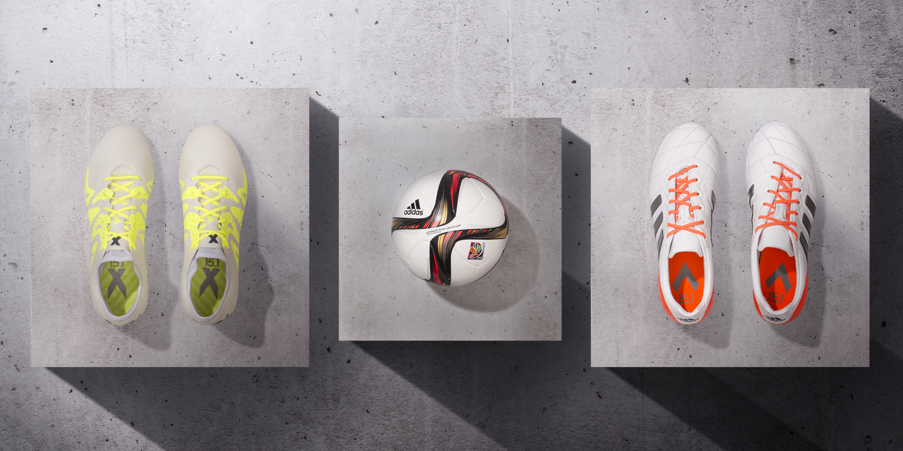
The new adidas X15 and ACE15 boots for the FIFA Women’s World Cup Canada 2015™ and Conext15 Final Vancouver Official Match Ball

From a footwear point of view, adidas has launched specially produced women’s boots to be worn during the FIFA Women’s World Cup Canada 2015™. This is the first time the brand has launched boots specifically for use during the FIFA Women’s World Cup.

adidas recently unleashed a revolution in football with the launch of the new X15 and ACE15, new silos specifically designed for the two types of player that exist in today’s game – the gamechanger and the playmaker.

Different to the men’s boots, both women’s boots will appear in exclusive new colourways for the FIFA Women’s World Cup Canada 2015™. While the colourways have changed, the revolutionary product benefits of the men’s shoes remain:

- The ACE15 shoe, worn by players such as Morgan Brian (USA) and Aya Miyama (Japan), is developed for the playmaker that controls the game and rules everything. The product innovations designed for this player include the new ground control outsole and stud alignment allowing complete control and the heelfit developed for the best fit. For women, control and touch is vital, so this version of the ACE15 is made of leather, to provide the most comfortable touch and control of the ball.

- The new X15 shoe, worn by players such as Jonelle Filigno (Canada) and Becky Sauerbrunn (USA), is developed for the gamechanger who destroys order and creates chaos. The unique features include the X-Cage, a new X-Claw stud alignment and the NSG grain across the shoe allowing optimum grip. The techfit collar gives an extremely supportive compression fit around the ankle.

To learn more about the limited edition boots, visit http://youtu.be/GEKMOUX2m-s

adidas will provide kits to 6 of the leading federations at the FIFA Women’s World Cup Canada 2015™. These include current FIFA Women’s World Cup™ holders Japan and two time winner Germany. Those teams will join Sweden, Spain, Colombia and Mexico in wearing the latest in adidas kit technology in Canada.

For further information please visit adidas.com/bethedifference or go to facebook.com/adidasfootball or follow @adidasfootball #BeTheDifference on twitter to join the conversation.

- END -

For further media information please visit http://news.adidas.com/GLOBAL/PERFORMANCE/FOOTBALL or contact:

Robert Hughes  adidas Global Football PR Director  Email: robert.hughes@adidas.com  Tel: +49/9132/84-6856 | Alan McGarrie  adidas Senior Global Football PR Manager  Email: alan.mcgarrie@adidas.com  Tel: +49/9132/84-4686

Notes to editors:
About adidas Women’s Football

adidas is the global leader in women’s football. It is the official sponsor / official supplier partner of the most important women’s football tournaments in the world, such as the FIFA Women’s World Cup™, the UEFA Women’s Champions League, and the UEFA Women’s European Championships. adidas also sponsors some of the world’s top women’s clubs including current UEFA Women’s Champions League holders FFC Frankfurt; and federations including current FIFA Women’s World Cup™ holders Japan and two time winner Germany. Female players also on the adidas roster are Verónica Boquete (Spain), Morgan Brian (USA), Jonelle Filigno (Canada), Vivianne Miedema (Netherlands), Aya Miyama (Japan) and Becky Sauerbrunn (USA).

