EMBARGOED UNTIL 0900hrs CET, MONDAY 1st JUNE
BOOTS MADE FOR THE GREATEST OF ALL TIME

adidas reveals Leo Messi’s boots for the
UEFA Champions League Final

Herzogenaurach, 1st June – The game has changed. adidas has identified that there are only two types of player - those that cause chaos and those that control the game. There is only one exception. One exceptional player. The player that can’t be defined because he transcends the game. The greatest player of all time: Leo Messi.

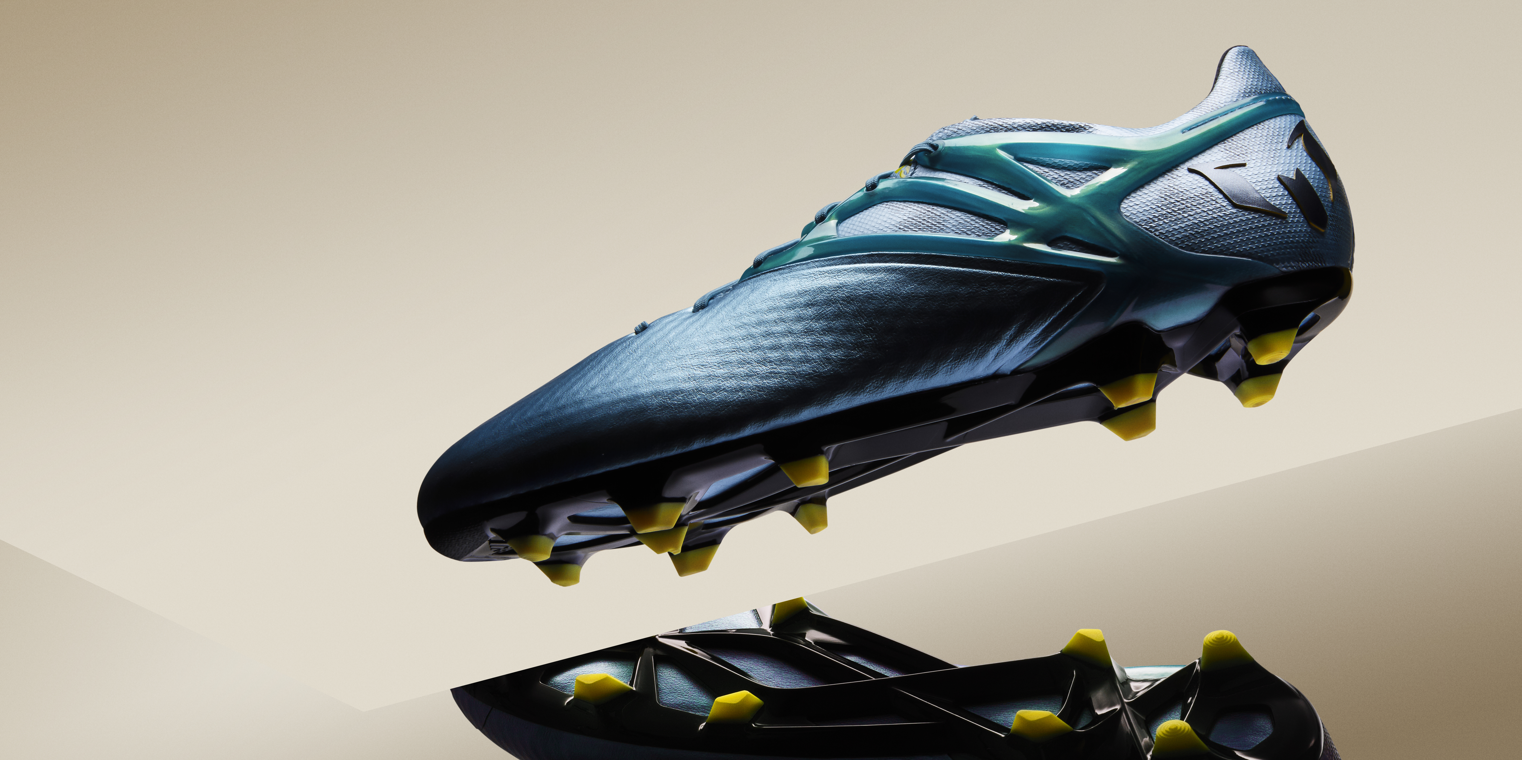
The adidas MESSI15

Ahead of this weekend’s UEFA Champions League Final in Berlin, adidas has delivered a unique pair of boots that serve Leo Messi’s unique talents. With unmatched skill and uncontrollable ability, he needs the ultimate weapon on his feet. That’s why adidas has created a silo designed solely with one player in mind. Revolutionary boots for the greatest of all time.

2015 has unquestionably been the year of Leo Messi. The Argentinian has swept aside all before him this year, and this weekend he will attempt to win the UEFA Champions League for a fourth time. When Messi takes the field in Berlin, looking to further cement his place as the greatest of all time, he will do so wearing boots designed to make the most of his brilliance.

The adidas MESSI15

The adidas MESSI15 has been designed with Leo Messi himself to maximise his unmatched talent. A selection of totally new product innovations makes this the perfect weapon for the Argentinian. The new messiTOUCH material which makes up the upper has an x-ray surface for lethal grip, stability and foot-fitting comfort. The unique new messiFRAME provides a locked-in fit, stability and maximum traction. The messiPRINT offers new, round forefoot studs, which alongside the messiGAMETRAX combine to provide a dynamic stud configuration and outsole that delivers explosive movement for the dynamic player.

Leo Messi, the best player in the world, will wear the adidas MESSI15 for the first time at the UEFA Champions League Final in Berlin on Saturday 6th June. For further information please visit adidas.com/bethedifference or go to facebook.com/adidasfootball or follow @adidasfootball #BeTheDifference on twitter or instagram to join the conversation.

- END -

For further media information please visit http://news.adidas.com/GLOBAL/PERFORMANCE/FOOTBALL or contact:

Robert Hughes  adidas Global Football PR Director  Email: robert.hughes@adidas.com  Tel: +49/9132/84-6856 | Alan McGarrie  adidas Senior Global Football PR Manager  Email: alan.mcgarrie@adidas.com  Tel: +49/9132/84-4686

Notes to editors:
About adidas Football

adidas is the global leader in football. It is the official sponsor / official supplier partner of the most important football tournaments in the world, such as the FIFA World Cup™, the FIFA Confederations Cup, the UEFA Champions League, the UEFA Europa League and the UEFA European Championships. adidas also sponsors some of the world’s top clubs including Real Madrid, FC Bayern Munich, AC Milan, Flamengo and Chelsea. Some of the world’s best players also on the adidas roster are Leo Messi, Gareth Bale, Thomas Müller, Luis Suárez, James Rodríguez, Diego Costa and Mesut Özil.

