adidas Outdoor apparel fall/winter ‘15

In fall/winter ’15, adidas Outdoor will continue its new direction for terrex. Several new versatile and lightweight winter products will be added to established key products. They are made without compromise, with the finest materials and always with the purpose of supporting athletes. The new terrex range is made for athletes with unlimited imagination who want to constantly redefine their limits and set new targets – no matter how they explore the outdoors in winter: climbing, skiing, running, biking or flying.

Product Overview
terrex TechRock GTX Jacket
terrex TechRock Climaheat Jacket or terrex Arctic Hero Jacket
terrex TechRock Climaheat Hooded Fleece
terrex TechRock Winter Pant
terrex Agravic PrimaLoft Jacket
terrex Agravic PrimaLoft Vest
terrex Agravic PrimaLoft Short
terrex Skyclimb Insulation Jacket
terrex Skyclimb Insulation Vest
terrex Skyclimb Top
terrex Skyclimb Pant
terrex IceSky Longsleeve
terrex Radical Crew Jacket
terrex Skyrunning Pant
terrex WoolBlaze Short Sleeve Tee

terrex TechRock GTX Jacket
This high-end, waterproof and breathable 3-layer Gore-Tex® Pro Shell Jacket was created to protect its user in extremely rough conditions. Combining maximum protection with packability and light weight, it is the jacket of choice for ice climbers and mountaineers. With extra attention on the pattern the terrex TechRock GTX Jacket guarantees unrestricted freedom of movement and an athletic fit at the same time.

Features & benefits:

- Material: 3-layer Gore-Tex® Pro Shell
- Water column: > 28k mm
- Fully adjustable & helmet-compatible hood
- Face mask with merino wool lining
- Waterproof zippers
- Preshaped sleeves with unlimited lift height
- Athletic fit
- Weight: 430g (men M)
- Price: € 450.00

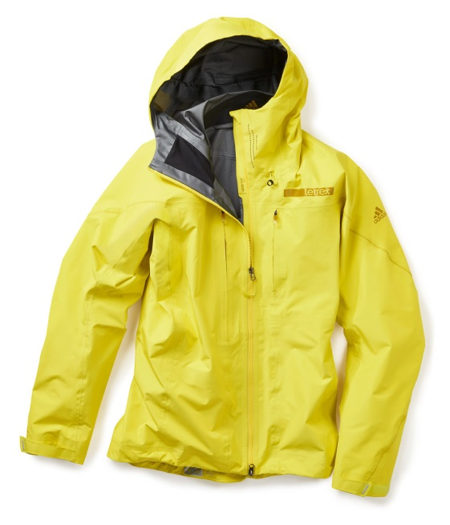

terrex TechRock Climaheat Jacket
The terrex TechRock Climaheat Jacket is made for alpinists and ice climbers who are looking for a very warm but still lightweight and packable jacket. In addition to its high-end insulation, which consists of premium RDS-certified 90/10 goose down with 800 fill power, this jacket offers many smart details for extra warmth. Heat seals at cuffs, collar and lower hem keep the warmth where it belongs – on your body. In order to provide extra coverage of the stitches without adding weight, the adidas designers developed a so-called “heat seal baffling” construction. Thanks to the different sizes of the baffles, every other baffle covers stitching lines and minimizes cold spots through overlap. With only 490 grams, this athletic down jacket keeps you warm even in the coldest conditions and fits into every backpack due to its great packability.

Features & benefits:
- RDS-certified 90/10 goose down
- Pertex® Endurance: air-permeable, coated fabric
that is highly breathable, water- and wind-resistant
- Pertex Quantum® GL: lightweight and strong
while offering good DWR
- Heat seal baffling: every other baffle covers stitching
lines, minimizing cold spots through overlap
- Heat seals at the cuffs, collar and hem keep the
warmth inside the jacket
- One security chest pocket
- Adjustable hood
- Weight: 490g
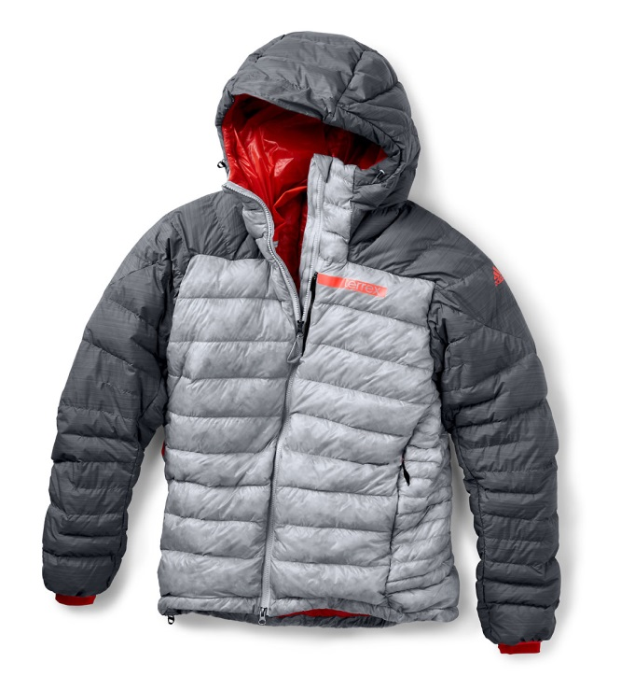
- Price: € 350.00

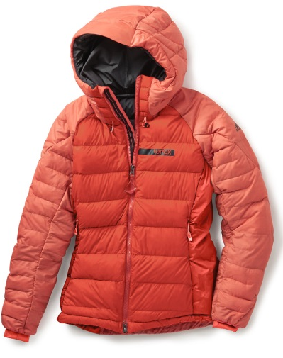

terrex TechRock Climaheat Hooded Fleece
This versatile fleece has one disadvantage: you probably never want to take it off again. Its Polartec® Thermal Pro High Loft fabric makes it extremely cozy, comfortable and fluffy. At the same time it can be compressed into very small spaces for travelling. The very strong and robust Pertex Equilibrium® overlay in critical areas makes it the ideal companion for rock as well as ice climbing and any other winter mountain sports activity.

Features & benefits:
- Pertex Equilibrium®: lightweight, robust and strong fabric
- Polartec® Thermal Pro High Loft: offers highest warmth-to-weight ratio due to high loft construction
- Two hand pockets with zip
- Athletic fit
- Weight: 425g (men M)
- Price: € 160.00

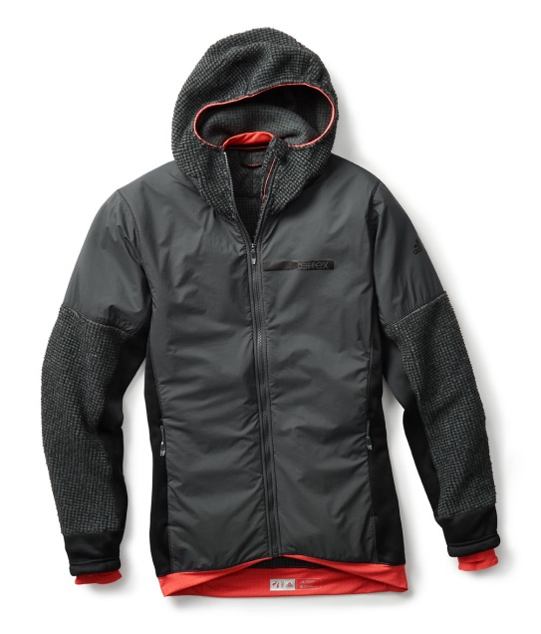

terrex TechRock Winter Pant
This waterproof and very durable pant provides all the protection you need for activities such as ice climbing, mountaineering, ski touring or freeriding. During the activity it provides great comfort, featuring the most breathable Softshell fabric in the market, Polartec® Power Shield® Pro with High Efficiency backer. The larger kicker patch offers extra protection against ski and crampon cuts.

Features & benefits:
- Polartec® Power Shield® Pro: durable, waterproof and breathable Softshell fabric
- Side ventilation opening
- Adjustable waist with velcro and elastic at the back
- Two hand pockets with zip
- Bottom protection against ski cuts
- Inner gaiter
- Athletic fit
- Weight: 770g (men M)
- Price: € 350.00

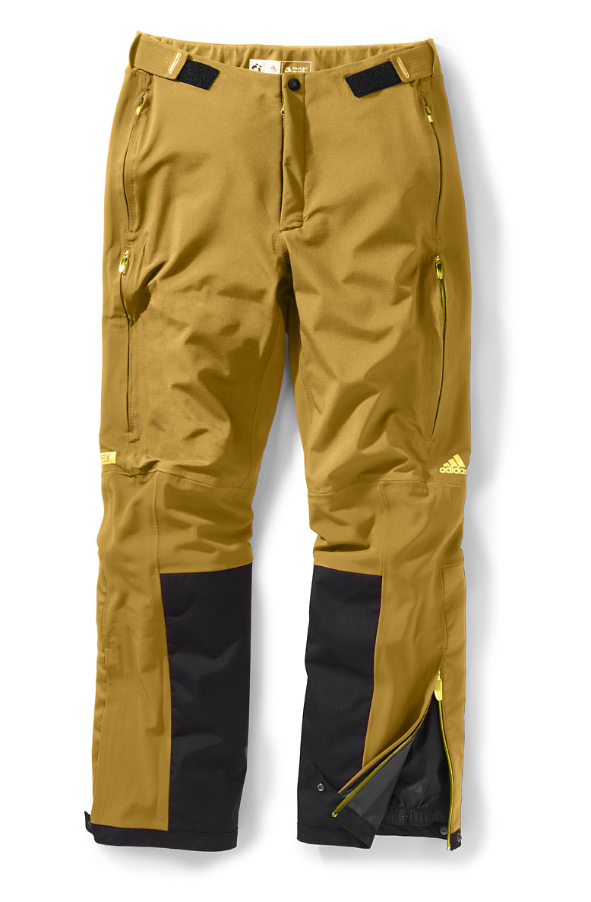

terrex Agravic PrimaLoft Jacket
Looking for a light, easy-care and packable all-year insulation jacket? Then this is your jacket of choice. It’s the ideal companion for ski touring, mountaineering and biking. The special highlight: A stitched pattern with reflective yarn that gives you 360° visibility in the dark.
Although it’s a newcomer in the adidas Outdoor range, the terrex Agravic PrimaLoft Jacket already is one of the favorite pieces of our athletes and product testers.

Features & benefits:
- PrimaLoft® Gold: ultra-fine microfiber insulation that is warm, soft and lightweight in combination with superior water resistance
- Pertex Quantum® GL: lightweight and strong while offering good DWR
- Pertex® Microlight: soft and lightweight fabric with a nylon coating on top to guarantee high resistance against abrasion
- Reflective all-over stitching
- Pack-it pocket
- Stab stitch
- Elastic cuffs on sleeves and lower hem
- Weight: 315g (men M)
- Price: € 200.00

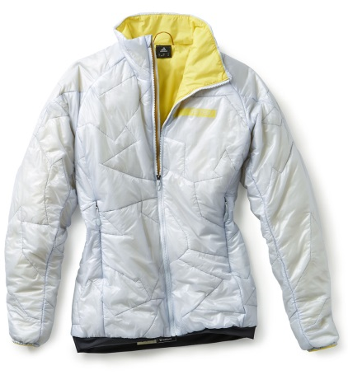

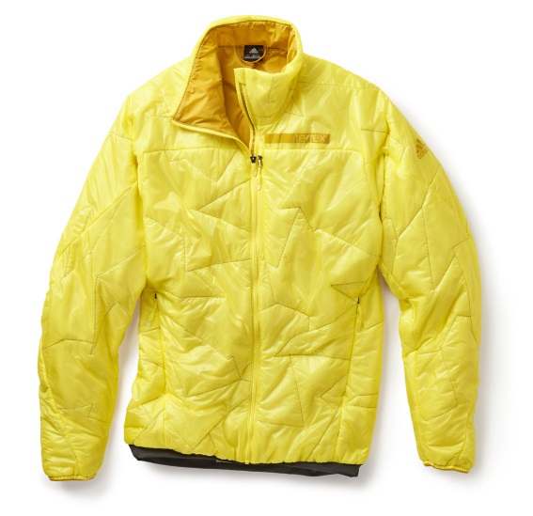

terrex Agravic PrimaLoft Vest
This innovative lightweight PrimaLoft Vest is a great product for intensive activities in cold conditions. It is an extremely practical product: easy to jump in, easy-care, warm and very small and packable. The lightest Pertex® outer and lining fabrics combined with the best PrimaLoft® Gold padding make the product very warm and compressible at the same time. The T-shirt silhouette gives you the extra protection in the shoulder area you when active in the cold. The stitched pattern with reflective yarn gives you 360° visibility in the dark.

Features & benefits:
- PrimaLoft® Gold: ultra-fine microfiber insulation that is warm, soft and lightweight in combination with superior water resistance
- Pertex Quantum® GL: lightweight and strong while offering good DWR
- Pertex® Microlight soft and lightweight fabric with a nylon coating on top to guarantee high resistance against abrasion
- Reflective all-over stitching
- Pack-it pocket
- Stab stitch
- Elastic cuffs on sleeves and lower hem
- Weight: 250g (men M)
- Price: € 170.00

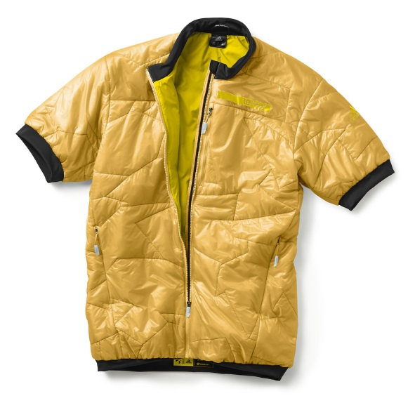

terrex Agravic PrimaLoft Short
A small piece but a big asset. The terrex Agravic PrimaLoft Short is the ideal product for athletes who don’t want to carry any additional gram of weight. You can easily wear a thin breathable pant when running or ski touring up the mountain and then put on the PrimaLoft Short during rest periods and you will not be freezing. The short guarantees outstanding freedom of movement and with the side opening you can quickly put it on or take it off or even wear it during the activity.

Features & benefits:
- PrimaLoft® Gold: ultra-fine microfiber insulation that is warm, soft and lightweight in combination with superior water resistance
- Pertex Quantum® GL: lightweight and strong while offering good DWR
- Pertex® Microlight: soft and lightweight fabric with a nylon coating on top to guarantee high resistance against abrasion
- Adjustable waist with velcro
- Reflective yarns
- Two hand pockets
- Side opening
- Weight: 130g (men M)
- Price: € 100.00

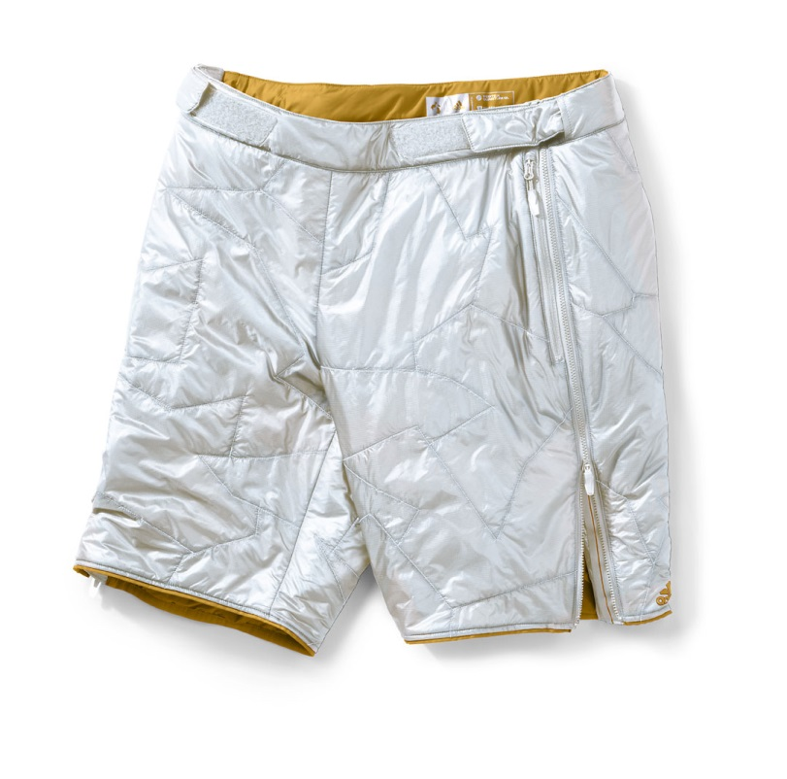

terrex Skyclimb Insulation Jacket
The terrex Skyclimb Insulation Jacket is a highly versatile product made of partial PrimaLoft® insulation combined with a 4-way stretch Softshell fabric. A 60g PrimaLoft® Gold layer in the front area covered with an abrasion-resistant lightweight woven overlay offers good protection against cold wind and light snow while the breathable Softshell fabric on arms and back provides excellent body climate.

Features & benefits:
- PrimaLoft® Gold: ultra-fine microfiber insulation that is warm, soft and lightweight in combination with superior water resistance
- FORMOTION®: ultimate performance and comfort while in motion. Guarantees unrestricted freedom of movement and an athletic fit at the same time
- Two hand pockets and one security chest pocket
- Athletic fit
- Weight: 250g (men M)
- Price: € 140.00

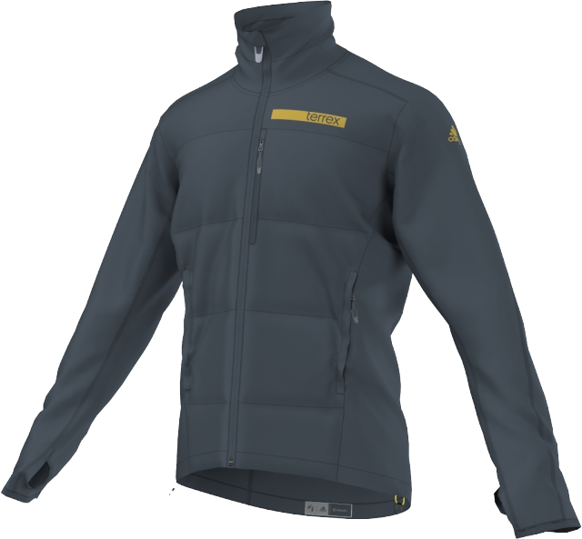

terrex Skyclimb Insulation Vest
Fast-paced winter mountain sports such as ski mountaineering are your sport of choice? Then you will love this vest. It combines light weight with great freedom of movement and features a material mix that offers both insulation and breathability.

Features & benefits:
- PrimaLoft® Gold: ultra-fine microfiber insulation that is warm, soft and lightweight in combination with superior water resistance
- FORMOTION®: ultimate performance and comfort while in motion. Guarantees unrestricted freedom of movement and an athletic fit at the same time
- Two hand pockets and one security chest pocket
- Athletic fit
- Weight: 200g (men M)
- Price: € 120.00

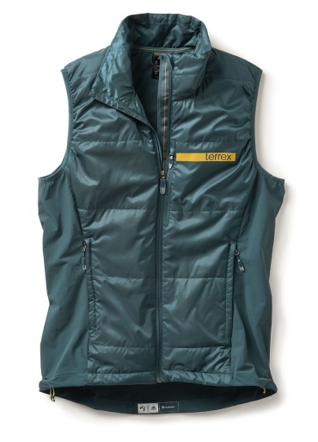

terrex Skyclimb Top
Do more with less. The terrex Skyclimb Top was created to do the job of three garments in just one piece. It is an ideal base layer, using the best-performing Polartec® Power Dry® High Efficiency fabric. It also functions as a mid-layer, using Polartec® Alpha® insulation, and it features an overlay of the lightest Pertex Equilibrium® adding the function of a windproof vest. All these fabrics have extraordinary mechanical wicking properties to ensure the highest level of comfort in a wide range of activities and weather scenarios. The placements of these fabrics make the top a perfect lightweight, versatile piece for fast-forward mountain sports activities.

Features & benefits:
- Polartec® Power Dry® High Efficiency: keeps your skin dry when sweating, dries quickly and feels comfortable next to the skin
- Polartec® Alpha®: combination of lightweight warmth and true breathability that provides warmth even when wet and dries quickly
- Pertex Equilibrium®: overlayer for additional wind protection. Moisture is transported away from the skin to the outside of the fabric where it evaporates
- Hybrid construction combining the advantages of different performance fabrics. It allows highest breathability and moisture management while offering warmth during low-activity times
- FORMOTION® cut: guarantees unrestricted freedom of movement and athletic fit at the same time
- ½ zip at front part of the mid-layer
- Price: € 150.00

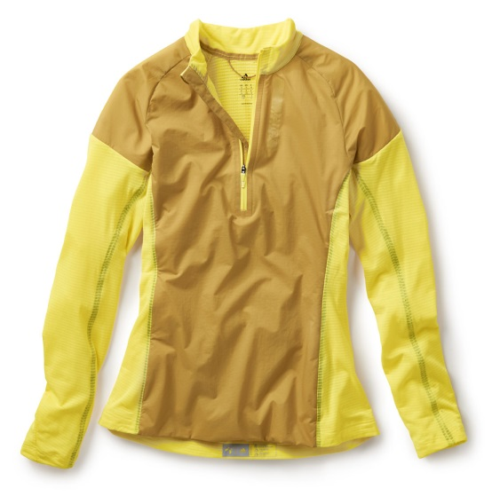
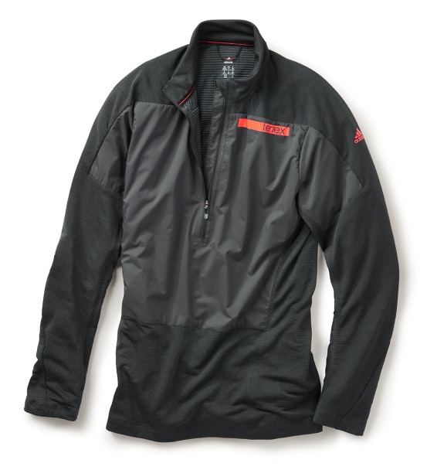

terrex Skyclimb Pant
The terrex Skyclimb Pant is – thanks to its shape and features – the ideal pant for ski touring. It provides maximum of freedom of movement and excellent protection in tough conditions. The strap at the lower leg keeps the hem in position and seals against snow.

Features & benefits:
- Preshaped knees
- One side mesh pocket and two hand pockets
- Elastic waist bands with draw cords
- Bottom protection against ski cuts
- Weight: 535g (men M)
- Price: € 180.00

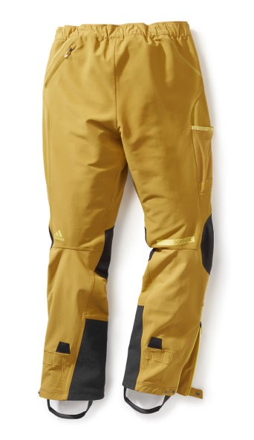
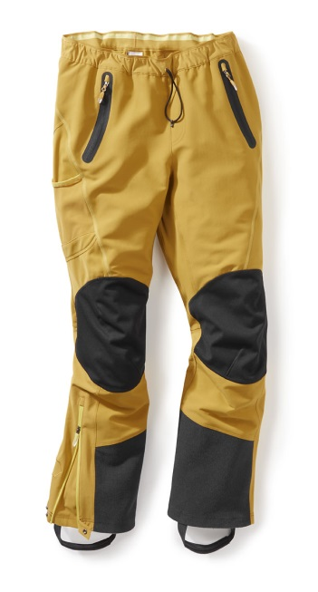

terrex IceSky Longsleeve
The terrex IceSky Longsleeve is a versatile lightweight fleece for intensive activities. It is highly breathable and can be worn as outer or mid-layer, depending on conditions and activity. The Climawarm® fabric offers great moisture management and thermal regulation.

Features & benefits:
- Climawarm®: comfortable body temperature and enhanced moisture management
- Half zip for extra ventilation
- Printed graphic gives the base layer a unique and different look
- Athletic fit
- Weight: 255g (men M)
- Price: € 80.00

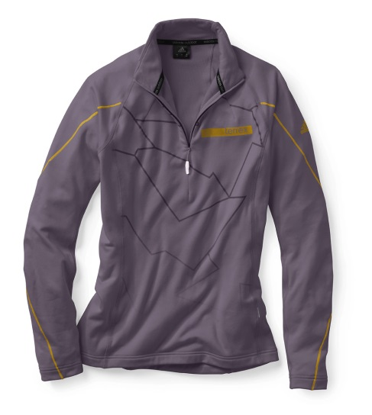
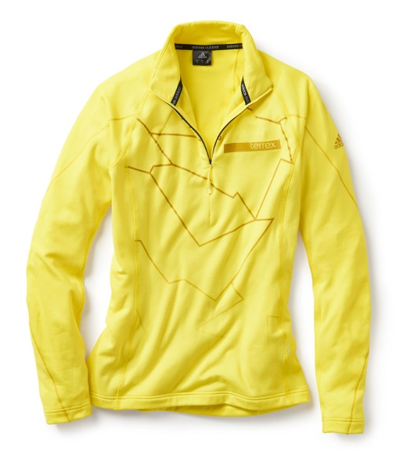

terrex Radical Crew Jacket
This new versatile jacket in a crew neck silhouette will be the favorite piece of fashionable outdoor enthusiasts who are looking for a versatile, active insulation layer. Its Polartec® Alpha insulation keeps you warm and comfortable. Stretch panels on the sides and preshaped sleeves guarantee outstanding freedom of movement. The windproof overlay with DWR treatment makes the terrex Radical Crew Jacket a highly versatile piece.

Features & benefits:
- Polartec® Alpha at the front: the most advanced technology, insulating and wind-resistant even when wet
- Climawarm®: comfortable body temperature and enhanced moisture management
- Kangaroo front pocket
- Pack-it pocket
- Athletic fit
- Weight: 345g (men M)
- Price: € 150.00

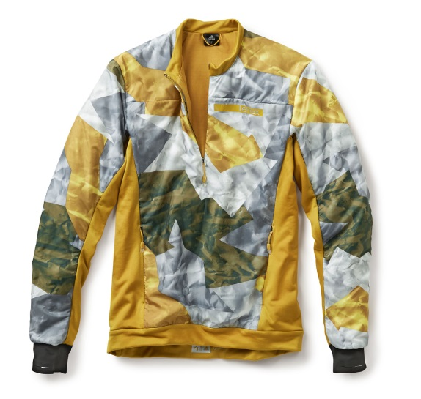

terrex Skyrunning Pant
The lightweight terrex Skyrunning Pant is ideal for fast-paced activities during winter or summer alpinism. It offers good breathability and resistance against abrasion as well as excellent freedom of movement. The highly elastic hem fits perfectly over ski boots and seals against snow.

Features & benefits:
- Firn ice crash fabric
- Ventilation at side
- Stretch protection fits over ski boots
- Two hand pockets and one back pocket with zip
- Athletic fit
- Weight: 370g (men M)
- Price: € 160.00

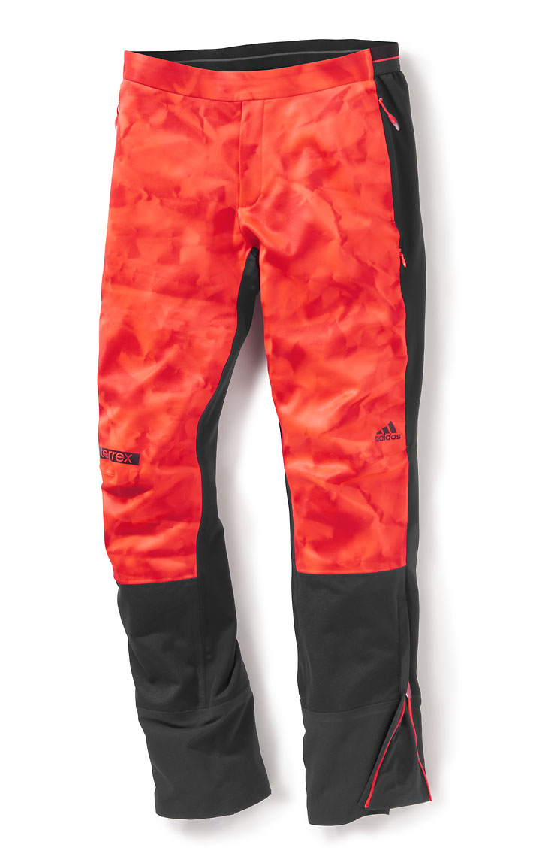

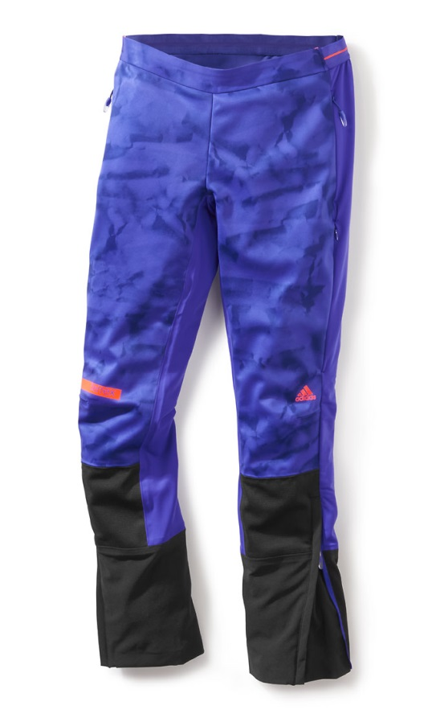

terrex WoolBlaze Short Sleeve Tee
This cozy merino wool blend T-shirt is a newcomer within the adidas terrex range. The fully knitted construction is made of a merino wool blend yarn. Its seamless back provides good comfort when wearing a backpack. The special highlight of this stylish tee is its wind-resistant camouflage front panel that can be opened completely when needed. It’s the perfect shirt for outdoor athletes who care about style and maximum functionality.

Features & benefits:
- Merino wool: natural, soft and breathable fiber that retains heat and absorbs moisture and smell
- Wind-resistant at the front thanks to windproof overlayer
- Full center front zip
- Security chest pocket
- Athletic fit
- Weight: 305g (men M)
- Price: € 150.00
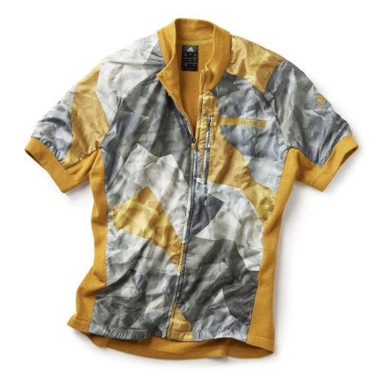

***

More information and regular updates about adidas Outdoor:
www.adidas.com/outdoor/
www.facebook.com/adidasoutdoor
www.instagram.com/adidasoutdoor
www.youtube.com/adidasoutdoortv
www.pinterest.com/adidasoutdoor

Media contact:

Lena Hackforth
Senior PR & Social Media Manager adidas Outdoor
+49 9132 84 4380
+49 160 884 4380 (mobile)
lena.hackforth@adidas.com

