ADIDAS LAUNCH LIMITED EDITION
“LOVE / HATE” ADIZERO F50

The adizero f50 Tattoo Pack is set to make its mark as the latest installment of the #ThereWillBeHaters collection

Herzogenaurach, Wednesday 4th March – adidas has launched a dramatic limited edition re-design of the adizero f50 as part of the #ThereWillBeHaters collection: the new adizero f50 Tattoo Pack.

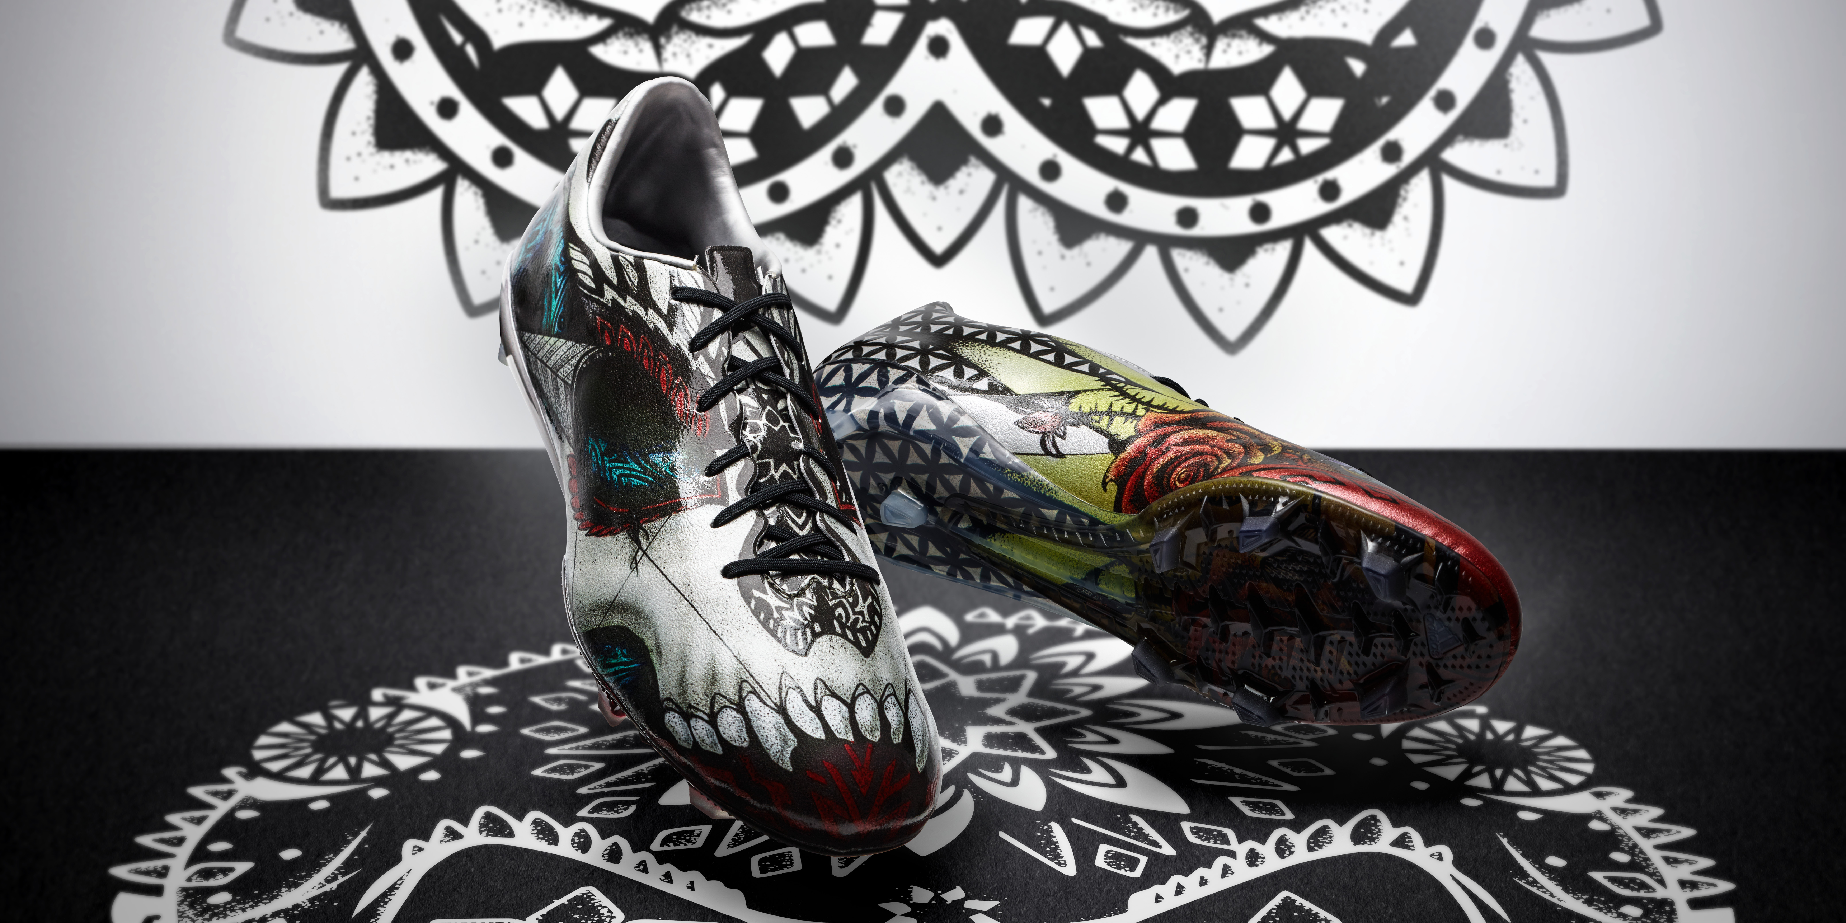
The all new adizero f50 Tattoo Pack

The design of the adizero f50 Tattoo Pack represents the creativity and self-expression that only the very best players are capable of. The left and right boots feature separate motifs that bring to life the themes of “love” and “hate”. The right boot features a menacing black skull motif emphasising strength, power and hatred. The left boot is designed with bright colours and diverse designs including a rose design that symbolise a player’s love of the game.

If you have “haters”, then it’s the ultimate compliment. The best players know that a great performance delivers “hate” from fans and opponents, particularly on social media, which then continues to fuel the confidence to deliver even greater performances. They thrive off it – and they make no apology in doing so.

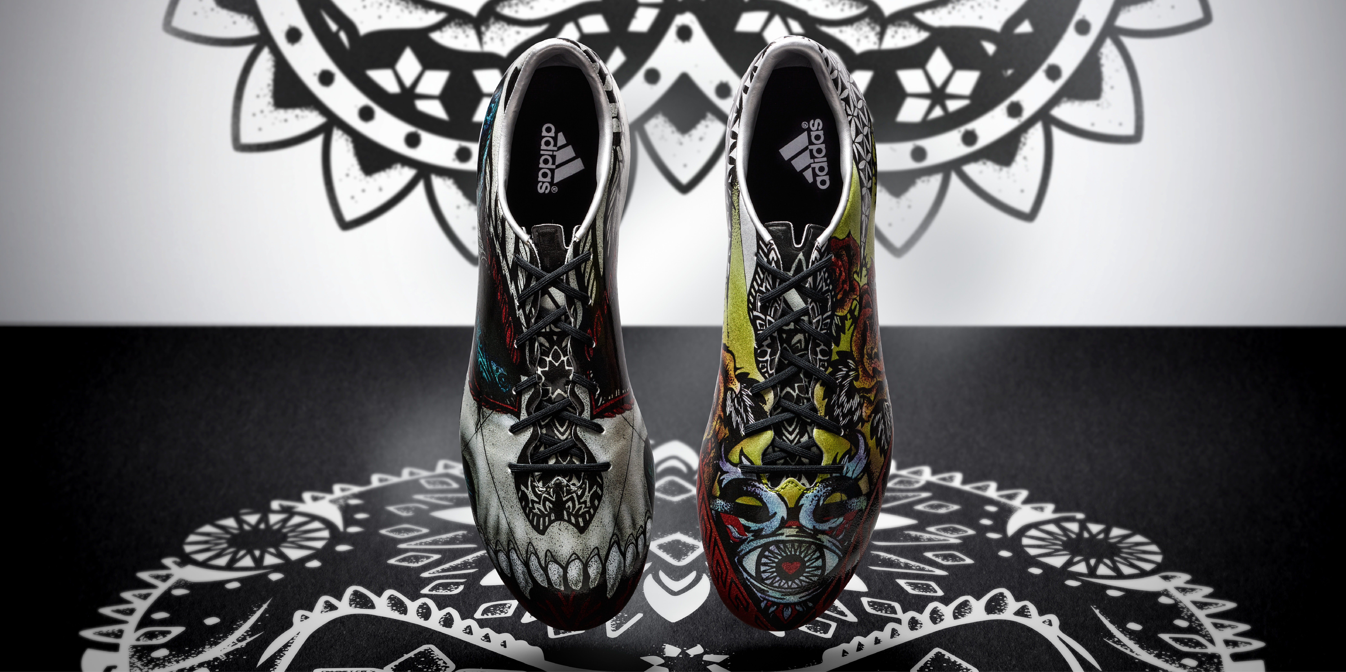
The all new adizero f50 Tattoo Pack

The new Tattoo Pack boot features all of the product innovations that make the adidas adizero f50 the ultimate weapon to maximise speed and manoeuvrability. The 3D dribbletex layer on the upper optimises speed dribbling in all conditions while the grip texture, stud configuration and second level of traction on the forefoot base provide maximum manoeuvrability.

The limited edition adidas adizero f50 Tattoo Pack boots are available to purchase from Monday 9th March at adidas own-retail outlets as well as specialist retailers worldwide. For further information please visit adidas.com or go to facebook.com/adidasfootball or follow @adidasfootball #ThereWillBeHaters on twitter to join the conversation.

- END -

For further media information please visit http://news.adidas.com/GLOBAL/PERFORMANCE/FOOTBALL or contact:

Robert Hughes  adidas Global Football PR Director  Email: robert.hughes@adidas.com  Tel: +49/9132/84-6856 | Alan McGarrie  adidas Senior Global Football PR Manager  Email: alan.mcgarrie@adidas.com  Tel: +49/9132/84-4686

Notes to editors:
About adidas Football
adidas is the global leader in football. It is the official sponsor / official supplier partner of the most important football tournaments in the world, such as the FIFA World Cup™, the FIFA Confederations Cup, the UEFA Champions League, the UEFA Europa League and the UEFA European Championships. adidas also sponsors some of the world’s top clubs including Real Madrid, FC Bayern Munich, AC Milan, Flamengo and Chelsea. Some of the world’s best players also on the adidas roster are Leo Messi, Gareth Bale, Thomas Müller, Arjen Robben, James Rodriguez, Karim Benzema and Bastian Schweinsteiger.

