EMBARGOED UNTIL 0800HRS CET, MONDAY 2ND FEBRUARY 2015

THERE WILL BE HATERS:
ADIDAS UNVEILS NEW FOOTBALL BOOT RANGE

“They hate your shiny new boots, because they wish they were in them”

Herzogenaurach, 2nd February 2015 – adidas has kicked convention today by launching a new set of football boots which are sure to inspire both hate and awe in equal measure. The new adizero f50, Predator, Nitrocharge and 11Pro have already appeared on the feet of some of the best players in the world, and now it’s your turn to be the “most hated” player on the pitch.

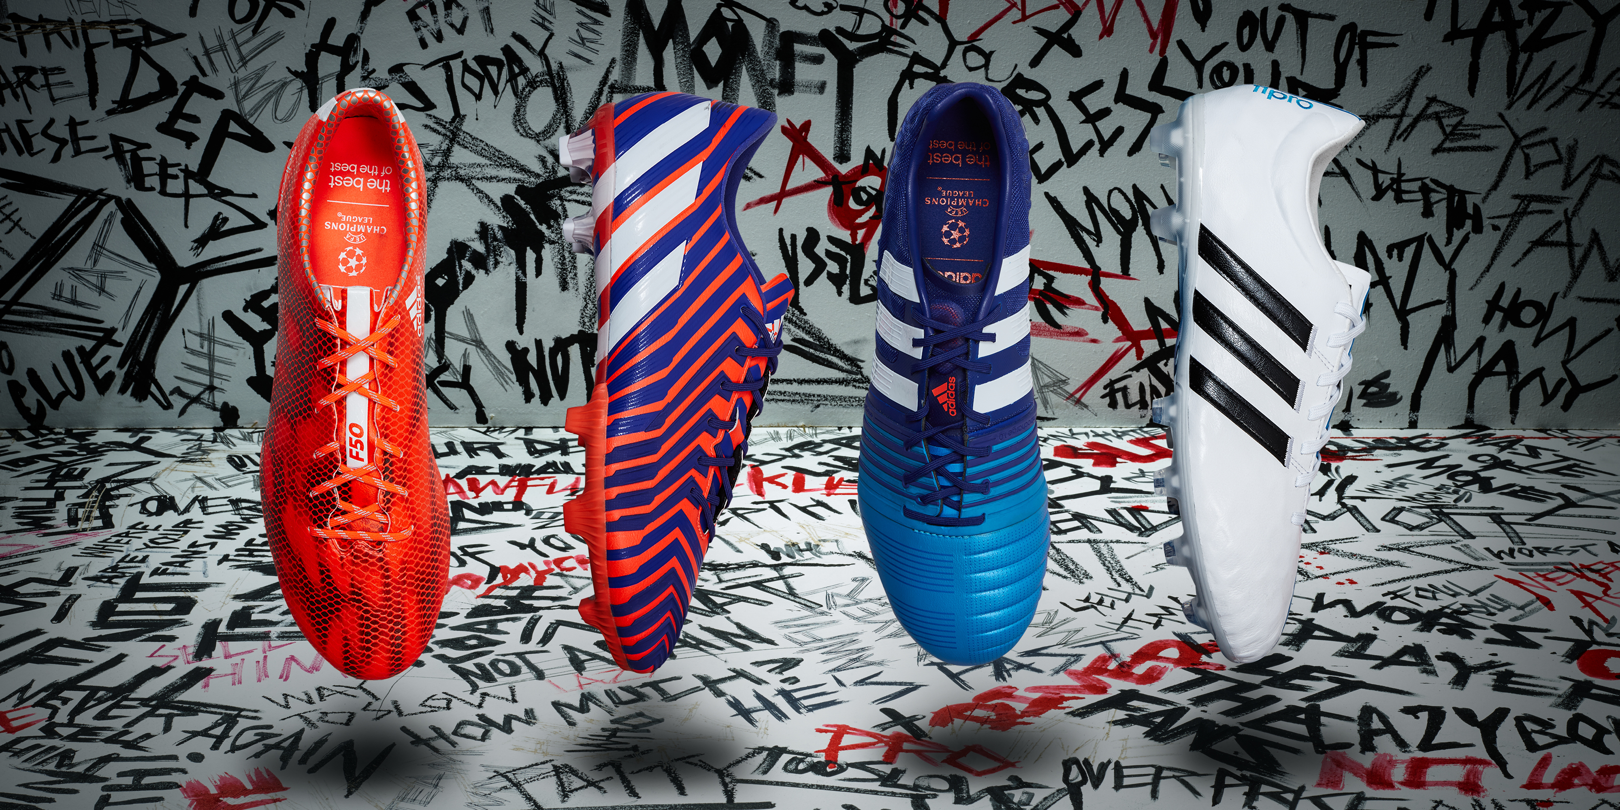
adizero f50, Predator, Nitrocharge & 11Pro

If you have “haters”, then it’s the ultimate compliment. The best players know that a great performance delivers “hate” from fans and opponents, particularly on social media, which then continues to fuel the confidence to deliver even greater performances. They thrive off it – and they make no apology in doing so.

The adidas #ThereWillBeHaters campaign was launched recently with a provocative new video featuring stars such as Gareth Bale, Luis Suarez, James Rodriguez and Karim Benzema, and the new boot range with the latest in adidas technology ensures you will deliver a “haters” performance when you step out onto the field.

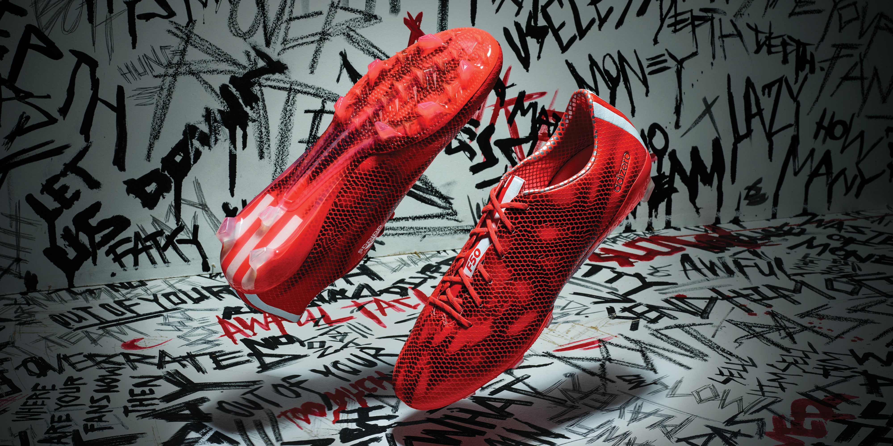
The adidas adizero f50

adizero f50
The adidas adizero f50 is worn by the most prolific players in world football and has been designed to maximise speed and manoeuvrability. A revolutionary new design including a “ghost” graphic, sleek red colour and new 3-Stripes branding ensures you will own the bragging rights on the pitch. A 3D dribbletex layer on the upper allows for better speed dribbling in wet or dry conditions. The outsole has also had a complete re-design, with a new grip texture and stud configuration with a second level of traction on the forefoot base, inspired by sprint spikes.

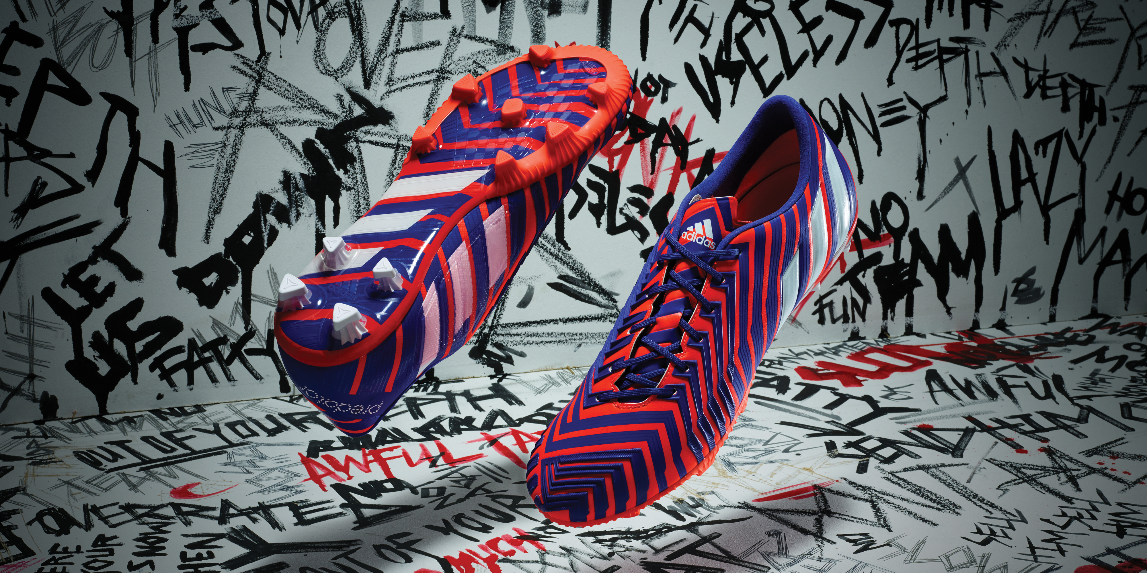
The adidas Predator

Predator
Following last year’s 20th anniversary of the iconic boot, the Predator has also been given a re-design. A newly designed super-soft upper provides all the benefits of leather and synthetic. The 3D engineered SL rubber zones, combined with the newly engineered gel pod, provide optimal grip on the ball and an enhanced capability for precision passing. The revolutionary control frame provides ultimate contact with the ball, with the transparent outsole giving you the magic touch and complete control.

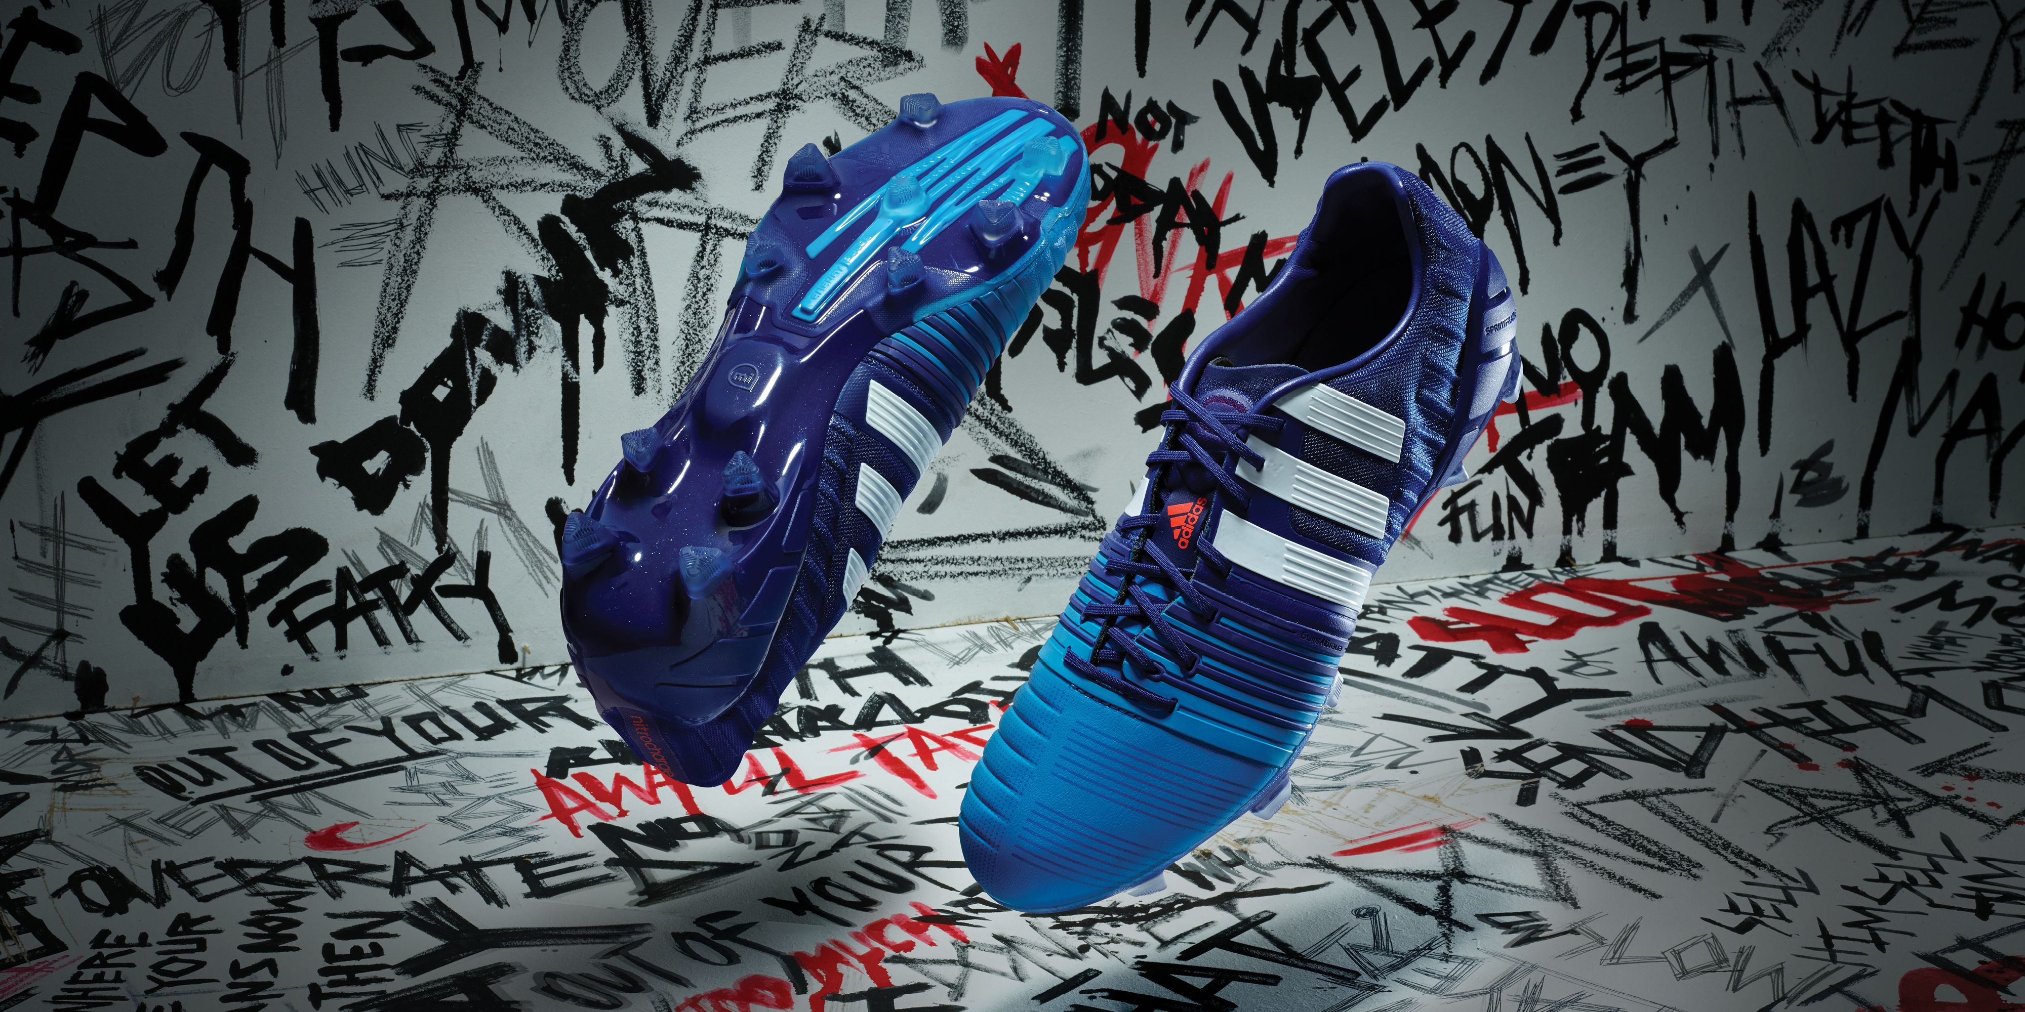
The adidas Nitrocharge

Nitrocharge
Nitrocharge has been re-energised with the latest technology. The energy-sling positioning has been used alongside an increased area of protection pads and protection mesh to provide unrivalled stability. Nitrocharge is the perfect boot for “The Engine”, box-to-box, all-action player.

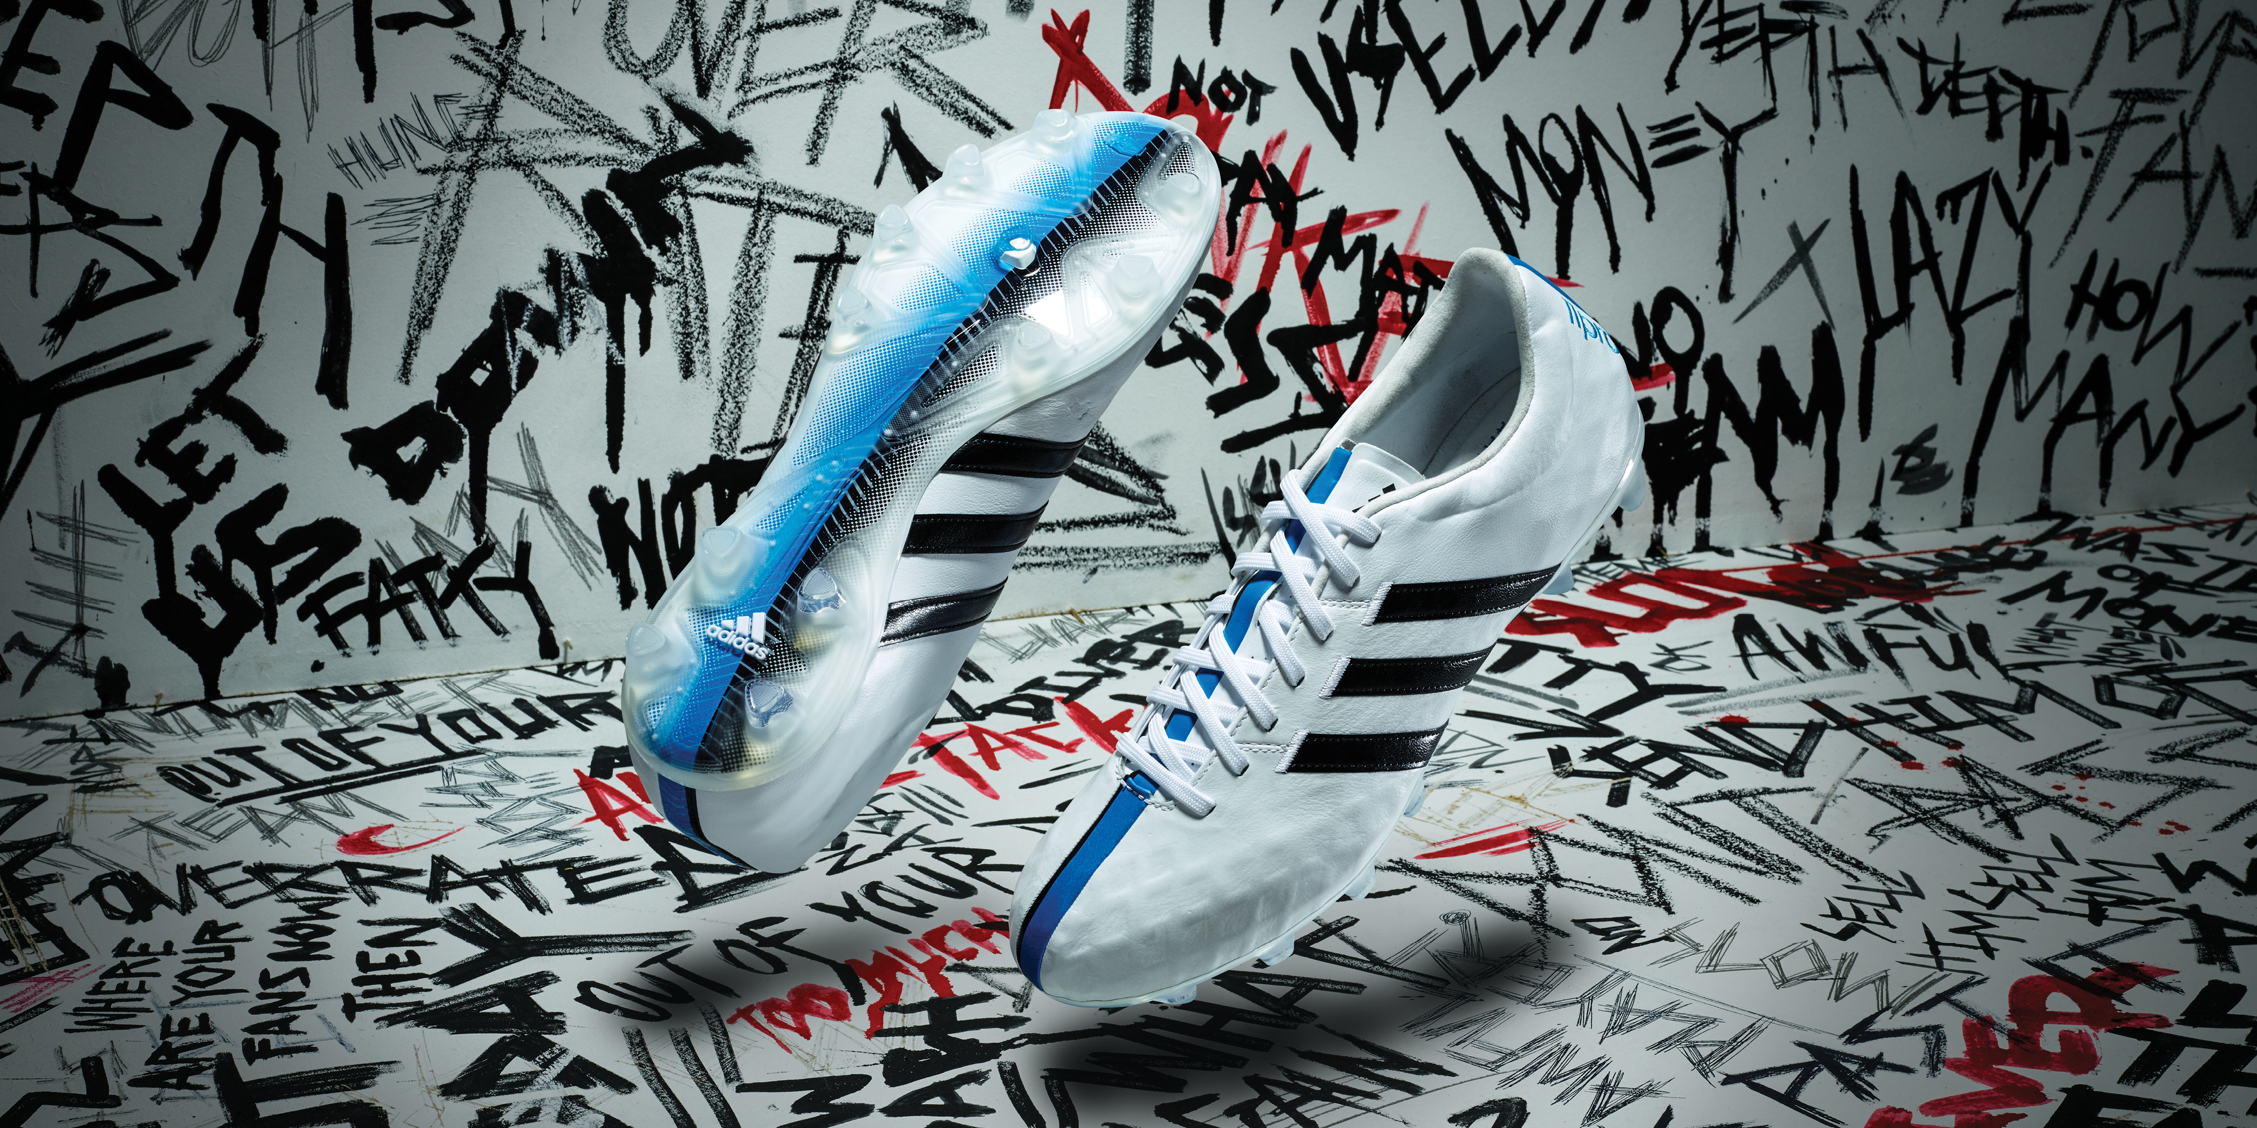
The adidas 11Pro

11Pro
The 11Pro is the most comfortable to date and is the “perfect suit” in terms of elegance and style. The skeleton in the heel and forefoot offers a better fit and increased stability. The all-new comfort outsole also features a comfort frame which distributes pressure across the shoe, while new smaller studs provide perfect ground penetration. The leather upper provides an ultra-comfortable fit as well as optimum control.

The all-new adidas adizero f50, adidas Predator, adidas Nitrocharge and adidas 11Pro are available to buy now at www.adidas.com/football. To join the conversation visit facebook.com/adidasfootball or follow @adidasfootball on twitter #ThereWillBeHaters.

- END -

For further media information please visit http://news.adidas.com/GLOBAL/PERFORMANCE/FOOTBALL or contact:

For further information please contact:

Robert Hughes  adidas Global Football PR Director  Email: robert.hughes@adidas.com  Tel: +49/9132/84-6856 | Alan McGarrie  adidas Senior Global Football PR Manager  Email: alan.mcgarrie@adidas.com  Tel: +49/9132/84-4686
Notes to editors:
About adidas Football
adidas is the global leader in football. It is the official sponsor / official supplier partner of the most important football tournaments in the world, such as the FIFA World Cup™, the FIFA Confederations Cup, the UEFA Champions League, the UEFA Europa League and the UEFA European Championships. adidas also sponsors some of the world’s top clubs including Real Madrid, FC Bayern Munich, AC Milan, Flamengo and Chelsea. Some of the world’s best players also on the adidas roster are Leo Messi, Gareth Bale, Thomas Müller, Arjen Robben, James Rodriguez, Karim Benzema and Bastian Schweinsteiger.

