Earth, Wind & Fire: adidas reveals new Ball inspired by nature

adidas unveils a new tournament match ball for 2015

Herzogenaurach, Wednesday 26th November – adidas has today revealed a new tournament match ball for 2015. The adidas conext15 Official Match Ball will replace the hugely successful Brazuca for selected leagues and competitions globally in 2015.

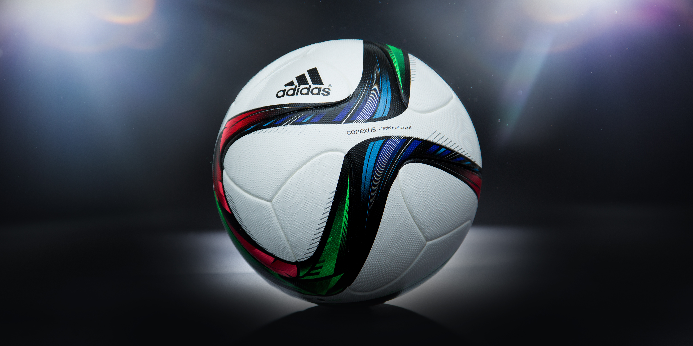
The adidas conext15 Official Match Ball

The conext15 features a new design inspired by the elements of nature: earth, wind & fire. The flowing green, red and blue design reflects the perfect balance of the three natural forces and is at the heart of the new conext15 ball.

The ball features the same ground-breaking technology that was used so successfully in Brazuca, the Official Match Ball of the 2014 FIFA World Cup Brazil™. Brazuca went through a thorough testing process over a two and a half year period involving more than 600 of the world’s top players and 30 teams in 10 countries across three continents, making it the most tested ball ever by adidas and ensuring that it is suited to all conditions.

The conext15 is one of adidas’ leading tournament match balls for 2015. The ball will be used in competitions such as FIFA Women’s World Cup Canada 2015 and the FIFA Club World Cup Morocco 2014, as well as in various league and cup competitions worldwide.

- END -

For further media information please visit http://news.adidas.com/GLOBAL/PERFORMANCE/FOOTBALL or contact:

For further information please contact:

Robert Hughes  adidas Global Football PR Director  Email: robert.hughes@adidas.com  Tel: +49/9132/84-6856 | Alan McGarrie  adidas Senior Global Football PR Manager  Email: alan.mcgarrie@adidas.com  Tel: +49/9132/84-4686

Notes to editors:
About adidas Football
adidas is the global leader in football. It is the official sponsor / official supplier partner of the most important football tournaments in the world, such as the FIFA World Cup™, the FIFA Confederations Cup, the UEFA Champions League, the UEFA Europa League and the UEFA European Championships. adidas also sponsors some of the world’s top clubs including Real Madrid, FC Bayern Munich, AC Milan, Flamengo and Chelsea. Some of the world’s best players also on the adidas roster are Leo Messi, Gareth Bale, Thomas Müller, Arjen Robben, James Rodriguez, Karim Benzema and Bastian Schweinsteiger.

