EMBARGOED UNTIL 0900HRS CET MONDAY 1ST DECEMBER

Barricade 2015: designing the future

Herzogenaurach, 1st December 2014 – adidas has unveiled the ‘Barricade 2015’ tennis shoe – the latest model in the Barricade line. The new model is the most complete reimagining of the design since the shoe’s inception 15 years ago. It’s lighter, more flexible and available in an all-new Night Flash colourway.
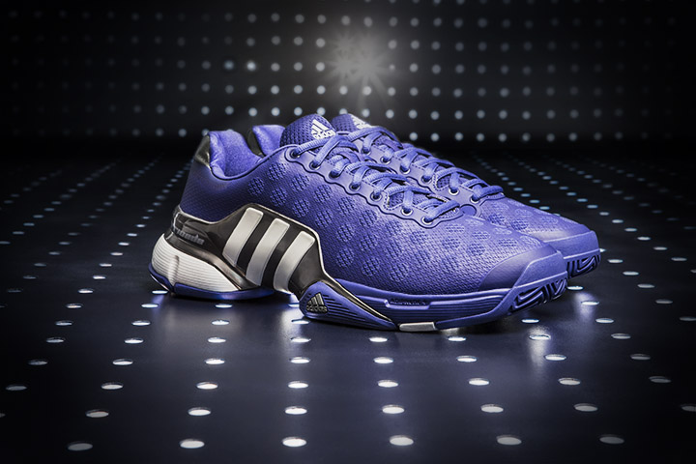
The Barricade 2015

adidas modeled the new design on the extreme playing style of some of their top Barricade players – including Jo-Wilfried Tsonga, Ernests Gulbis, Kei Nishikori and Novak Djokovic – creating a shoe that can deal with the sharp directional changes and slides that characterize the modern game. The Barricade 2015 provides players with unbeatable stability and durability.

Thomas Weege, Vice President for Heartbeat Sports Design, led the research. “Analyzing our player’s on-court performance was an essential part of the design process. Our athletes put their skills to the test every match and we needed to do the same ourselves. By redesigning some core elements of the shoe, we have managed to create a design that is a real departure from previous Barricade designs, while still retaining the core qualities of absolute stability and durability.”

After analyzing feedback from professional players and amateurs alike, the designers have maximized the comfort of the new design by introducing an innovative and new Barricade chassis, which replaces the Barricade Claw. The stabilizing chassis has been repositioned towards the heel, freeing up the forefoot and giving the shoe much greater flexibility. The Barricade 2015 is also the first to feature a synthetic-mesh toe shell for maximum breathability.

For the inside line on the shoe’s design, watch the product design video here:

[LINK]

The Barricade 2015 in the all-new Night Flash colourway will be available on the 1st December on adidas.com and selected retailers.

- END -

For further information please contact:

Ole Westerholt  adidas Global Tennis Communications Manager  Email: ole.westerholt@adidas.com  Tel: +49/9132/84-5758 | Tom Vollebregt  adidas Tennis Social Media Manager  Email: Tom.vollebregt@adidas.com  Tel: +31/20573-4843
Notes to editors:
About adidas Tennis
adidas Tennis is represented by some of the top players amongst Ana Ivanovic, Angelique Kerber, Caroline Wozniacki, Simona Halep, Andy Murray, Jo Wilfried Tsonga and Novak Djokovic For more information on adidas Tennis, please visit www.adidas.com/tennis. For additional images please visit our media news room news.adidas.com and follow us on Twitter or on Instagram under @adidasTennis.
About adidas
adidas is a global designer, developer and marketer of athletic footwear, apparel and accessories with the mission to be the leading sports brand in the world. Brand adidas is part of the adidas Group, a corporation that includes brands such as Reebok, TaylorMade and Rockport.

