#miZXFLUX app officially launches in U.S.

Users can now purchase custom shoes and bring original designs to life

New York, November 11, 2014 – In recent months, tens of thousands of original ZXFLUX designs have flooded social media, all created by the #miZXFLUX app – the first-of-its-kind consumer facing tool that has set a new bar in sneaker customization. The wait is over for U.S. users who are now able to purchase their designs.

#miZXFLUX app

Limited only by imagination, the highly anticipated #miZXFLUX app puts the power of design in the hands of the consumer to apply any image in the world to the infinitely versatile ZXFLUX model. Infinite Possibilities.

With either an iOS or Android device, users will be able to take new photographs and apply them to the ZXFLUX’s upper, with a seamless user interface from start to finish.

Once their design is selected, a 360° 3D preview will allow users to rotate, scale and position their design until it’s just right, with the ability to then save and share their designs on social networks and more.

Beginning today November 11, users in the U.S. will be able to purchase a pair of custom ZXFLUX shoes through the #miZXFLUX app. Orders take 4-6 weeks. 110USD.

ZXFLUX Experience

adidas Originals is planning to celebrate all things ZXFLUX and bring Infinite Possibilities to life with a never before seen visual experience at a New York City exhibition.

More details to come.

Share and Follow the Story

#zxflux
#mizxflux
#adidasoriginals
#adidas

@adidasoriginals
@adidas

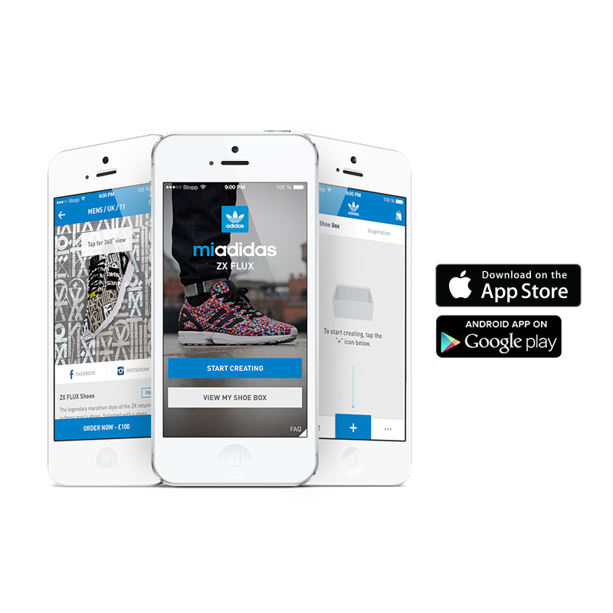

adidas Originals is the authentic lifestyle brand, symbolised by the Trefoil logo bringing heritage styles of the adidas history back to life in a way that is relevant to today’s stylish consumers.

