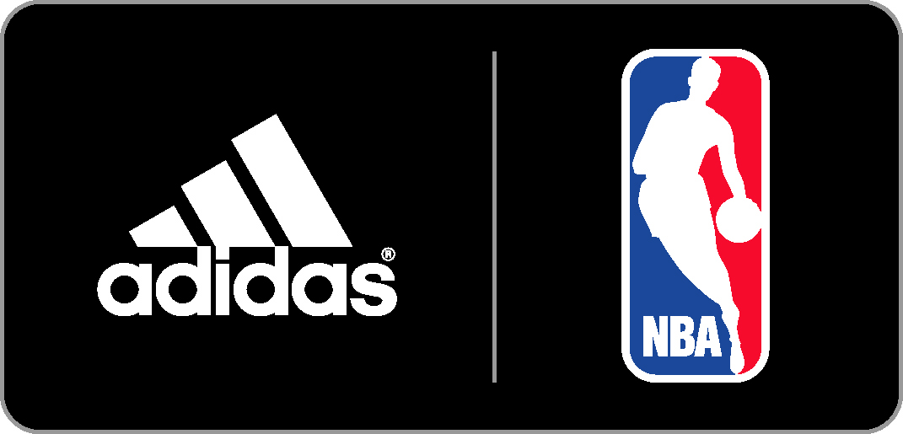

NBA AND ADIDAS LAUNCH MARKETING CAMPAIGN TO INTRODUCE

ALL-NEW SWINGMAN JERSEYS

– “NBA Swingman” Campaign Features NBA Stars Dwight Howard, Andrew Wiggins,
Damian Lillard, Kenneth Faried and Joakim Noah –

NEW YORK, Oct. 28, 2014 – adidas and the National Basketball Association (NBA) today announced the debut of a new “NBA Swingman” campaign highlighted by five television spots that celebrate the launch of the revamped jersey design. Tipping off the campaign is a TV commercial featuring Dwight Howard of the Houston Rockets. Spots featuring Andrew Wiggins of the Minnesota Timberwolves, Damian Lillard of the Portland Trail Blazers, Kenneth Faried of the Denver Nuggets and Joakim Noah of the Chicago Bulls will follow in the coming weeks.

Created by adidas, the series of TV spots captures a humorous, documentary-style approach to showcase the “Swingman in all of us.” The five athletes are cast in a variety of situations in which their “Swingman” body-doubles fill in for their duties as NBA superstars. The new adidas NBA Swingman jerseys were created with a similar concept in mind – bring fans closer to the game than ever before with an updated design featuring premium materials and an improved fit.

"Each season we look for new ways to entertain fans and showcase our latest gear,” said adidas Global Basketball General Manager Chris Grancio. “The new Swingman jerseys are more similar to on-court authentic jerseys than ever before, and the TV spots celebrate that in a fun way.”

“NBA Swingman” featuring Dwight Howard – http://youtu.be/_5PuDMFW16A

Beginning today, “NBA Swingman” will be live on the league’s digital platforms and will air across the league’s national broadcast partners ABC, ESPN, TNT and NBA TV, as well as its regional sports networks. In an effort to reach basketball fans around the world, the NBA will also air international versions of the spots in key regions.

“We continue to work closely with adidas to enhance the NBA experience for our fans around the world,” said NBA President, Global Operations and Merchandising Salvatore LaRocca. “The new Swingman jersey is an updated version of our most successful apparel product and we’re excited to introduce this new product with a unique marketing campaign.”

In addition to the five TV spots, the fully integrated “NBA Swingman” campaign includes marketing across social media, public relations, retail and digital platforms.

adidas NBA Swingman Jersey
All-new adidas NBA Swingman jerseys feature improved materials and fit to better replicate the jerseys worn on the NBA court by players. The premium mesh body of the jersey provides enhanced comfort and appearance while the tailored fit offers a slimmer cut and reduced length for superior style. In addition, the name and numbers on the jerseys are applied through a new process that provides a similar performance look and feel as authentic NBA jerseys.

Fans can purchase the adidas NBA Swingman jerseys at NBAStore.com, the NBA Store on Fifth Avenue in New York City and team retailers now for $110 in adult sizes and $75 in youth sizes.

About the NBA
The NBA is a global sports and media business built around three professional sports leagues: the National Basketball Association, the Women’s National Basketball Association, and the NBA Development League. The league has established a major international presence with offices in 13 markets worldwide, games and programming in 215 countries and territories in 47 languages, and NBA merchandise for sale in more than 125,000 stores in 100 countries on 6 continents. NBA rosters at the start of the 2013-14 season featured a record 92 international players from 39 countries and territories. NBA Digital’s assets include NBA TV, which is available in 60 million U.S. homes, and NBA.com, which recorded 26.9 billion page views during the 2013-14 season, with more than half of all visitors originating from outside of North America. The NBA is the No. 1 professional sports league on social media, with 700 million likes and followers globally across all league, team, and player platforms. Through NBA Cares, the league and its teams and players have donated more than $242 million to charity, completed more than 3 million hours of hands-on community service, and created more than 915 places where kids and families can live, learn, or play.

About adidas Basketball
adidas has been providing innovative products for the world’s best athletes for more than 60 years, from past legends to today’s superstars, such as Derrick Rose, Dwight Howard, Damian Lillard, John Wall and Candace Parker. On April 11, 2006 adidas and the National Basketball Association signed an 11-year global merchandising partnership making the adidas brand the official uniform and apparel provider for the NBA, the Women’s National Basketball Association (WNBA) and the NBA Development League (D-League) beginning with the 2006-2007 season.

# # #

Join the conversation on Twitter and Instagram by following @NBA and @adidasHoops with #NBASwingman. For more information, contact:

Sheena Morales, NBA Madeline Breskin, adidas PR
(o) 212-407-8204 (o) 971-234-2220
(m) 201-560-7682 (m) 971-295-6936
smorales@nba.com madeline.breskin@adidas.com

