EMBARGOED UNTIL 1400hrs CET Wednesday 27th August
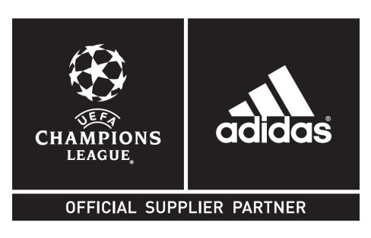
adidas presents the Official Match Ball for the
UEFA Champions League 2014/2015
New Group Stage ball inspired by on-field “rivalry”

Herzogenaurach, 27th August 2014 – Today, adidas unveiled the Official Match Ball of the UEFA Champions League 2014/2015. The adidas Finale 14 was officially revealed as the ball to be used on-pitch throughout the Group Stages of the most important club football competition in Europe
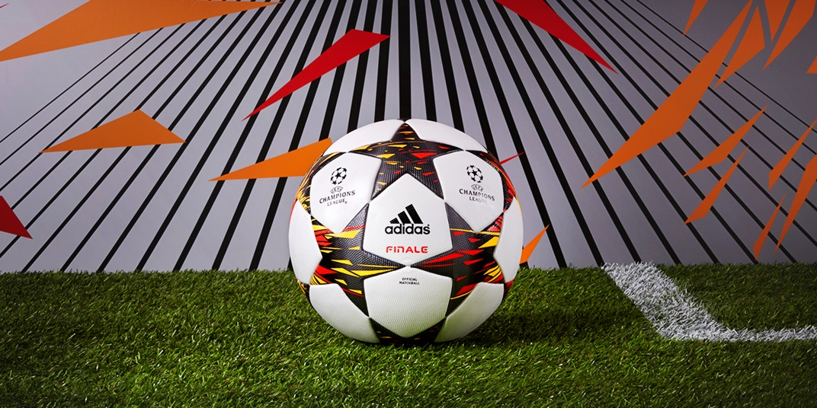

With the design of this season´s ball adidas is once again pushing boundaries: it is the first ever in UEFA Champions League history to clearly distinguish between the left and right sides. While the overall design continues to be uniform, the dual approach represents the rivalries between the competing teams in this year’s tournament, with coloured panels facing off in explosions of solar red and solar gold coloured shapes with a black background. The design of the ball highlights the moment of impact between two teams when meeting each other on the pitch.

The adidas Finale 14 Official Match Ball features an outer coating texture designed to provide optimal grip at the point of impact. The famous thermally bonded star panel design on the match ball, based on the design of the UEFA Champions League logo, provides a seamless surface and, as such, a truer flight.

The UEFA Champions League Official Match Ball will be further highlighted in the adidas Gamedayplus series. adidas Gamedayplus, which is hosted on Youtube, is a show that gives fans the latest news on the UEFA Champions League for the 2014/15 season. The show will feature exclusive interviews, products and segments featuring the world's best players and clubs. Plus it gives fans opportunities to win once in a lifetime prizes, such as an all-expenses paid trip to the UEFA Champions League Final 2015 and signed kit from some of the world's best players. To access Gamedayplus please visit: www.adidas.com/gamedayplus.

The adidas Finale 14 will be used on field during all UEFA Champions League Group stage matches from September 16th onwards up until the 10th of December 2014. It is available now for purchase in selected adidas retail outlets, associated stockists and via www.adidas.com/football. Join the adidas UEFA Champions League conversation on Twitter: @adidasfootball.
- Ends -

For further media information please visit http://news.adidas.com/GLOBAL/PERFORMANCE/FOOTBALL or contact:

For further information please contact:

Robert Hughes
Senior Global PR Manager Football

Email: Robert.Hughes@adidas.com
Tel: +49-160 884 6856

Alan McGarrie
adidas Global Football PR Manager
Email: alan.mcgarrie@adidas.com
Tel: +49/9132/84-4686

Notes to Editors:
adidas Production of Official Match Balls since 1970
adidas’ experience in football production is unparalleled. adidas has been making footballs since 1963 and is now the world’s leading manufacturer, always at the cutting edge of technology. adidas has supplied the Official Match Balls to all major UEFA and FIFA tournaments since 1970, and since 2006 is also the Official Supplier of the match ball for all UEFA Champions League games. The adidas Finale ball has been used for the UEFA Champions League Final since the 2000/2001 season. Since 2008, adidas is also the Official Supplier of the match ball for the Africa Cup of Nations organized by the Confédération Africaine de Football (CAF).

