From street to pitch - Victorious in Style

adidas unveil new Bayern Munich 2014/2015 away-kit

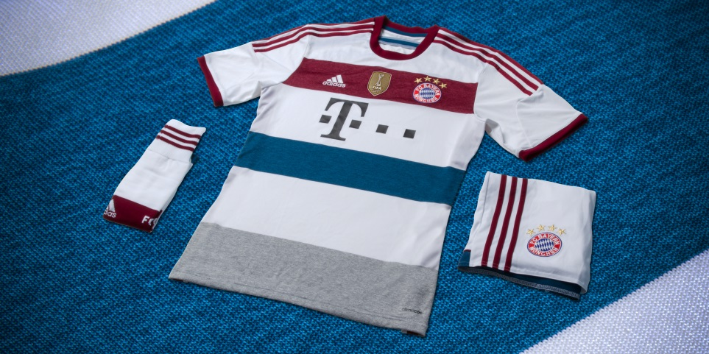

Munich, Friday, July 25th, 2014 – adidas and Bayern Munich are proud to unveil the new official away-jersey for the 2014/2015 season, a classic yet modern kit inspired by current fashion trends and street wear.

Ahead of a season in which the goal will once again be to win every competition in which the club is involved, adidas wanted to ensure that Bayern Munich bridged the gap between pitch and street by designing a kit which not only shines on the field of play but also is stylishly cool and proudly sported by fans.

The away kit has striking colours, both respecting the elegance of the club but also incorporating the most modern fashion trends.

The predominantly white jersey displays an engineered front panel fabric which features three additional horizontal bands in striking iconic FCB colours – dark red, tribe blue and mid grey. The dark red colour is further present in the adidas iconic three stripes that shape the sleeves of the shirt.
Like the home jersey, the back neck of the away jersey also boasts the now famous ´Mia san Mia´ wording – the German motto that all Bayern fans proudly know by heart and which means ´We are who we are´ in English. Additionally, the “Bayern München“ wording is also already applied on the back panel of the kit.
The shorts of the kit are also white, featuring dark red stripes and a tribe blue horizontal band.

Availability
Bayern Munich’s away-kit will debut on field in this weekend´s Telekom Cup which will take place in Hamburg. It is available to buy from today, July 25th, in select adidas retail outlets, associated stockists, the Bayern Munich Online-Shop (www.fcbayern.de/shop)
and via www.adidas.com/football. Join the adidas football conversation at www.facebook.com/adidasfootball or on Twitter: @adidasfootball.

For further information please contact:
Robert Hughes  adidas Senior Global Football PR Manager  Email: robert.hughes@adidas.com  Tel: +49/9132/84-6856 | Alan McGarrie  adidas Global Football PR Manager  Email: alan.mcgarrie@adidas.com  Tel: +49/9132/84-4686

Notes to editors:
About adidas Football
adidas is the global leader in football. It is the official sponsor / official supplier partner of the most important football tournaments in the world, such as the FIFA World Cup™, the FIFA Confederations Cup, the UEFA Champions League, the UEFA Europa League and the UEFA European Championships. adidas also sponsors some of the world’s top clubs including Real Madrid, FC Bayern Munich, AC Milan, Flamengo and Chelsea. Some of the world’s best players also on the adidas roster are Leo Messi, Gareth Bale, Mesut Özil, James Rodriguez, Dani Alves, Oscar, Xavi, Karim Benzema and Bastian Schweinsteiger.

