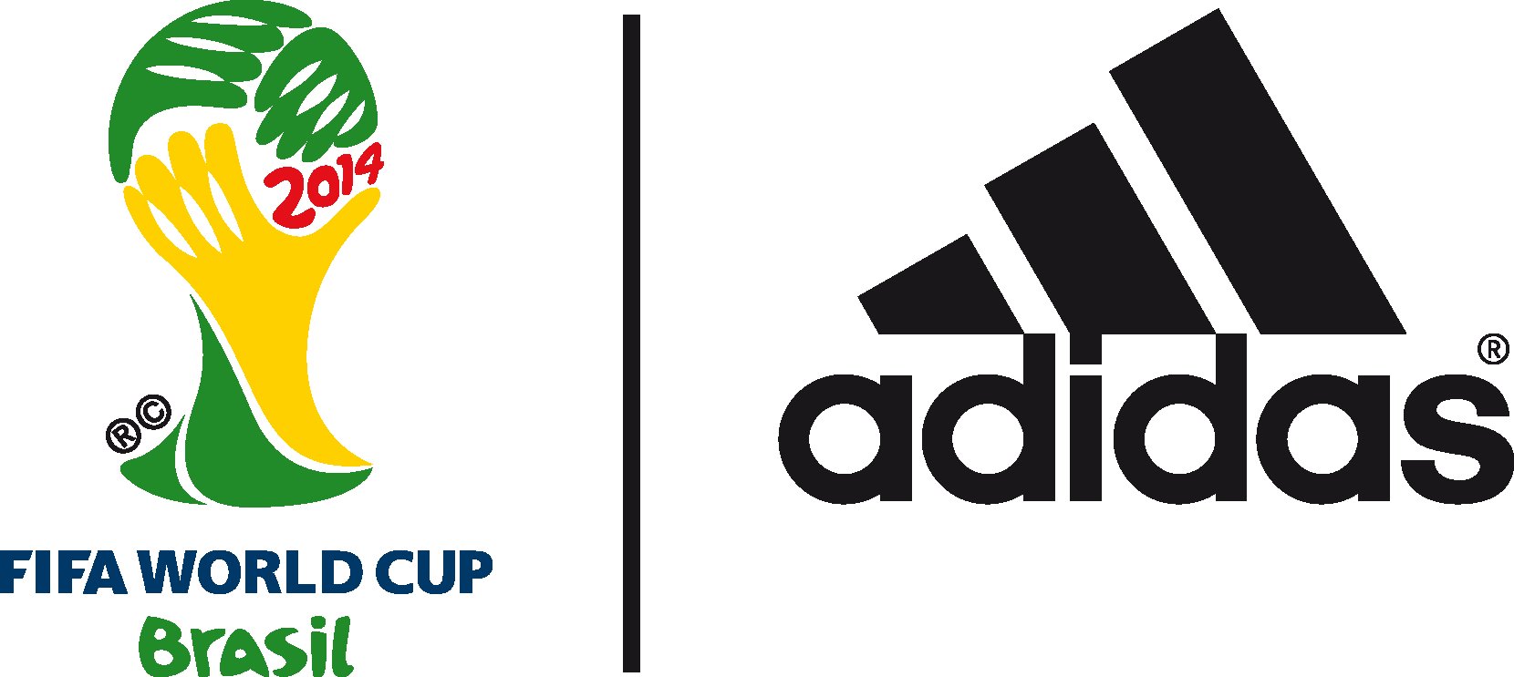

David Beckham predicts Argentina to win the 2014 FIFA World Cup BrazilTM in adidas finale show

England legend stars in The Dugout and backs Messi to shine in 2014 FIFA World Cup Brazil™ Final

Link to show here: http://www.youtube.com/watch?v=PNgG5wtBZdI

12th July 2014 – Herzogenaurach/ Rio de Janeiro – Former England captain and footballing superstar David Beckham has predicted Argentina to win the 2014 FIFA World Cup Brazil™. The England legend made the prediction/statement on the final episode of‘The Dugout’, a new initiative set up by adidas at the 2014 FIFA World Cup Brazil™ designed for football fans from around the world.

Taking place ahead of Sunday’s 2014 FIFA World Cup Brazil™ final between Germany and Argentina at the Brazil Clube Regatas Flamengo, Gavea, the final episode saw Beckham giving his thoughts on this year’s tournament, and recounting his personal history with the adidas Predator football boot to mark the 20th anniversary of Predator, with the new Predator boot to be launched on Wednesday 16th July.

Speaking on the show, Beckham stated: “It has been a truly fantastic tournament, with two great teams in the final. Whilst they have no superstar, Germany has a fantastic team, where they work really well together and have played some amazing football at this tournament. Argentina also has a great team, but they also have Messi, who is quite simply an unbelievable footballer and who I cannot wait to see play with my kids on this greatest of stages. This is why I am going for a 3-1 Argentina win.”

Beckham also singled out Colombian superstar James Rodriguez as one of the players of the 2014 FIFA World Cup Brazil™, with his goal against Uruguay a true highlight of the tournament.

Beckham added, “My advice to James would be to just continue to enjoy playing this wonderful game, and not let the added attention that will inevitably follow this tournament faze him. He has the makings of a true star, with an incredibly bright future ahead of him. He is so young with already so much experience. He can certainly go on to become one of the world’s best players.”

Beckham also went on emphasise his admiration for the Brazilian footballers who he had played with throughout his career, as well discussing the rise of the MLS and how the league had transformed since his arrival in the USA from Real Madrid back in 2007.

Hosted by KICKTV hosts Jimmy Conrad, Layla Anna-Lee and Hugh Wizzy, The Dugout has brought an audience of millions of football fans closer than ever before to adidas footballers and legends, providing debate, views and reactions to all the action in Brazil on and off the field. The series has been broadcast over the course of the tournament, with star appearances including Cafu, Fernando Hierro, Patrick Vieira and Kaka.

The final show also saw another episode of the adidas miCoach Smart Ball Power Challenge. The Smart Ball, which houses a sensor package and helps measure the speed, curve, trajectory and spin of the ball and the challenge, saw Kaka beat Patrick Vieira’s benchmark speed of 111kph, with a winning speed of 112kph.

With adidas-sponsored sides Argentina and Germany making the Final once again, the World’s leading football brand has cemented its success story at the 2014 FIFA World Cup Brazil™.
As well as domination on the pitch, adidas has been the most talked about brand at the World Cup 2014 across all major social media channels, with the #allin or nothing campaign represented strongly across Twitter, YouTube, Facebook, Instagram and Tumblr; posting a combination of planned, anticipated and reactive content for the duration of the five week event.

Link to show here: http://www.youtube.com/watch?v=PNgG5wtBZdI

Join the adidas football conversation at www.facebook.com/adidasfootball or on Twitter: @adidasfootball.

***
- END -

For further media information please visit http://news.adidas.com/GLOBAL/PERFORMANCE/FOOTBALL or contact:

Robert Hughes  adidas Senior Global Football PR Manager  Email: robert.hughes@adidas.com  Tel: +49/9132/84-6856 | Alan McGarrie  adidas Global Football PR Manager  Email: alan.mcgarrie@adidas.com  Tel: +49/9132/84-4686
Notes to editors:
About adidas Football
adidas is the global leader in football. It is the official sponsor / official supplier partner of the most important football tournaments in the world, such as the FIFA World Cup™, the FIFA Confederations Cup, the UEFA Champions League, the UEFA Europa League and the UEFA European Championships. adidas also sponsors some of the world’s top clubs including Real Madrid, FC Bayern Munich, AC Milan, Flamengo and Chelsea. Some of the world’s best players also on the adidas roster are Leo Messi, Gareth Bale, Thomas Müller, Arjen Robben, James Rodriguez, Dani Alves, Karim Benzema and Bastian Schweinsteiger.

***

