FOR IMMEDIATE RELEASE

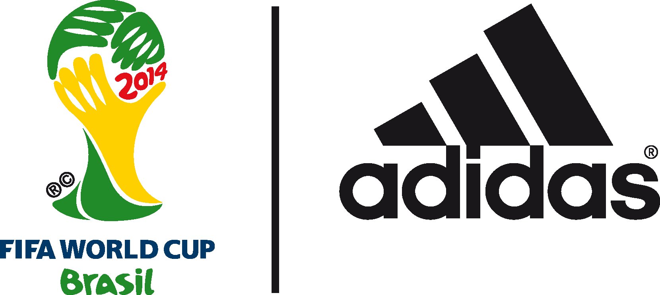

David Beckham to feature in adidas finale show at the 2014 FIFA World Cup BrazilTM

England legend to star in The Dugout ahead of 2014 FIFA World Cup Brazil™ Final

10th July 2014 –Rio de Janeiro – On the eve of the 2014 FIFA World Cup Brazil™ Final, adidas is inviting fans to join the finale show of its World Cup series – The Dugout, streamed on YouTube.

Taking place at 1100 (BRT) the final episode in the series of adidas Dugout shows in Rio will feature England legend and global icon David Beckham. The show will see Beckham answering questions live from the adidas studio, giving his thoughts on this year’s tournament, and recounting his personal history with the adidas Predator football boot to mark the 20th anniversary of Predator.

To watch The Dugout live go to the adidas YouTube page from 1100 BRT today (12th July).

Hosted by KICKTV hosts Jimmy Conrad, Layla Anna-Lee and Hugh Wizzy, The Dugout will bring an audience of millions of football fans closer than ever before to adidas footballers and legends, providing debate, views and reactions to all the action in Brazil on and off the field. The series has been broadcast over the course of the tournament, with star appearances including Cafu, Fernando Hierro, Patrick Vieira and Kaka.

The final show will also see another episode of the adidas miCoach Smart Ball Power Challenge. The Smart Ball houses a sensor package which helps measure the speed, curve, trajectory and spin of the ball and the challenge will see Kaka attempt to beat Patrick Vieira’s benchmark speed of 111kph. There will also be a report from the FIFA Interactive World Cup, where a new World Champion was crowned at the top of Sugarloaf Mountain last week.

The show airs on YouTube and adidas social channels at 1100 (BRT) ahead of the 2014 FIFA World Cup Brazil™ Final. To watch go to https://www.youtube.com/watch?v=PNgG5wtBZdI.

Teaser trailer is available here:
http://youtu.be/IdBU6vrSr08

Join the adidas football conversation at www.facebook.com/adidasfootball or on Twitter: @adidasfootball.

***
- END -

For further media information please visit http://news.adidas.com/GLOBAL/PERFORMANCE/FOOTBALL or contact:

Robert Hughes  adidas Senior Global Football PR Manager  Email: robert.hughes@adidas.com  Tel: +49/9132/84-6856 | Alan McGarrie  adidas Global Football PR Manager  Email: alan.mcgarrie@adidas.com  Tel: +49/9132/84-4686
Notes to editors:
About adidas Football
adidas is the global leader in football. It is the official sponsor / official supplier partner of the most important football tournaments in the world, such as the FIFA World Cup™, the FIFA Confederations Cup, the UEFA Champions League, the UEFA Europa League and the UEFA European Championships. adidas also sponsors some of the world’s top clubs including Real Madrid, FC Bayern Munich, AC Milan, Flamengo and Chelsea. Some of the world’s best players also on the adidas roster are Leo Messi, Gareth Bale, Mesut Özil, Dani Alves, Oscar, Xavi, Karim Benzema and Bastian Schweinsteiger.

Broadcast dates and YouTube video URLs

The Dugout - 12th July
VIDEO URL: https://www.youtube.com/watch?v=PNgG5wtBZdI

***

