FOR IMMEDIATE RELEASE

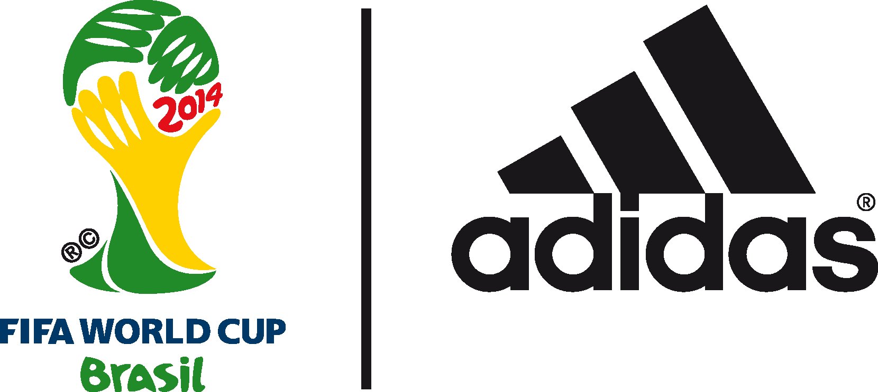

@brazuca to reveal adidas Golden Ball award nominees

In a world first, contenders for best player of the 2014 FIFA World Cup Brazil™ to be announced by @brazuca twitter feed

10th July 2014 –Rio de Janeiro – This week history will be made as the adidas Golden Ball award goes digital. The nominees for the best player award at the 2014 FIFA World Cup Brazil™ will be revealed on the @brazuca twitter feed at 2:30PM (BRT) on Friday 11th July.

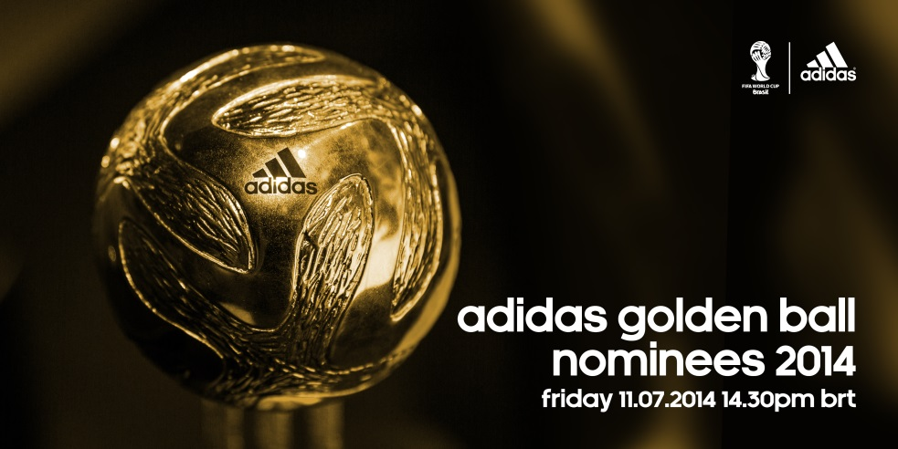

The 2014 FIFA World Cup Brazil™ (@fifaworldcup) has been one of the best tournaments in history, with the 159 goals scored in Brazil already surpassing the 145 scored in South Africa. Many of the world’s best players have lit up the pitch in Brazil, but only one will be rewarded with the prestigious adidas Golden Ball award.

adidas has awarded the adidas Golden Ball to the best player of the FIFA World Cup™ for over 30 years. This year the award is being thrust into the digital age with the help of @brazuca. In a world first, the nominations for the award will be announced live on the @brazuca twitter feed in its own unique style.

@brazuca is the twitter feed of the official match ball of the 2014 FIFA World Cup Brazil™, the first product from adidas to have its own twitter account. @brazuca has been a huge success with over 3 million twitter followers and rising. From inception to sentience, the adidas @brazuca handle has been tweeted at and followed by some of the world’s most high profile footballing personalities including ex-England striker Gary Lineker OBE, FIFA president Sepp Blatter and German international midfielder Bastian Schweinsteiger.

@brazuca has provided real time commentary on the games and major talking points throughout the tournament, providing fans with a unique insight into the biggest tournament in the world from the perspective of the match ball. This included the moment when debate surrounded a goal from France’s Karim Benezma, which required the use of goal-line technology. The resulting tweet from @brazuca achieved over 16.5k retweets and 7k favourites – the most of any brand related tweet during the tournament to date.

To find out who is in contention to be named the adidas Golden Ball winner, follow @brazuca on Twitter. Join the adidas football conversation at www.facebook.com/adidasfootball or on Twitter: @adidasfootball.
***
- END -

For further media information please visit http://news.adidas.com/GLOBAL/PERFORMANCE/FOOTBALL or contact:

Robert Hughes  adidas Senior Global Football PR Manager  Email: robert.hughes@adidas.com  Tel: +49/9132/84-6856 | Alan McGarrie  adidas Global Football PR Manager  Email: alan.mcgarrie@adidas.com  Tel: +49/9132/84-4686
Notes to editors:
About adidas Football
adidas is the global leader in football. It is the official sponsor / official supplier partner of the most important football tournaments in the world, such as the FIFA World Cup™, the FIFA Confederations Cup, the UEFA Champions League, the UEFA Europa League and the UEFA European Championships. adidas also sponsors some of the world’s top clubs including Real Madrid, FC Bayern Munich, AC Milan, Flamengo and Chelsea. Some of the world’s best players also on the adidas roster are Leo Messi, Gareth Bale, Mesut Özil, Dani Alves, Oscar, Xavi, Karim Benzema and Bastian Schweinsteiger.
***

